Overview
This project aims to “[use] vision language foundation models (VLM) [and LLMs] to control assistive robotic devices,” primarily in the form of a basic, supernumerary robotic limb that can swivel and perform basic tasks. This is a proof of concept project to lay the groundwork for future, more ambitious projects.

The arm will be worn by a user (most likely around their hips) and will perform commands imputed via a prompt line or speech input. Object detection and data input will come from the Meta Project Aria glasses, which will either be worn by the user or attached somewhere on the robot purely for data streaming. Processing will be handled by a portable computation setup (a separate laptop or a small, onboard computing device).

Topics we are likely to explore include VLAs, eye-tracking detection,

Professor Slade’s Exact Vision:
“Specifically, I think we should explore how to control a supernumerary robotic limb that is equipped with vision sensors and a simple gripper to augment many tasks of daily living, targeting a use case for older adults. E.g. finding something within sight of the person (glasses, an apple, etc), performing a manipulation task (grasping the person wrist to help lift a cup, or grasping a cup directly), or providing additional safety measures (grasping a railing during stair climbing, etc). We can use some very simple hardware to act as our robotic platform.

For hardware we could use the meta glasses mounted on a very simple robotic arm. We can just stream the data from the meta glasses to a laptop initially and later add a portable computation setup to run the models.”

This summer, we will be working on the project from June 2nd to August 8th (10 weeks), during which we aim to build a rudimentary, physical prototype that works as described in the project description.

POCs:
- Professor Slade: slade@seas.harvard.edu
- Raymond Liu: liur@g.harvard.edu
- Charlie Chen: charliechen@college.harvard.edu
- Alex Ko: alexko@college.harvard.edu

Specific Timeline with project goals/milestones to follow below upon further discussion.
Timeline:
Phase 0: (Week 1/2)
Conduct preliminary background research on VLAs and supernumerary robotic limbs (specifically arms). Decide the general direction that we want to go with our project

Phase 1: (Week 2 - Week 4)
Build a 1 DOF proof of concept arm (stick attached to a servo) and demonstrate that SmolVLA can be configured to output instructions for n-DOF arms while using data from the Project Aria front facing cameras

1.1: Build basic hardware setup using an arduino, some basic circuitry, and a servo
1.2: Interface Python and VS Code with the Arduino Serial Monitor
1.3: Access the Project Aria forward facing camera feed and plug data into SmolVLA
1.4: Reconfigure SmolVLA output layer so that it outputs a single angle to be fed into the servo
1.5: Put everything together and test the proof of concept

Phase 2: (Week 5 - Week 10)
Build a 3 DOF, supernumerary arm controlled by SmolVLA that takes in camera and eye tracking data from the Project Aria glasses. The Arm should at the very least be able to pick up objects on a table

2.1.1: Design hardware setup while considering material properties, size/scale, types of DOF, etc…
2.1.2: Research how multi DOF arms work and how to both build and code one
2.2: Create a preliminary CAD design and source parts for it
2.3: Build a first prototype of the arm and then iterate upon it
2.4.1: Integrate eye tracking data into SmolVLA
2.4.2: Retrain model if necessary
2.5: Reconfigure SmolVLA output layer to the specifications of the experimental arm
2.6: Put everything together and see if it all functions correctly.

Phase 3 (if time):
Redesign arm to include a swiveling functionality so that it can swing side to side on the wearer.

Phase 4 (post summer, optional):
Create a basic study/research paper outline by investigating what tasks the arm could functionally perform and then proposing a line of testing, collecting data, and eventually writing a small paper (maybe for a local robotics conference).

Revised Overview
Overarching question: How effectively can VLAs perform tasks that require human-robot interaction?
- How effectively can existing VLAs be applied to supernumerary robotic arms (as opposed to stationary arms in a controlled environment)
- How effectively can existing VLAs understand their surroundings and instructions while performing human-robot interaction tasks

Overall timeline:
- Use existing SO-101 6-DOF arm (the one on Alex’s desk) + a webcam (instead of Aria glasses) to perform human-interactive tasks
  - Mount the arm onto a human (CAD a new base piece, design an interface for human to wear)
  - This serves as an MVP0 for an SRA running on SmolVLA performing human-interactive tasks, and is an intermediate step before custom hardware
  - Note: this allows us to have some sort of presentable milestone by the end of the summer, but it runs parallel to the work we did this past month (instead of building off of it)
- Once we have that MVP, do one of the following tasks for the rest of the summer:
- Start coming up with benchmarks/conduct trials with humans for human-interactive tasks
  - Consider custom arm/locking joints if 6-DOF turns out to be too complicated
- Start building a custom 4-DOF arm to carry out human-interactive tasks (so we’re not just using this one existing library for all of our implementation)
  - This also allows us to use the Aria glasses instead of a webcam
- During the school year:
  - Build custom robot arm
  - Explore building our own VLA that takes in the additional data that the Aria glasses collect

Types of Tasks
We want human-interactive tasks, i.e. tasks that
- target activities of daily living (ADLs)
- require the robot to interact with the human

- Find and pass glasses
- Pick up and hold water bottle while human drinks
- Spoon-feed human
- Stabilize hand while brushing teeth
- Grip waistband of pants to help with pulling them up/down
- Picking up something they dropped

Revised Experimental Protocol
Revised Experimental Protocol:

Protocol Overview: For each of the base tasks, we conduct 5 trials of every combination of variations. Each task will be evaluated for success rate on a normalized scale from 0-1. We take the average of the 5 trials for each task-variation combination. At the end of the experiment, we will survey the user for perceived success and helpfulness of the arm.

Things we need: We will need lab iPhones for the OpenCap setup to measure/quantify human movement throughout tasks (in order to assign level of human movement for task variations). We will also need a controlled, uncluttered environment (empty room, desk pushed up against a wall – we can use either a corner of Haedo/Fil/Teo’s room or just a random empty SEC room) to ensure we can control the amount of clutter/distractions in the environment.

Hardware setup: We will have the SO-101 looped around the base of the subject’s neck to secure it to the subject’s chest. We will be using an iPhone strapped to the subject’s shoulder (using a PellKing mount) for the camera, with Continuity Camera on the ultra-wide lens. We also have a wrist camera mounted on the SO-101’s end effector. We will also have two lab iPhones recording the environment with OpenCap.

Limitations: The human must always be looking at what they are doing due to lack of spatial awareness from the robot.

Base Tasks:

For basic non-HRI and one-time interaction tasks, assign normalized point values at different progress checkpoints for each task (this way we can fairly provide partial credit). A 0 represents failure to hit the first checkpoint, and 1 represents full successful task completion.

For continued interaction tasks, measure success by percentage of overall task time (maybe we do 10-30 seconds) robot is completing the task. We can quantify how much the human needs to move/adjust based on their movement in OpenCap (and maybe turn that into a success metric too? And also definitely a variation metric)

Basic non-HRI tasks:
- Pick up and place a utensil in an open drawer: “Put the [spoon] in the drawer”
  - ADL category: Housecleaning
  - Progress checkpoints:
    - Robot moves towards glasses
    - Robot picks up glasses
    - Robot moves towards drawer
    - Robot places in drawer
- Move an object to the left/right: “Move the [plate] to the left”
  - ADL category: General
  - Progress checkpoints:
    - Robot moves towards object
    - Robot begins to move object to left/right
    - Robot lets go after moving
- Stack plastic cups on top of each other: “Stack the cups”
  - ADL category: Housecleaning
  - Progress checkpoints:
    - Robot moves towards cup
    - Robot picks up cup
    - Robot moves towards stacked cups
    - Robot stacks cup

One-time interaction tasks:
- Find and place glasses in subject’s hand: “Hand me my glasses”
  - ADL category: General
  - Progress checkpoints:
    - Robot moves towards glasses
    - Robot picks up glasses
    - Robot moves towards human hand
    - Robot places in human hand
- Find and place a utensil in subject’s hand: “Hand me the [spoon]”
  - ADL category: Feeding
  - Progress checkpoints:
    - Robot moves towards utensil
    - Robot picks up utensil
    - Robot moves towards human hand
    - Robot places in human hand
- Pick up utensil from hand and place it in an open drawer: “Put the [spoon] in the drawer”
  - ADL category: Housecleaning
  - Progress checkpoints:
    - Robot moves towards utensil
    - Robot picks up utensil
    - Robot moves towards open drawer
    - Robot places in open drawer

Continued interaction tasks: (measure by time?)
- Stabilize forearm while brushing teeth: “Help me while I brush my teeth”
  - ADL category: Hygiene
- Pick up and hold water bottle while human drinks from it: “Hold up the waterbottle”
  - ADL category: Feeding
- Hold up pants while human puts on belt: “Hold up my pants”
  - ADL category: Dressing

Task Variations:
- Amount of human movement (quantify human movement with OpenCap data)
  - Camera frame and person’s torso (or wherever the camera is mounted) is as still as possible
  - Slight movement side to side throughout the task, quantified by IMU acceleration
  - Fast or larger movement or quick stops throughout the movement
- Amount of workspace clutter
  - Workspace only features objects involved in the task (and ones that cannot be removed)
  - Workspace features a small, quantified number of background artifacts (could be physical objects or distracting shapes/colors)
  - Workspace features a large, quantified number of background artifacts (could be physical objects or distracting shapes/colors)
- Orientation of object of interest (upside down for example)
  - Object is in a standard orientation (defined on a task by task basis)
  - Object still features identifiable characteristics, but those characteristics may be slightly obstructed or in different orientations
  - Object is the same type of object, but a different version entirely (different pair of glasses, for example)
- Initial arm location
  - Human arm always starts in the expected position (maybe as similar to how data was recorded)
  - Arm starts in a different position not normal for the given task
  - Arm starts somewhat or entirely out of frame and then moves in/out depending on how far into the task the robot is

Post-Experiment Survey Questions:
- System Usability Scale – 1 (strongly disagree) to 5 (strongly agree)
  - I think that I would like to use this system frequently.
  - I found the system unnecessarily complex.
  - I thought the system was easy to use.
  - I think that I would need the support of a technical person to be able to use this system.
  - I found the various functions in this system were well integrated.
  - I thought there was too much inconsistency in this system.
  - I would imagine that most people would learn to use this system very quickly.
  - I found the system very cumbersome to use.
  - I felt very confident using the system.
  - I needed to learn a lot of things before I could get going with this system.
- NASA TLX – 1 to 100 (steps of 5)
  - Mental Demand: How much mental and perceptual activity was required? Was the task easy or demanding, simple or complex?
  - Physical Demand: How much physical activity was required? Was the task easy or demanding, slack or strenuous?
  - Temporal Demand: How much time pressure did you feel due to the pace at which the tasks or task elements occurred? Was the pace slow or rapid?
  - Own Performance: How successful were you in performing the task? How satisfied were you with your performance?
  - Effort: How hard did you have to work (mentally and physically) to accomplish your level of performance?
  - Frustration Level: How irritated, stressed, and annoyed versus content, relaxed, and complacent did you feel during the task?

Notes

9/28

Charlie:
- Trying to fine-tune pi0
  - Re-pulled repository
- Lerobot repo changes:
  - Script names changed – will have to go through and re-update what we use in our sh files (e.g. train.py got renamed to lerobot_train.py)
  - New dataset version! We will need to update all of our datasets to v3.0 from v2.1
    - python -m lerobot.datasets.v30.convert_dataset_v21_to_v30 --repo-id=$repo_id
  - Make sure you pip install pi
  - https://huggingface.co/docs/lerobot/main/en/pi0

8/20

Charlie:
- Did some research just to see what new papers are talking about, and there are papers starting to explore using 3D spatial data for model input as well – we could try using Aria glasses’ SLAM cameras for this! Although, this would take us out of the lerobot framework. We should think about if this should be a next step after our conference paper (if training fine-tuning goes well) or if we should shift to using this type of model (maybe if using our current approach still doesn’t work)
  - PointVLA: https://arxiv.org/abs/2503.07511
    - Takes a pre-trained 2D VLA and adds a 3D part to the action expert
      - Avoids needing massive amounts of 3D training data
  - GeoVLA: https://arxiv.org/abs/2508.09071
    - 3D data is turned into point cloud concurrently with the VLM
    - How do they get around the training data problem?

8/6
Alex:
- Presentation and last day before the summer!
- Met with Slade and took notes in the meeting 4 learnings
- Excited to resume in the fall!
  - Make sure to work on

8/5
Charlie:
- Journal club
- Working on slides for presentation tomorrow
- Writeup for meeting with Slade tomorrow
- Idea:
  - Label task as “Pick up the glasses and place them in my hand”
    - Leverage keywords (https://huggingface.co/blog/smolvla#improving-task-annotations)

Alex:
- Journal Club prep in the morning (I had methods 😢)
- Worked on slides and writeup for tomorrow

8/4
Alex:
- Charlie and I trained a few models over the weekend
  - All possible combinations of 2cam/3cam, batch size 64 or 128, and steps 20k or 40k
  - Charlie got access to the SEAS cluster and trained on H100 GPUs (very very fast)
  - Confirmed that the number of cpus used for training does indeed make a difference
- Helped testing with Charlie
  - Note on the testing: We’re in a weird place now because our training didn’t work nearly as well as we would have hoped for and we’re not entirely sure why. Maybe it’s because we collected poor data, maybe it’s because smolVLA is not equipped for our use case, maybe it’s because we just don’t have enough episodes, etc… We’re training Pi0 right now to have an alternative but the reality is we’re not entirely sure how to proceed and what to do next (our meeting on Wednesday with Patrick ideally would come even sooner but it’s okay).
- Printing extra copies of the joint guards so that we don’t have to deal with breakages again in the future
  - Printers were all full so going to throw these things on tomorrow morning

Charlie:
- Got access to and verified training on seas_gpu cluster (with h100s) – this is much faster and lets us train for up to 7 days, we should just be using this from now on, especially once we get more data
- Revised training script to have more readable log file names
- Tested our trained models and they aren’t doing too well…
  - 2 cam setups (front + wrist) just don’t seem to be learning to move the end effector to the glasses
    - It keeps moving somewhat off and to the right of the glasses and trying to grip it
  - 3 cam setups are working a little bit better!
    - 64 batch, 20k steps seemed to work best out of the ones we tried
      - Maybe the others were overfitting due to our limited dataset?
    - Seemed to work better when we decreased chunk_size_threshold from 0.5 (default) to 0.3
- Things we should do in the future:
  - Maybe decrease robot.max_relative_target from 20 to 15 (slower, smoother, more controlled movements)
  - When recording training data:
    - Make sure movements are slower and smoother and efficient
    - Make sure glasses and hand are in full view of wrist camera before opening/closing end effector
  - Fine-tune pi0 models too – maybe it’s just a limitation of SmolVLA
    - “Output_dir” not recognized – tried just running the training script without that flag
    - Had to pip install pi0 (through lerrobot library)
      - Error installing correct version of rerun
        - conda install -c conda-forge rerun-sdk=0.22.0
      - No module named pytest
        - python -m pip install pytest
      - Need to go to https://huggingface.co/google/paligemma-3b-pt-224 and login with huggingface and accept the terms to gain access to the model

8/1
Day Summary: Get FASRC Trainings to work over the weekend

Alex:
- FASRC Faster training
  - Using multiple GPUs: Short answer is that multiple GPU training is possible BUT your script needs to know how to use the extra GPUs (you have to make a code level change)
    - We are not doing this. Training allocation across hardware is a whole different can of worms that warrants taking multiple classes
  - Using Checkpoints: Ray proposed this. Investigating now
  - Helpful: Job monitoring can be done via Nvida Cuda after loading the appropriate packages: https://docs.rc.fas.harvard.edu/kb/gpgpu-computing-on-the-cluster/
  - # allocated cpus: Charlie’s script did not have the line “#SBATCH --cpus-per-task=8” included. This is confirmed to make a difference in training. Note that memory usage SIGNIFICANTLY increases however
- Notes on Charlie’s scripts
  - Make sure you are not in the conda environment when you run sbatch
  - I’m still having issues with packages missing even after seemingly following the instructions from the lerobot page. There’s a chance that the version of python may be giving me issues so I’m going to restart my environment. Fingers crossed that this works because this was the exact issue I ran into with my previous set of scripts (that I abandoned)
    - 🤦‍♂️this is what was getting me (python 3.12 does not support all of the packages supported in python 3.10) - rookie coding mistake lmao
    - Note that when installing, you need to alter the pyproject.toml file to remove the versions on the rerun install. Apparently what lerobot is looking for isn’t available to be downloaded (so just download the most modern version)

Charlie:
- https://github.com/huggingface/lerobot/issues/1632 – seems like existing code can only support single-GPU training
  - Idt it’s worth trying to add parallel computing on our own
- Training on better GPUs
  - --gres=gpu:<model>:1
  - To find out what specific types of gpu’s are available on a partition run scontrol show partition <PartitionName> and look under the TRES category.
  - From what I can tell, our best bet is still gpu partition with an A100 🙁
    - gpu doesn’t have any H100s, and there are no other gpu partitions with longer runtimes
    - SEAS cluster has H100s and 7 day runtime, but I don’t think I have access to that – maybe ask Ray/Patrick about that
- Batch size 64, 20k steps should be on track to finish before timing out (2cam and 3cam)
  - Batch size 64, 40k steps will not finish
  - Batch size 128 significantly increases runtime – maybe examine how much memory is being used afterwards and increase memory again?
  - Consider batch size 32 for 40k steps
- Action items:
  - Try training heftier models on partition with longer allowed runtime and/or faster GPUs than A100
  - Finalize tasks
  - Revise metrics (especially for continued interaction tasks)
  - See what OpenCap data we can get, how to get COM, etc

7/31
Day Summary: Send scripts to train on FASRC

Alex:
- Note:
  - When trying to create an environment in miniforge it’s important that you create the environment by explicitly specifying the version of Python (conda create -n <env_name> python=<version>). For some reason minforge doesn’t automatically route pip and python otherwise
- I set up training using Charlie’s script on my computer now, but charlie actually sent a ton of training scripts to FASRC so we are okay in that department
- Something to investigate in the future is why training is taking so much longer this time around
  - Not sure if it is a different configuration with Charlie’s script or if it is due to feeding in a ton more data in the form of different camera streams

Charlie:
- Fine tuned the model with each combination of the following:
  - # cameras: {2cam, 3cam}
  - batch size: {64, 128}
  - # steps: {20k, 40k}
- Originally trained last night but realized it would time out – this time I gave 128GB memory and 72 hrs, hopefully that’s enough

7/30
Day Summary: Collect dataset, send for training

Alex:
- Initial Trial Design:
  - We’ve decided to just focus on picking up the pair of glasses and then putting them into the user’s hand with the various camera angles
- FASRC Scripts
  - I worked on these for a while in the morning but things just weren’t working out. Decided to abandon for the time being because frankly taking way way way too much time and not important enough for this project moving forward.

Charlie:
- Figuring out script to remove a camera’s info from a dataset (so we can record with a 3-camera setup and also train a model on only 2 cameras without needing to record a new dataset)
- Collecting training data again, but better data:
  - Task: “Pick up my glasses and hand them to me”
  - 3-camera setup – shoulder continuity camera, wrist-mounted camera, webcam side view
  - We can add new tasks to this same dataset
  - Variations (2 trials per combination):
    - 5 different glasses positions
    - 2 glasses positions:
      - Upright facing towards robot
      - Upright facing away from robot
    - 2 hands:
      - Left hand
      - Right hand
    - 2 hand positions:
      - L/R hand
      - Middle
- Pruning dataset:
  - Ran into some issues but ended up getting it figured out
    - Use http HfApi() functions to create repo, upload folder, create tag, etc
  - Parquet files don’t contain camera info, just gotta change metadata and delete video directory
  - Had to manually add tag for dataset version (v2.1)

7/29
Day Summary: Cleanup physical embodiment, install all black pieces

Alex:
- Pulled the 3D prints, assembled them back onto the arms (including a camera mount for the wrist camera on the follower)
  - Notes on the handle: Clearance isn’t the best, but Charlie likes what we have going so I don’t think it’s a big deal to make changes vs. leave as is. It does slide in a little too easily so I might want to make it tighter just for security
  - Assembled the new arm (all black now). Covered up the loose ends of the straps with blue tape so it’s less finicky
- Cleaned up my desk and uploaded photos of various things to the drive folder and throughout the notes doc
  - Lol my desk was so cluttered and something just had to be done

7/28
Day Summary: Test Async Inference using trained model on just glasses, make additional minor changes

Charlie:
- Alex fine-tuned the model (20K and 30K steps)
- Test fine-tuned model performance on “hand me the glasses”
- Settling on prompt wording for the final model
  - Should we differentiate HRI tasks in the prompt phrasing? E.g. “put the spoon in the drawer” could refer to picking up spoon from table OR picking up spoon from subject’s hand
- Thinking ahead:
  - Get some sample OpenCap data so that we can figure out what data to get from it and how to process it to use as our stability/success metrics
    - Maybe collect it ourselves to get familiarized & so we can have the subject really moving around, etc and doing the specific types of motions we will have our subject doing so we can see how useful each metric is
- Inference:
  - Ran into GRPC version error – turns out pip was pointing to the wrong directory for some reason
    - Fixed by running python -m pip install -e “.[async]” instead of just pip install
  - Works! Kind of
    - Robot learned the motion, doesn't really recognize glasses or hand though (we think that’s just because training data was bad)
- Sample OpenCap data:
  - https://chatgpt.com/share/e/6887e9db-7e94-8000-bbd8-055c6b72d5b4
  - Extract COM
  - What other metrics can we use??

Next steps:
- Wait for leader arm handle to finish printing
- Reprint physical ROM stops in black filament
- Also use wrist-mounted camera to collect data
  - Loosely ziptie to arm
  - USB-A extension cable
- Test out 3rd environment camera as well
- Collect better training data
  - Maybe train model on “pick up glasses” task and “place glasses in hand” task and then combine into “pick up glasses and place glasses in hand”
- Using lipo battery instead of 12V, 5A cable to supply power to the arm
  - Ask Dom?
- Play around with OpenCap data to extract COM and other metrics

Alex:
- I finetuned over the weekend 20k and 30k step models
  - Small note, the model card on the 20k one is kind of broken but fine on the 30k one. Not sure what’s going on there
  - For my batching script, discovered an error where if you change the yaml file while another run is pending, things break. Going to fix the error by printing to the console file (“.out” file) and then reading values from there after the job has started. This allows you to change the yaml file in real time and also circumvents creating unnecessary copies elsewhere that could clutter the directory
  - Implemented changes and testing on a fresh environment (the goal of this script is to go from nothing to being able to train)
- Created the handle for the leader arm according to Charlie’s requests
  - Sent the part to the printer
  - Added additional parts to a gcode file that Charlie is going to throw on. We just need things to be in black
- Tested async inference with Charlie, see his notes above
  - Video

7/25
Day Summary: Met with Haedo for OpenCap demo, collected glasses initial training dataset

Alex:
- List of Things todo
  - CAD hand mount for leader arm
  - Collect initial test dataset using shoulder mounted camera
  - Test performance of data on pi-0 fast and smolvla
  - Confirm batch scripts work and send to Charlie
- Meeting with Haedo on OpenCap
  - Super easy system to use, just requires two iphone cameras, tripods, and the webapi
  - Used as a replacement for MoCAP and outputs the model of a person with their kinematics data
  - Processing can be done purely via parsing and python, or for our use case looking for COMs it may make sense to go through OpenSim (although Haedo was not as familiar with the COM functionality so we are going to have to research and play around with that on our own)

Charlie:
- Wrote batch script for fine-tuning
- Collected training dataset

7/24
Day Summary:

Alex:
- Robot hardstops
  - Took prints off of the bed and put them on the robot but they cracked due to poor printing. Also realized the pulled back design gave too much room for the arm to move towards the person’s head so I just made it straight for the next round. Reprinting now
  - Talked with Charlie about it afterward, he suggested to put double supports and to round them so that force was distributed more in the direction that the arm would be moving and cause less flex in the piece (good point)
  - Just added the under_arm stopper
- Recorded basic number of episodes and got things to run on FASRC
  - Recording was super annoying because there was a huge buffer between episode times that really slowed our progress down. We found this fix though for the future: https://github.com/huggingface/lerobot/pull/1390
  - I got things to train on FASRC using my batched script (used a ton of memory for reason)
    - Required 44gb of data, other one was 47gb
Charlie:
- Got everything printed and recorded a toy dataset!
- Recording takes a longgg time to process in between episodes
  - https://github.com/huggingface/lerobot/issues/1434: temporary fix to batch process data at the end instead of between episodes

7/23:
Day Summary: Revise experiment aspects, Create physical stops

Charlie:
- Revise experiment
  - Regrouped experiments to:
    - Basic non-HRI tasks (to test non-static base)
    - One-time interaction tasks (robot only interacts with human a single time)
    - Continued interaction tasks (robot is interacting with human for the duration of the task)

Alex:
- I added the hard stops for the arm and in the process have an almost entirely working version in Fusion. V1 is printing now (although it’s in bright green so I’ll look to reprint once I verify that it works for its intended purpose)
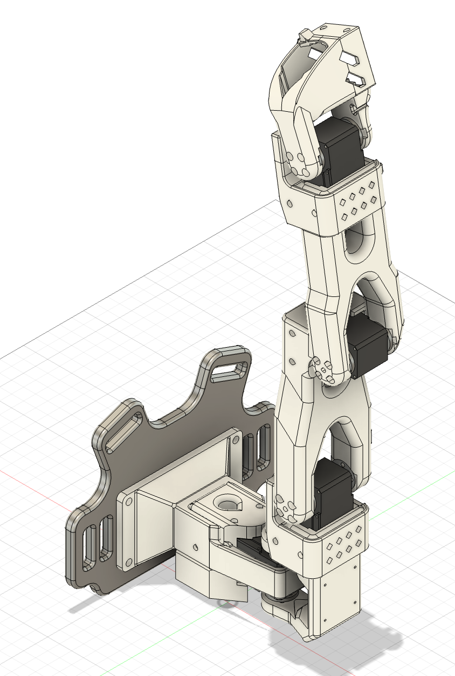
- Realized that I printed two of the same attachments so printing the other one now
- Cameras:
  - We ordered a shoulder mount for an iPhone camera. That should come in a few days

7/22:
Day Summary: Journal club, test mounting system and make appropriate changes

Charlie:
- Journal club in the morning
- Testing out next iteration of back plate for chest mounting now (1 separate band for each shoulder)
- We need some way to secure the back plate downwards (maybe some sort of waist strap?)
- See Alex’s section for thought processes
- Slacked Jae about ordering a shoulder camera mount

Things we need to do:
- Physical stops for arm to restrict ROM
- Figure out camera situation - Tabled, waiting for shoulder mount
- Settle on mounting system – let’s just do backpack for now
- Collect simple dataset on one HRI task & fine-tune model
- Finalize experiment
- Set up OpenCAP - Doing this on Friday with Haedo
- Actually collect data + fine-tune model for our specific tasks
- Run the experiment

Alex:
- Old iteration of mounting from yesterday didn’t work at all. The green piece just kept on slipping upwards and the robot always sagged (but the waist strap flowed through very fluidly so this iteration captured what we needed it to. The reality is that the design just doesn’t work well)
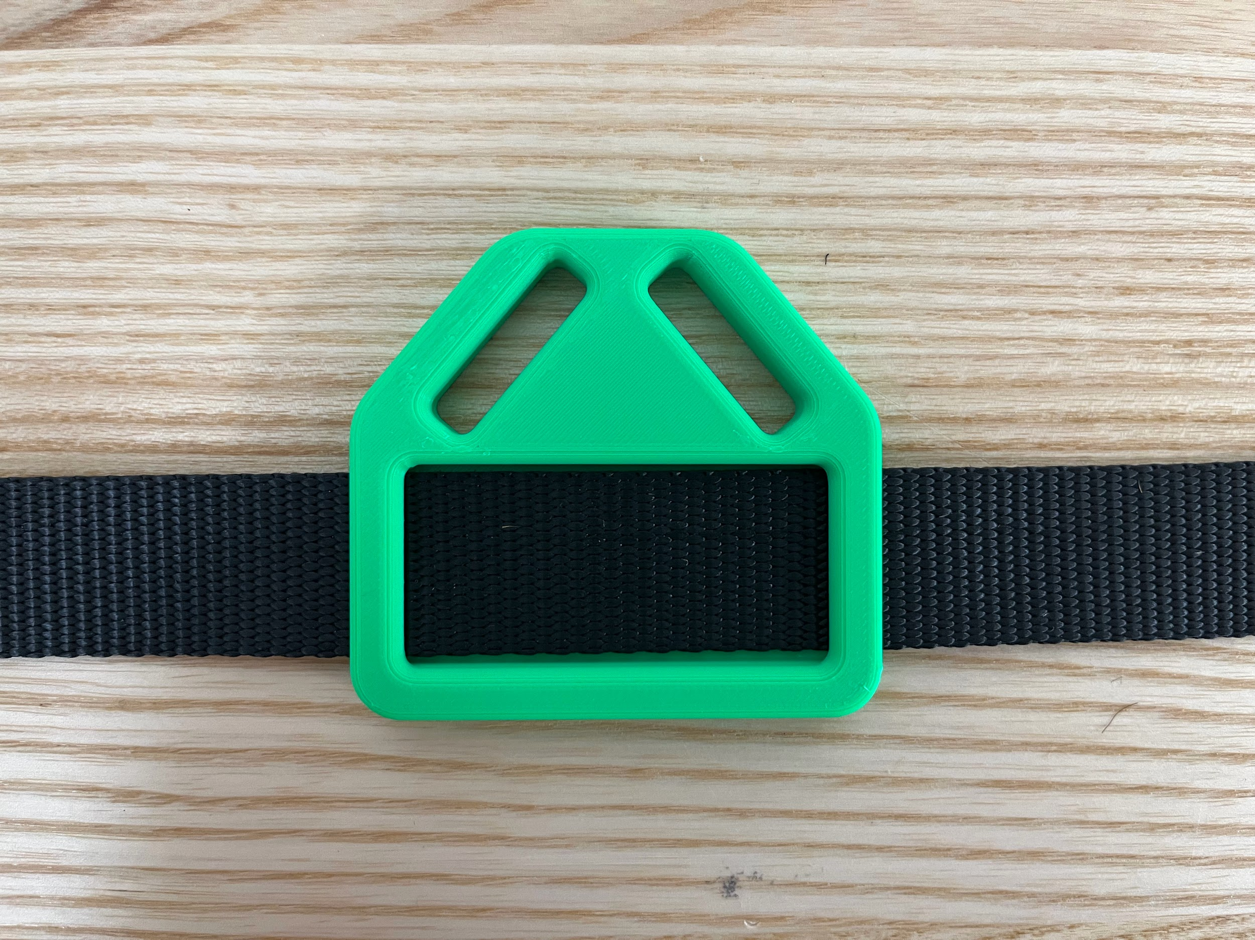
- We next tried using a backpack and running the strip through the top handle of the bag. This seemed to be very comfortable minus the shoulder/neck area where pressure was being applied
- Mounting system testing:
  - Necklace design where the shoulder straps just wrap around the neck
    - Works
    - Not super comfortable as the neck strap is digging into the back of your neck
    - Not ideal safety wise
  - Backpack design where the shoulder straps wrap through the top handle of the backpack
    - Clunky with the backpack and needing to take it on and off the whole time
    - More safe than necklace design
  - Thigh straps design
    - Sturdiest of the three designs, least amount of tilt forward due to weight
    - Most annoying design to put on, looks kind of funky, eliminates possible pants related tests
- Cameras:
  - With Continuity Camera you’re able to make use of the .5x lens and get a wider field of view (distortion is present but not too bad)
    - Head mounting doesn’t really work (most of the robot is obstructed and even when it comes into frame the base (shoulder rotation) is never in frame
    - Chest mount doesn’t work as robot obstructs view and generally falls in the same area
    - Can do shoulder mount (not perfect but covers more area)

Moving forward for cameras we are going to get a shoulder mount for the iphone. If the discord says that it helps a ton or we find that the shoulder camera is not sufficient, we can add a wrist mounted camera and have two video inputs

7/21
Day Summary: Mount related testing

Charlie:
- Finish board shield CAD
- Tested body mount – chest mount ergonomically good but is too high to pick things up from table while standing up. We decided to try out an overalls design instead – mounted lower on the body (upper stomach).

Alex:
- Worked with Charlie to experiment on the mounting plate system
  - Sag forward is definitely something that we saw. Ways to combat this are put a brick of foam at the bottom of the place and foam on the back shoulder of the straps
  - Initial back plate design kinda sucked and didn’t move freely at all. I redesigned it so that the strap flows across it without friction. Also included a second vertical hole for the now overall like straps to run through

- Installed Charlie’s motor board shielding design ← Great job Charlie!
- TODO: Put the whole thing back together tomorrow and test (the software side of things is for the most part done/we need to test as well)

7/18
Day Summary: Met with Haedo, designed strap mounting system, worked on restricting ROM

Alex:
- Meeting with Haedo, Fil, and Teo
  - They were just given their current project from previous students and told by Professor Slade to make use of the current setup so they didn’t really design the mounting portion
  - One change they did mention that really helped was thigh straps. The thigh straps helped minimize the moments due to the arm moving and stabilize it while maximizing the assistive output.
  - Haedo thought that OpenCap would be better for our use case than IMUs and offered to help us set it up when we get around to it
- Design strap on design for arm with waist buckle space
  - See Charlie’s picture below for general design
  - CADed first prototype pieces, sent to the printer and waiting for them to print
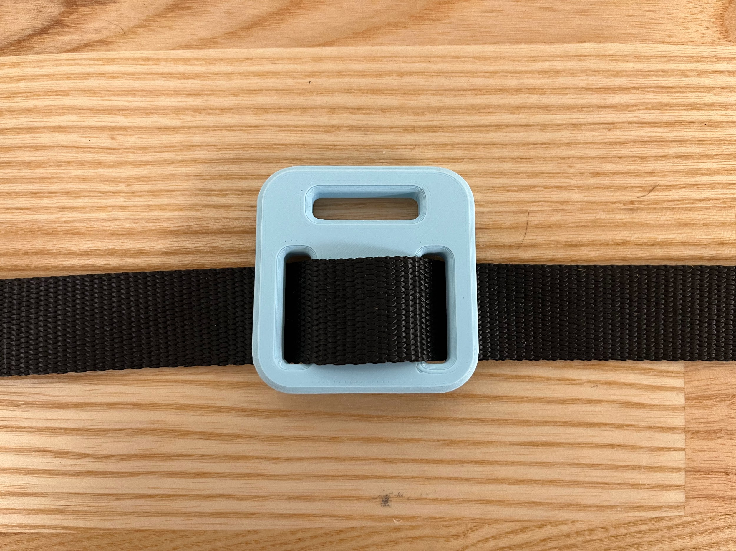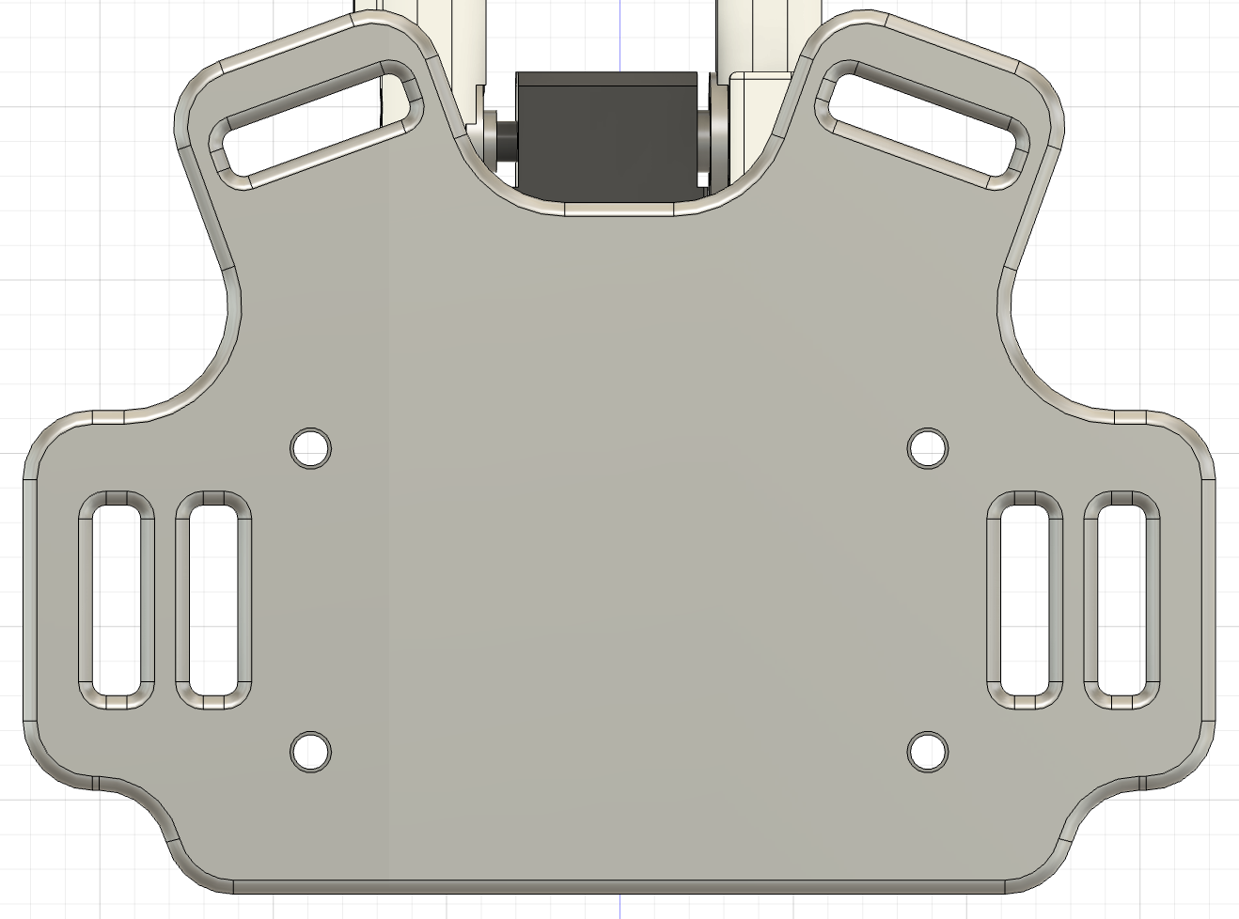

- Thinking about camera stuff
  - Messaged Ray asking for potential head camera mount for an iphone
- Thinking for the fall:
  - Note that HCRP proposals are due within the first week of school. We should have something each drafted up before school actually starts

Charlie:
- Settled on strap design for chest mount
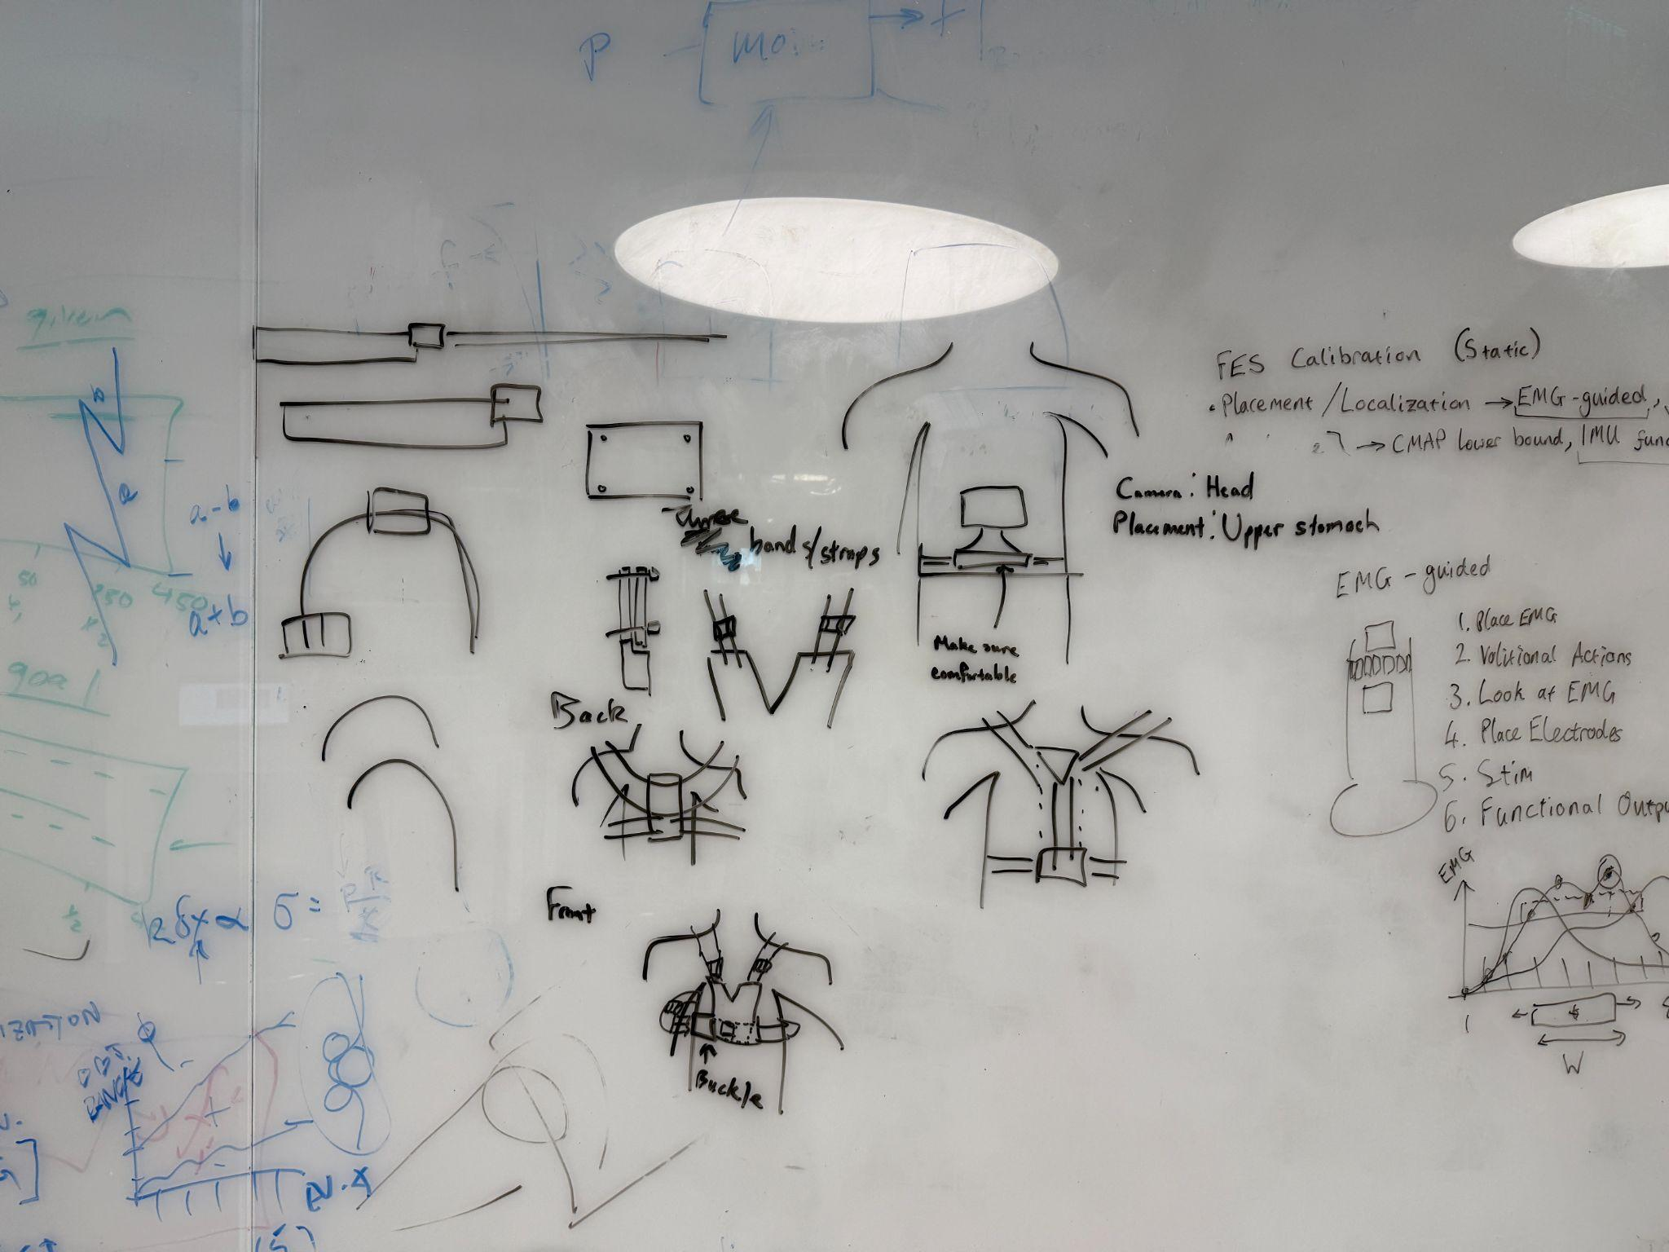
  - 3 total bands:
    - Shoulder: loop through → fastener → through backplate → fastener → loop through
    - Chest plate buckle: buckle → loop through chest plate → loop back through buckle
    - Cross-chest loop: buckle → through back plate → loop back through buckle
- Limiting ROM:
  - Try 1-1 mapping between leader and follower arm
  - If I move the leader arm past calibrated bounds, will it throw an error? Or just not move?
    - It will NOT throw an error!
    - We will design + print something to physically limit the ROM of the arms
- Edited calibration to restrict arm ROM (1-1 mapping)
- TODO:
  - CAD the board shield
  - Finalize experimental protocol

7/17
Day Summary: Investigated limited range of motion, recorded data and confirmed we can use with a finetuned model, met with Professor Slade

Charlie:
- Test limiting ROM for one of the motors so the arm doesn’t hit the user
  - Running into issues with teleoperation 💀
  - Ok teleop issues fixed but now it’s issues with limiting the ROM – I think we just ignore that for now
  - https://chatgpt.com/share/e/68791b7f-7fc0-8000-92bd-45af17ab147d
    - Editing code to manually limit ROM?
- Test recording data script to see how it works
- TODO for tmr:
  - Brainstorm chest mount together and CAD necessary parts
  - Restrict ROM in code (try just editing calibration)
  - CAD the board shield
  - Finalize experimental protocol

Alex:
- Explored limited range of motion using “max_relative_target” parameter
  - Turns out this parameter is functionally for slowing down the velocity of the robot despite its name
  - There was a bug we identified in the code however involving the dtype of the number passed in and that was reported to github
- Recording data and running finetuned smolvla
  - We ran into some issues recording data using the pre-built scripts on my computer but we switched to charlie’s computer and things work out
  - DATA RECORDING NOTES:
    - Keyboard controls:
      - Tap right arrow key '->' to exit early (if there is a specified episode time) while recording an episode and go to resetting the environment.
      - Tap right arrow key '->' (again) to exit early while resetting the environment and move onto recording the next episode.
      - Tap left arrow key '<-' to exit early and re-record the current episode
      - Tap escape key 'esc' to stop the data recording.
    - Audio
      - There are audio prompts during recording so make sure to have sound on
  - Recorded some dummy data and then finetuned using FASRC
  - Robot runs! Was flailing about and we had to control C pretty quickly but this is good for the future when we get actual data
    - Note that the “max_relative_target” parameter actually does come in handy from earlier to slow down the robot’s movements and reduce risk of suddenly hitting the user
    - TODO: We definitely have to find a way to restrict the robot’s range of motion
      - For some reason it wanted to move backwards towards me a ton with the dummy data. That is a huge safety concern when we strap it to a person and I’m unable to just extend my arms further away to keep the arm away from me.
      - Reached out to people on the discord server to see if they know how to do this. Charlie is looking through the codebase

7/16
Day Summary: LeRobot Mobile testing, outlining future experimental protocol

Alex:
- Started the second thing of grippers on the 3d printer. Hopefully updates make them usable and comfortable this time around
- LeRobot testing
  - My teleop_so101.py script that I coded last time around works perfectly (before changes below
  - Issues: Async inference is just not working (there may be some underlying library issues) so we are tabling it for the time being and will come back to it tomorrow
- NOTE: LeRobot added asynchronous functionality on July 10th and the changes are detailed in this blog post. They moved around a lot of things then so this is why stuff has really changed
  - Folder structure (removal of common) was removed on July 1st
Charlie:
- Looking more at VLA paper methods sections/appendixes for tasks and success measures – check Meeting 3 Learnings tab
- For future – github issue about adding additional inputs (we can use this for glasses eye-tracking data perhaps) https://github.com/huggingface/lerobot/issues/266
- Note about in-distribution vs out-of-distribution tasks/objects – we should look more closely at SmolVLA training data to know what is in/out of distribution
- TODO: differentiate between workspace vs environment terminology

Notes about Experimental Protocol Outline:
From Professor Slade:
For the project doc if you can suggest an experimental protocol that would be great. I'd focus on what tasks you want to do, how many repetitions, any other configuration details, and which experimental measures you want to take (which will dictate what sensors / lab space we may need if any).

Experimental Protocol:
- Tasks: (we want to cover different activities of daily living & different modes of HRI, and different categories of tasks so that things can scale up in future research)
- Find and pass glasses
  - Passing something TO the human (more direct human-robot interaction)
  - ADL Category: General
- Pick up and hold water bottle while humans drinks
  - Hold something still while human uses it
  - ADL Category: Food/drink
- Stabilize hand while brushing teeth
  - Stabilize human body part while performing action
  - ADL Category: Hygiene
- Grip waistband of pants to help with pulling them up/down (may or may not be possible due to SO101’s joint restrictions)
  - Hold up pants while human puts on belt
    - Hold something still while human is manipulating it
  - ADL Category: Dressing
- Picking up dropped object (person would have to bend down, unless this is on a table)
- How many repetitions
  - [look at at VLA papers to see what they did]
    - Llarva: success rate
    - SmolVLA: success rate
      - Simulation – 0/1 for failure/success
      - Real-world – decompose into subtasks, score from 0-1 (e.g. 0.5 for picking up cube but placing it wrong)
      - Only evaluated on 4 real-world tasks
        - 5 different conditions, varying starting positions, etc
    - OpenVLA:
      - 17 tasks, 10 trials each
      - Assign task categories (we should probably do by type of manipulation)
      - Has different things like
        - Easy version: gripper is initialized on top of the object to be picked up
        - Non-easy version: must also horizontally navigate there
        - With clutter (0.5 points for moving towards the right thing but not picking it up)
        - 0.5 points for making contact but not picking up
      - Visual generalization: different appearance than training data
      - Motion generalization: different initial object positions/orientations, robot forced to move beyond training distribution of positions, adjusted trajectory, etc
      - Physical generalization: different size/shaped object from training data
      - Semantic generalization: different target object, unseen instruction
    - Pi0: Success Rate with partial credit
      - 0/0.5/1 for failure/partial success/complete success
      - This was a significant paper that tested all sorts of things in varying categories. Tasks within those categories included the below:
        - Shirt folding, Bussing (easy and hard versions), Grocery bagging, Toast out of toaster, Table setting, Towel folding, Tupperware in microwave, Paper towel replacement, stack bowls, etc… (a lot more)
      - Generalization to tasks post pre-training
    - Pi0.5: success rate with +1 point per intermediate task (max score differs across tasks)
- Other configuration details
- Experimental measures (→ what sensors/lab space we may need if any)

Pare down to 4 tasks

Task versions:
- Things to vary:
  - Amount of clutter
  - Orientation of object of interest (upside down for example)
  - Initial arm location
    - Center, left, right (for both pre-training and the testing)
  - Amount of human movement (quantify human movement with IMU data)
    - Human is static (functionally a table mounted arm)
    - Slightly non-static human base (small movements, swaying, etc – we probably need a slightly rigorous way to quantify this)
    - Human actually moving/doing something else
  - Placement of human arm in frame
- Easy version: no clutter, arm already kind of the right place, not too much human movement
- Normal version: some clutter but not a mess, arm in frame (maybe somewhat moving), slight movement side to side but things are always in frame
- Hard version:
- 5-10 trials of each

Limitations: Human always has to be looking at what they are doing due to no spatial awareness form the robot

7/15
Day Summary: Abstract editing, setup various meetings, 3d printed grippers, think about paper aspects

Charlie:
- Question: Do we frame our paper through robot-human interaction or through ADLs?
  - I’m thinking robot-human interaction, but then why are we even focusing so much on ADLs?
- Going through SRL papers focusing on methods section for inspiration
- Ideas:
  - Measure success of task (maybe just binary success/fail?)
  - Survey user for ease of use
  - ^^needs to objectively complete the task and also not be super bad for the user
- Playing around with Fusion
- Finishing up draft abstract (to direct the rest of our research)

Alex:
- Picked up redone 3D printed base, waiting on grippers now
  - Loft from plate to mounting part should be longer (will prevent arm from ever hitting person’s chest
  - Note for grippers in the future: Remember to increase Wall Density!!!
  - Pulled grippers off and while they work some improvements can be made. Namely giving more space for the fingers and making the bridge thicker to increase structural integrity. Reprinting tomorrow morning
- Took a look over Charlie’s abstract and offered some brief edits for otherwise a great start
- Typed up preliminary Meeting 3 Learnings Doc

7/14
Day Summary: CAD prototyping hardware, research ADLs and come up with basic study/paper direction

Charlie:
- Todos for this week (ideally):
  - Design + print arm mount
  - Figure out backpack straps vs vest – Charlie
  - Finalize arm mount
  - Finalize list of tasks – Charlie
  - Test out lerobot/smolvla strapped to human
  - Record data & fine-tune model to our specific human-interactive tasks
- Then:
  - Come up with metric
  - Start writing abstract
- Activities of daily living:
  - Basic ADLs – “skills required to manage one's basic physical needs”:
    - Ambulating: The Extent of an individual's ability to move from 1 position to another and walk independently.
    - Feeding: The Ability of an individual to feed oneself.
    - Dressing: The ability to select appropriate clothes and to put them on.
    - Personal hygiene: The ability to bathe and groom oneself and maintain dental hygiene, nail, and hair care.
    - Continence: The ability to control bladder and bowel function.
    - Toileting: The ability to get to and from the toilet, use it appropriately, and clean oneself afterward.
  - Instrumental ALDs – “require more complex thinking skills, including organizational skills”:
    - Transportation: The ability to plan for and manage transportation, either by driving or by organizing other means of transport.
    - Managing finances: The ability to pay bills and manage financial assets.
    - Shopping: The ability to organize and be aware of needed items and procure them, such as maintaining adequate groceries in the home for sustenance or shopping for necessary clothing and other products.
    - Meal preparation: The ability to manage everything required to prepare a meal, including safely operating cooking devices and food storage needs.
    - Housecleaning and home maintenance: The ability to clean dishes after eating, maintain living areas in a reasonably clean and tidy state, and keep up with home maintenance.
    - Managing communication with others: The ability to manage telephone and mail.
    - Managing medications: The ability to obtain medications and take them correctly as directed.
  - I say we stick with basic ADLs because they are more physical by nature (i.e. more suited for a SRA) and also less complex tasks to perform
    - We should target just a few ADLs suited for SRA assistance
  - Katz & Lawson ADL scales measure patient’s abilities to perform ADLs – have these inform our task selection
    - There’s also the Kohlman Evaluation of Living Skills
  - Appendix 6 tasks of interest:
    - Climb stairs (grasp railing?)
    - Feed yourself
    - Make yourself a hot drink
    - Take hot drinks from one room to another
    - Wash up
    - Make yourself a hot snack
    - Wash small items of clothing
- Task list (all ADLs that interact with human):
  - Find and pass glasses
  - Pick up and hold water bottle while human drinks
  - Spoon-feed human
  - Stabilize hand while brushing teeth
  - Grip waistband of pants to help with pulling them up/down
  - Picking up something they dropped
- Post-lunch: read papers about ADLs and assistive tech/SRAs to look at any existing metrics/benchmarks to measure effectiveness

Alex:
- CADed and 3D Printed the adjusted parts - need to figure out mounting next
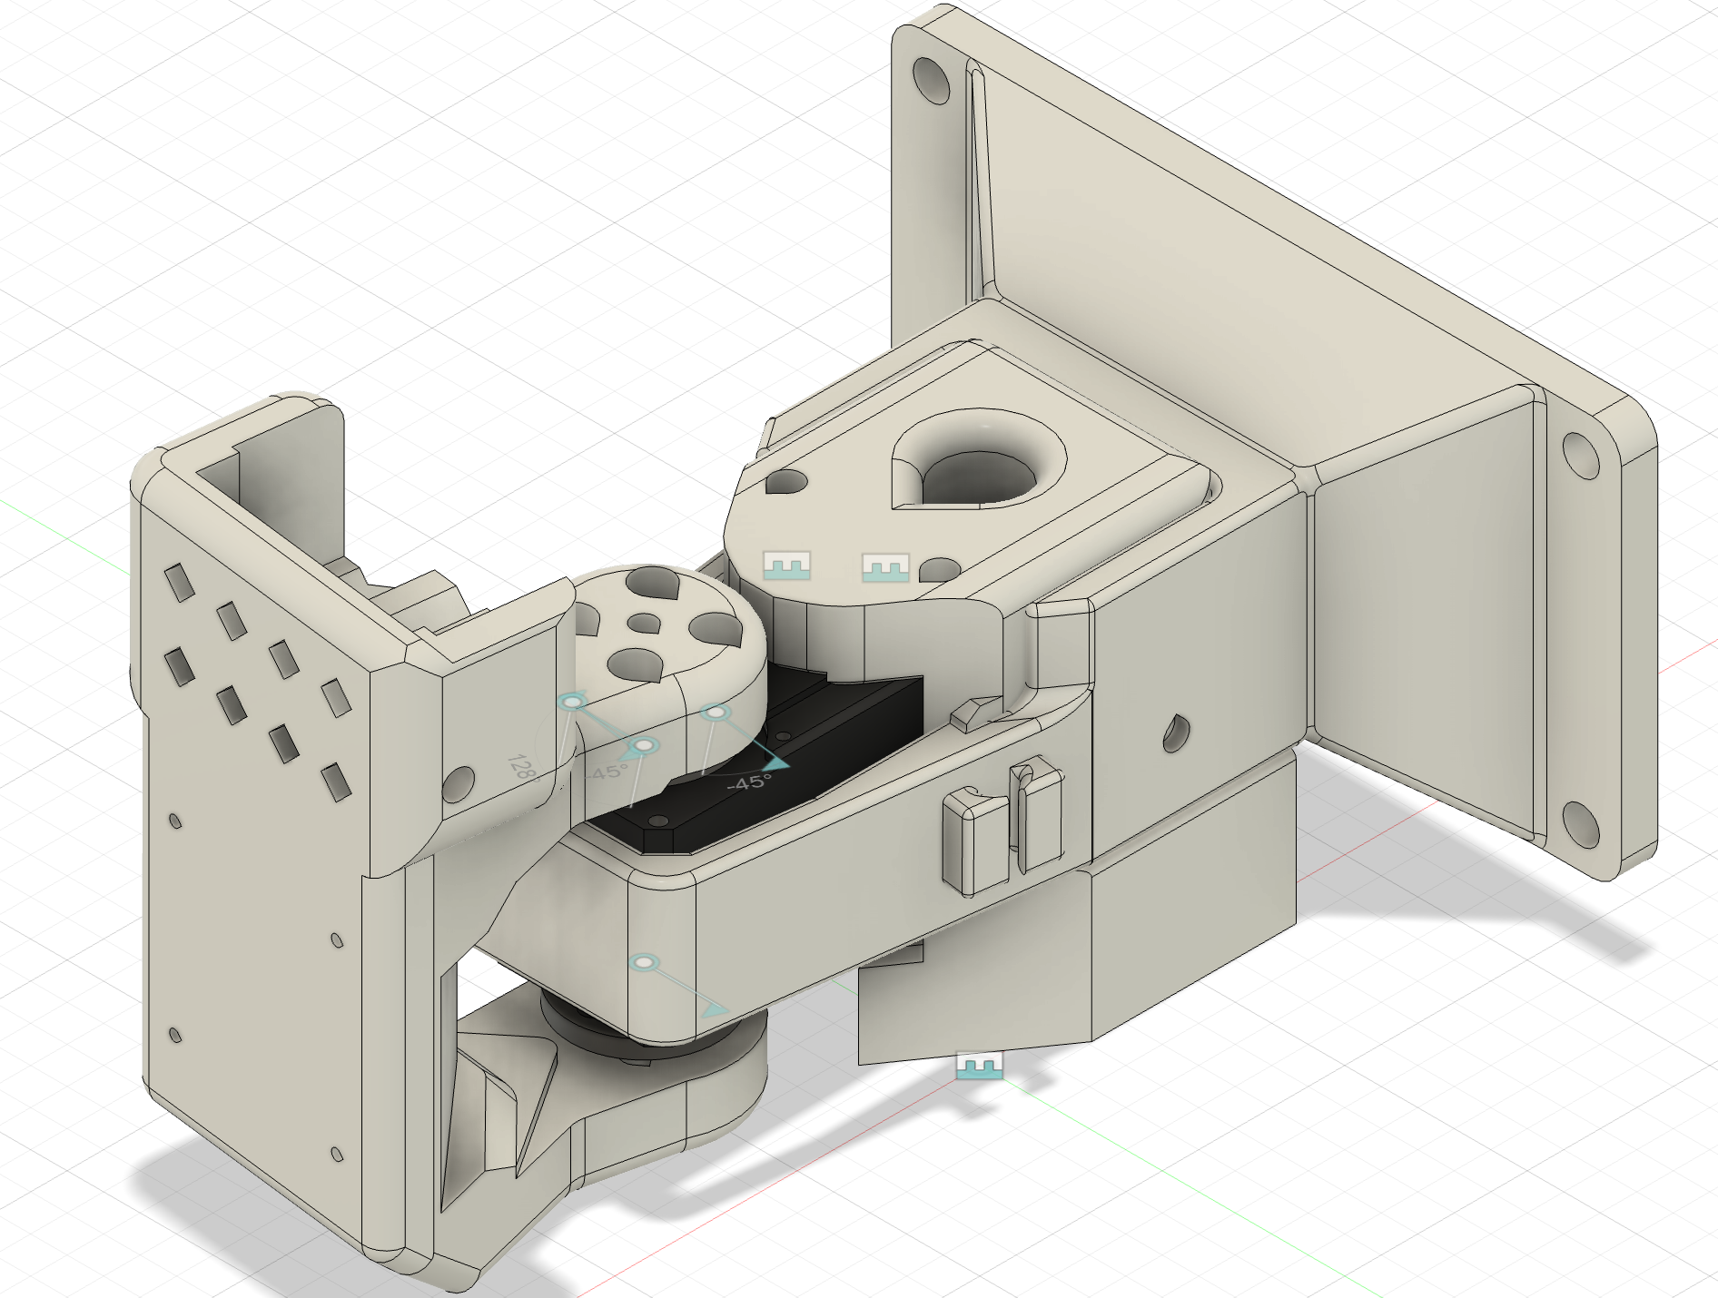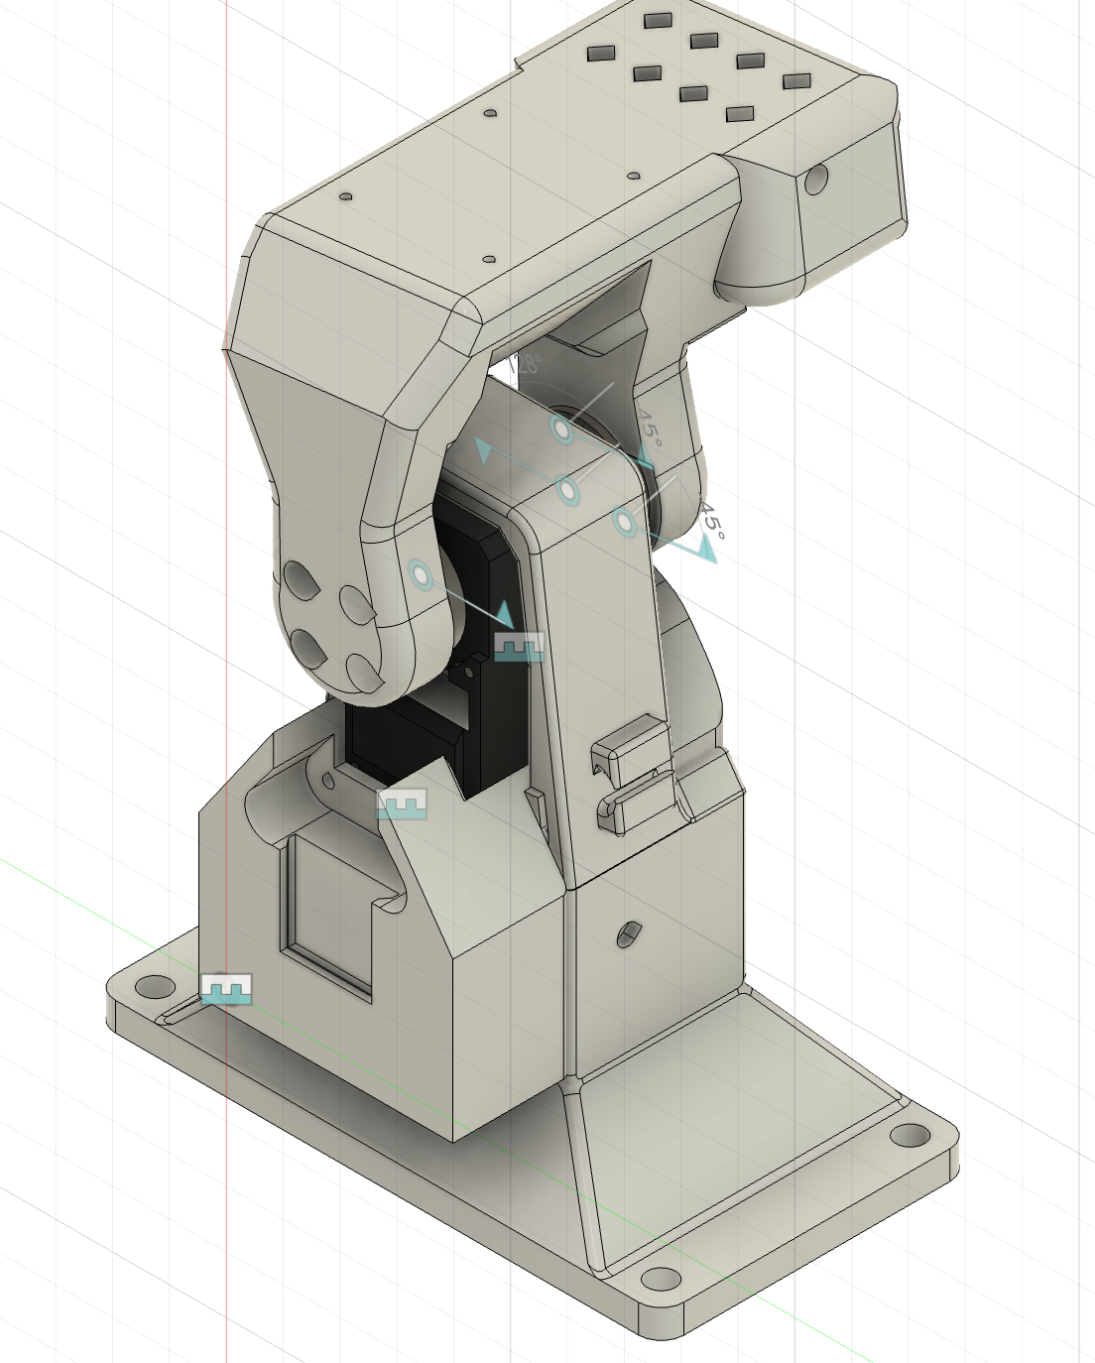
- Also created grippers so that we can prototype with the setup:

7/11
Day Summary: Hardware brainstorming, get to better know LeRobot codebase

Charlie:
- Look through SO-101 codebase/Lerobot library to see how easily we can integrate a custom arm
  - “The follower arm uses 6x STS3215 motors with 1/345 gearing”
    - Feetech motors - Note these are based on the dynamixel servos (the bus is a fork of the dynamixel bus)
- Brainstormed hardware setup
  - 1st idea: basically extend outer piece (where the board currently sits) to a big base plate, all 1 piece
    - Board sits on top/side
    - Either do a rigid vest setup or add backpack straps
  - 2nd idea: have like a rod go through
- Brainstorming list of tasks (see Revised Overview)
- Next steps:
  - Select 4–6 representative tasks covering different interaction modes (e.g. handover, co-manipulation, social).
  - Define performance metrics for each:
    - Objective: transfer time, positional error, force tracking error.
    - Subjective: perceived comfort, naturalness, cognitive load (via questionnaires).

Alex:
- Brainstormed hardware setup with Charlie:
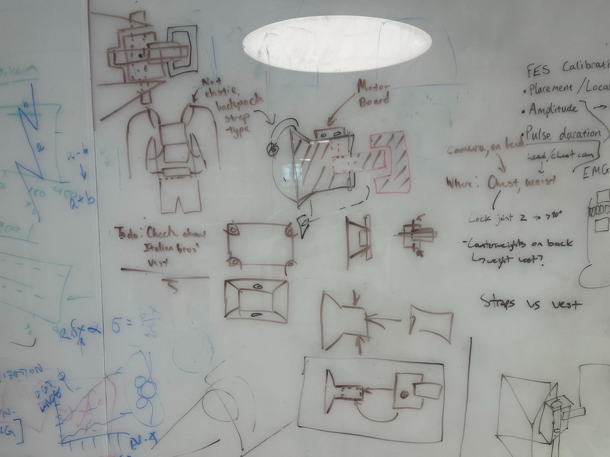
- CAD a mounting system for LeRobot Arm
  - Re-CAD base part to be mountable on a person (going to have to consider part strength so that it doesn’t break)
  - Ugh LeRobot CAD files are only STL not STEP or SolidWorks Parts (I might use fusion to resolve all of this, they have a good stl healing function and it works on Mac)
    - Setup my Fusion Account and everything so we should generally be good to go here
    - Lowkey going to re-CAD the two base parts myself if the STEP files don’t exist or are inaccessible (asking for them on discord rn)
    - UPDATE: Step files exist I just didn’t see them previously…
  - Feetech STS3215 CAD (STL and STEP, sldprt files) and datasheet

7/10
Day Summary: Fix batching scripts, meet with professor slade

Charlie:
- Tried on the updated fine-tuned model – still didn’t work :(((
  - But it was moving more nicely through the full range of motion
- Retried on base model and still didn’t work
- Got it to work!!
  - Works with fine-tuned model when I don’t update the policy state dictionary with dataset statistics
    - Realized that I forgot to change the dataset to the updated one from the old one – this may have been causing the problem
      - Yep that’s what was causing the problem
  - Still doesn’t really work with base model with updated stats to training dataset (but that’s to be expected)
- Wrote code for multi-dof arm support in multi-dof-support branch
  - Code works for autonomous loop but doesn’t work for teleop – for that, still go to main
- Question: How do we teleoperate a higher-DOF arm?
  - Game controller? Leader/follower?
- Future to-dos:
  - Voice input for commands
  - Higher-DOF arm
  - Adapting to run on Raspberry Pi?

Alex:
- Still working on a fix for the FASRC batching. No idea but something is wrong with the tensor timestamps…
  - Rearranged a ton of things but main thing I’m trying right now is to add a script that fixes the codes retroactively
  - Fixed! The tensor patch worked. Small bugs preventing me from training now but hopefully everything is smooth moving forward
  - Success! Everything is now working. I need to do some more tests to double, triple check everything works (namely the push to hugging face part)
  - Batching now works start to finish and I am pushing updates to my branch in github
    - Small note: it still shows up as failed when you run sacct - j <JOB_ID>, but everything else seems to work so I don’t think this is a huge issue
    - TODO: Check if the readme stuff still works
      - This in fact did not work and I have been implementing a fix

7/9 Notes
Day Summary: Test 1 DOF system, debug associated errors, retrain on correct dataset labels

Alex:
- FASRC fine tuning from yesterday succeeded but pushing to HF failed
  - Got this error: “huggingface_hub.errors.HfHubHTTPError: 429 Client Error: Too Many Requests for url: https://huggingface.co/api/repos/create”
  - Solved with a new python script. Going to work to integrate into the package right now
  - Everything is integrated between four scripts (left pushing as a separate script in the event that you only want to push/pushing previously failed)
- Testing finetuned smolvla on prototype
  - Hmmm results were not very promising
  - Charlie’s model (batch_size=64, steps=20k) seemed no better than what we had last week.
  - My model (batch_size=128, steps=20k) actually seemed to work better and roughly followed what we trained it to do when moving left, but it had no ability whatsoever to move to the right
- Well… we realized the dataset we trained with improperly labeled servo ranges from 180 to -180 when it should have been from 90 to -90 degrees… We’re going to try to fix this
  - Charlie is working on a fix for this
  - Hopefully this is why the prototype wouldn’t move left earlier
- And now for some reason everything on my FASRC training script isn’t working…
  - Spent all afternoon debugging, going to have to debug more tomorrow

Charlie:
- Tried with the fine-tuned model, didn’t work 🙁
  - Side note: ran into an issue with uploading the fine-tuned model to HF but it seems like it’s just a network thing?
- Realized that the angle ranges for the arm/VLA should have been [-90, 90] (and not [-180, 180])
  - Vibecoded a fix to the dataset
  - Fine-tuned SVLA again on the fixed dataset – really hope this works

7/8 Notes
Day Summary: Properly fine tuning on FASRC

Charlie:
- Trying to get test model to work in gpu_test partition
  - Just module load python, and then follow the lerobot setup instructions with conda:
    - conda create
    - conda activate
    - conda install ffmpeg
    - pip install -e .
    - pip install -e “.[smolvla]”
    - wandb login
    - huggingface-cli login
    - Run train.py
  - Works with test! Now just going to do it on the actual gpu partition with default hyperparams
    - Training with default hyperparams (64 batch size, 20K steps)
    - I allotted 8 hours for it, just waiting now…

Alex:
- Brought proper battery pack in… finally RIP AAA bomb battery
- FASRC batch training
  - Cleaning up scripts to fix pushing to HF, make it so that changes can all be made from just a .yaml file (no need to touch .sh or .py files)
    - Pushed to my branch in the SRA github repo (which is behind in a lot of other regards but now it has the scripts)
  - Works! I now have a system that runs start to finish and handles package uploading, training, wandb monitoring, and HF uploading
  - I am finetuning at a batch_size of 128 and a step value of 20k

7/7 Notes
Day Summary: Trying to train on FASRC

Alex:
- Testing Protocol:
  - Perform in a well lit, clean area (the tables behind our own)
  - Collect 160 episodes:
    - 16 total orientations (8 for right-side-up, 8 for upside-down)
    - 5 spots where the glasses are placed (2 episodes per orientation per spot)
    - 2 starting servo positions (all the way to the left, all the way to the right)
  - Make sure no distractions in frame (for now)
  - Tree diagram of how the episodes are going to be collected (left). Testing setup on the right
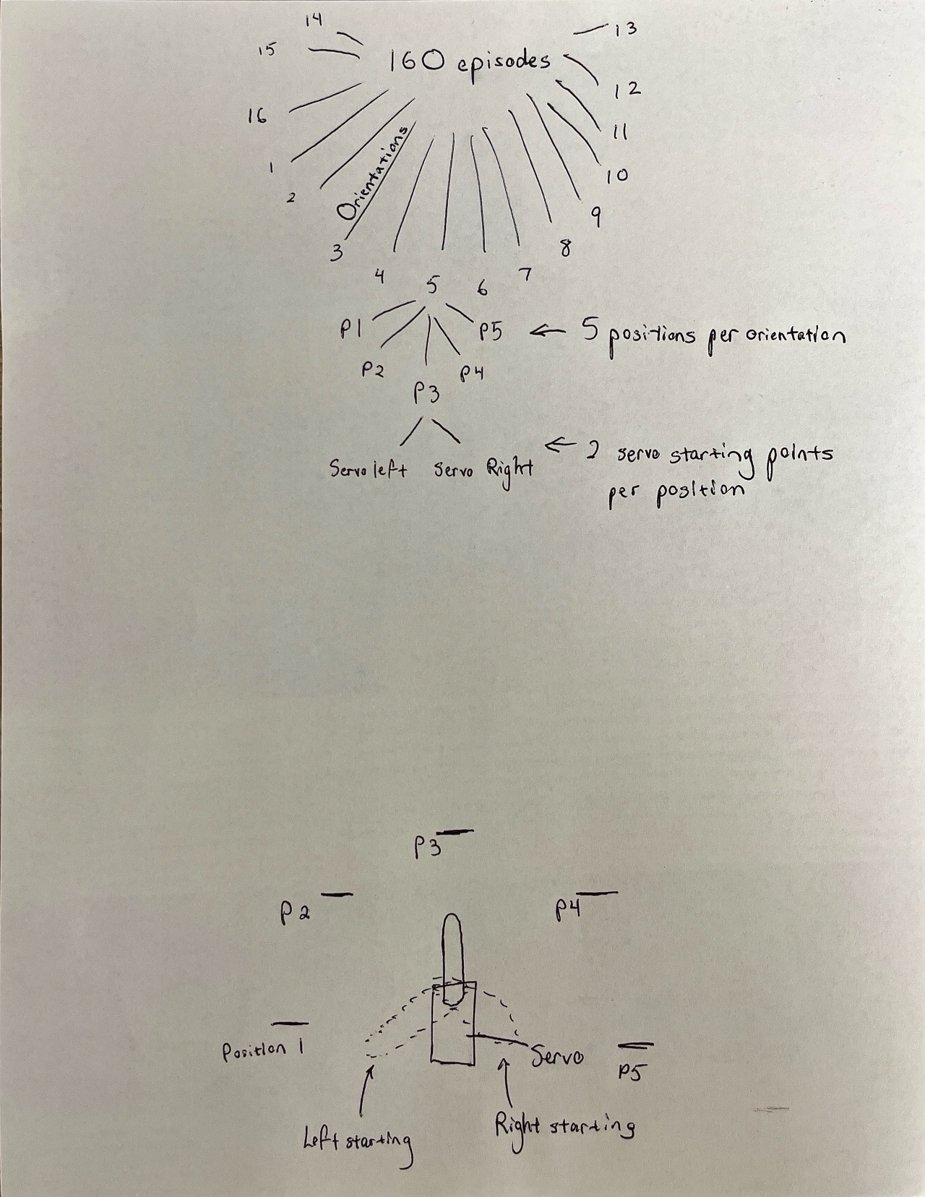
- Collected Dataset here (160 episodes of the protocol described above)
- Setup FASRC account
  - Setup guide
  - Training docs (they have a bunch of training videos that we should probably watch through their entirety)
- TODO: Really need to figure out the battery situation for the robot
- Trying to get FASRC to work. Notes on commands
  - “module –purge” deletes all of the existing packages
  - “module load Anaconda3/5.0.1-fasrc01” – add the conda environment
  - squeue -u $USER
  - sbatch
  - sacct -j JOBID
- UPDATE: Got FASRC to work with an A100 GPU (40GB of vram)
  - Running a test training on the gpu_test partition with a reduced batch size and a reduced number of steps
  - Accomplished using scripts stored on the FASRC server (a .sh script that calls a .py script)
  - Progress is being monitored on wandb
    - Chance it craps out due to limited memory
  - Training worked but job failed in the end due to an error uploading to HF
    - Weights should still exist in the results folder

Charlie:
- FASRC commands (after ssh-ing in):
  - salloc
  - module load python
  - Follow the lerobot setup instructions (use conda not mamba)
- Running into a lot of issues with mamba – when I try to specify python version and/or when I try to install ffmpeg, I run into an issue with the lockfile

7/3 Notes
Day Summary: Trained SmolVLA on 50 episodes for 1.5 hrs (Google Colab public), got prototype to work poorly

Alex:
- SmolVLA Fine-Tuning
  - Running into some issues with the Google Colab. See this video and this guide
  - Charlie seems to have gotten it to work though
  - FFMPEG and TorchCodec related issues detailed here:
    - ffmpeg or libtorchcodec runtime errors on specifically macOS are usually due to a dynamic library path issue
    - Import error for “GradScaler” is due to a TorchCodec compatibility issue (needs to be version 2.3.0 or newer)
  - Colab fine-tuning is working! (batch size = 25, steps = 20000)
    - Note that there is a maximum runtime on free subscription of around 4 hrs (we would need to access compute through Harvard)
    - I added this code block running after running into an error so may be necessary (after smolvla packages installation)
!apt-get update -qq
!apt-get install -y ffmpeg
!pip install --upgrade torchcodec

# Reset the runtime to confirm the new packages are running
import os
os.kill(os.getpid(), 9)
  - Charlie successfully fine-tuned the model using Colab and uploaded to HuggingFace but something weird happened that is preventing him from downloading the weights to try to actually run the model (we’re working on it)
- Housekeeping for AI training
  - We both got Wandb and HF setup (my username is asyk454 for both)
- Basic AI/ML training terminology readings
  - Epochs
  - Loss/Loss Functions

Charlie:
- Started running fine-tuning code!
  - Doesn’t work locally (something with ffmpeg/torchcodec, I didn’t feel like debugging it right now)
    - I just made a conda environment a la lerobot setup and it works now lol
  - Seems to be working on Colab though
    - Is it deadlocked lol keeps on saying it’s disabling parallelism
    - Started fine-tuning with batch size 8, 4000 steps as proof of concept
      - About 200 steps per 4 and a little minutes (total runtime around 1hr 20 min)
- For next week: bring in window’s laptop to fine-tune on (we should check the specs, but the vram on the card is going to be the most important thing)

HUGE UPDATE: We got the prototype system to work! Accuracy was pretty bad and the servo struggled to rotate right, BUT whenever we moved the glasses left the servo would slowly adjust to the correct orientation, indicating that our system is generally working!

Our next steps are to retrain the model using more robust parameters (more uniform training data that is less noisy (clean table), larger batch sizes, more steps, and on more capable hardware) and then report our successes to Professor Slade. Plan for the immediate future is as follows:

Friday:
- Reach out to Ray about using more powerful hardware for VLA training

Monday:
- Create structured procedure for collecting data in a clean(er) environment and then collect data
- Train new model version on Harvard’s hardware (thinking batch size of at least 32 with 20k steps) and then upload to HF
- In the meantime we could try to get voice commands to work? No idea how complicated this is but if it turns out to be very difficult we can kick the can down the road

Tuesday:
- Download the new model and test! If everything goes well (or well enough) then email Professor Slade to update him on our progress
- Start planning 3/4 DOF system and do basic mechanical design (lay out design considerations and then decide)

Note: For the Professor Slade meeting, it may make sense to record our robot before hand and just show him a video so we don’t have to lug over our super janky setup

7/2 Notes
Day Summary: Debug testing apparatus, collect 50 episodes of glasses data

Alex:
- Proof Of Concept Testing:
  - Goal is to demonstrate that the VLA can work on the 1 DOF hardware after some post training
  - Objects that we will be testing on are various household items that we can just find around the lab (to simulate real world conditions)
    - Tape, phone, wallet, waterbottle, scissors, watches, keys, etc…
  - Servo will not be held in place (at least initially) to try to demonstrate that the system does not depend on stationary conditions
    - Basically would be looking for if the servo can adjust back to the target if its origin is moved
  - We should also see how the system reacts to camera movements and even if we move the cameras out of frame and then back into frame
    - Will things still work or seriously break?
- Helping Charlie debug why the servo movement is not smooth
  - Something to try out is the ServoEasing Library
    - Import the library, use the basic commands
  - Try writing using milliseconds as apparently it may help you get finer control
  - You can play around with the pwm curves and make them less of square waves to get more natural accelerations/decelerations
    - https://www.instructables.com/Servo-Ramping-and-Soft-Start/
    - https://forum.arduino.cc/t/servomotor-smooth-moves/985415
  - May want to look into using ESP32Servo.h library instead of Servo.h library
  - UPDATE: Got to be smooth enough for our testing purposes
- Data collection
  - 50 episodes of the servo moving to where glasses are on a table (recommended number from the Hugging Face Docs)

7/1 Notes:
Day Summary: Clean up testing, write testing procedure, setup Alex’s linux system

Alex:
- With the linux install up and running, I am trying to get a project aria stream to work
  - Running into issues with getting the glasses to stream at all. For some reason commands that should work are just not working
  - I have no clue what’s up… when I run aria –help in my environment nothing prints. This is after installing and reinstalling packages multiple times…
  - Note: We’re thinking about pivoting away from this entirely given that Charlie got the custom system to work
- Charlie and I resolved the servo jittering problem.
  - Turns out powering the servo through the 5v from the Arduino causes a current limit or something and the servo can’t operate properly. We resolved it by attaching a separate 6v set of AAA batteries in series to power the servo and the jittering went away.
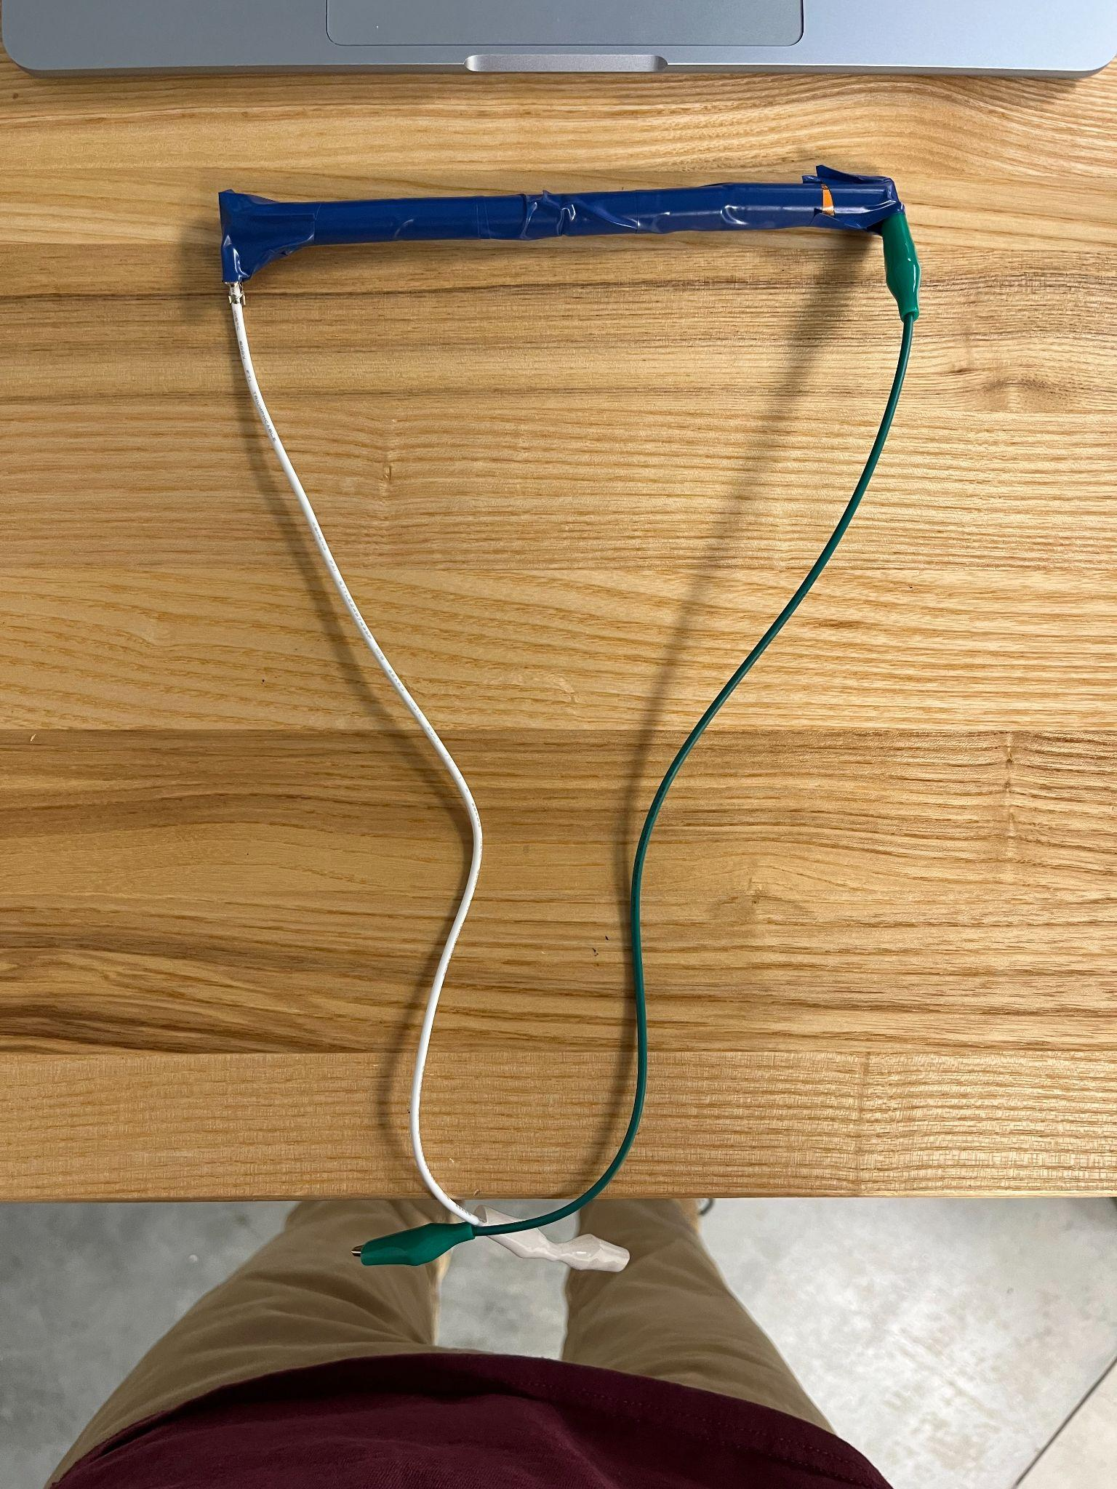
  - Side note we made a very scuffed setup where we blue duct taped the batteries together with alligator clips on the ends. Note that green is positive and white is negative
- Worked on creating preliminary testing procedure below
  - Realized this is a little too much for what we want (I misunderstood Charlie initially), but still keeping it because it could be helpful for when we actually design our experiment down the line
  - Some of the data measurement things with angles is also not super relevant. In papers we read, most of the success was quantified solely based on whether a task could be accomplished or not (binary). Maybe we will trend to that.
- TODO: Record data and test smolVLA tmr (bring in various objects to test/train the system on (Legos are going to make things very easy))
  - If this works, schedule meeting with Professor Slade to update him on progress and then start drafting up actual setup design in the mean time

Charlie:
- Cleaning up code (next step is task recording)
- Switched to reading bytes instead of lines (avoid jitter?)
  - Use bytes and make each communication have the same fixed length
  - Protocol: [command code, argument]
  - It’s still jittering. Trying the following:
    - Don’t write to the arduino every loop – just write when it changes
    - Decrease baud rate
    - Try stable power rails (not just the Arduino’s 5V)
      - THIS WAS THE PROBLEM
- Cleaned up code
  - Code should be good (only made VERY minor changes)
- Write code to smooth out teleop code (right now it just snaps to every 3 degrees)
  - Accelera
- TODO: see if fine-tuning code works

Basic Prototype Experiment:
Objective: The goal of this experiment is to demonstrate that we can deploy smolVLA to a semi effective degree on custom, non-proprietary hardware. Proving that this is the case means that we should reliably be able to move forward with designing a more complex system to attach to a person.

Experiment Design:
Our experiment will occur in three phases:
- With smolVLA implemented on the custom system, run pre-trials where the robot goes through the decided upon procedure
- Collect and record data before training smolVLA to this specific robotic embodiment
- Retest the trained custom system using the same procedure as in step 1

Some things that need to be outlined:
- Specific testing procedure (how many objects? What is the differentiator?)
- How to measure success (are we looking for how closely it points to the object? If the end effector is constantly moving how would we quantify when it is in its final, measurable position?)
- Training procedure
- Testing setup (stationary hardware for training, testing, etc…?)

Testing Procedure:
Different colored objects are going to be the easiest so maybe we roll with that? We could try to find legos or something very small and simple? With the legos we could add a second degree of complexity by comparing bricks of different shapes/sizes but they are the same color. And then final thing do we want a stationary or moving camera? Could we maybe introduce a non stationary camera for a monkey test trial at the end?

Materials: Red, green, blue Legos. 4 stud bricks, 8 stud bricks, single stud plates, 4 stud plates, 8 stud plates (2x4), etc…
Given the constraints of the training data format, we’re going to have to be pretty specific with our commands. Ex: “Pick up the 4 studded, green brick”

Measured values are going to be angles, but how are we going to measure the angle every time in a non manual way? Right now I’m thinking we could put a mat that is like a big protractor and then place objects at different angles? Something like this
- This is the probably the most important thing to figure out because if we can reliably get the angular position of the placed objects then we can compute the difference between the ground truth and servo values and then run something like a chi squared test
Simple implementation of this could be we stick a sweeping IR sensor on the end of the servo device and have it look out for objects and report the degrees that it is off from it when the servo finally comes to a stop. This isn’t perfect though because it doesn’t take into account the shape of the block and differing points from which it would measure

Training Procedure:
Training data has to be just a video feed plus an action description and then manual motion to the object

6/30 Notes
Day Summary: Got custom data recording program to work and push to huggingface

Charlie:
- Custom teleop + recording code:
  - push_to_hub() function wasn’t working – now trying passing in the dataset_repo_id as a parameter into the function and logging in via the huggingface-cli before running the code
    - Still isn’t working lol I will keep debugging
  - Works now! I just gave up on doing it within the code, but you can just do it within the command-line:
    - $ huggingface-cli upload cchenalds17/svla_custom_aria_1dof ./recorded_datasets/cchenalds17/svla_custom_aria_1dof --repo-type=dataset
  - Lmfao works in code now, issue was just that the aria glasses take up the network or whatever (e.g. internet doesn’t work either while they’re streaming) so I just disconnect they glasses before uploading to huggingface
  - Add code for changing the task before recording – press ‘t’ to change task (while not recording) so you don’t need to record the same task every session
  - Added code to allow resuming recording to the same dataset
- Wrapped glasses stuff in try-excepts for error catching and to make sure the glasses properly stop streaming when errors are thrown
- TODO: switch to reading bytes instead of lines (avoid jitter?)
  - Use bytes and make each communication have the same fixed length
- TODO: clean up code
- TODO: see if fine-tuning works

Alex:
- Decided to partition my computer at home with a Linux Install so that I can at least write testing scripts for the project aria to LeRobot libraries
  - Ubuntu installer can handle all of the partitioning. Install using this guide (need a usb drive to do this)
  - Ok I ran into some issues doing this but I think I solved the problem. Note that UEFI SecureBoot must be turned off while installing and that if two options for booting into the .iso file appear try both (one might not work)
- Now that Charlie got the prototype to work I’m going to create a basic procedure and testing outline for us to validate the proof of concept this afternoon

6/27 Notes
Day Summary: Worked on custom teleop + recording code, learned about LeRobot Robot class for potential use in the future

Charlie:
- Custom teleop + recording code:
  - Will need to fix the teleop loop again to store a current_frame thing so it still takes in keyboard inputs when ariaframe is None
    - Done! (still need to test)
      - Used self.display_frame and self.current_frame. display_frame just stays and gets updated with new Aria frames so it smoothes out the opencv control loop with keyboard inputs. current_frame is the frame that gets written to the dataset. It gets reset after being recorded so it doesn’t record the same frame twice
    - Loop works!
  - Push to HF hub?
    - Figuring out dimensions stuff now. All datasets I’ve seen give shape [6], but np arrays are shape (6,) so I’m trying to resolve that
      - I ended up just changing the features shape to (6,)
  - TODO: switch to reading bytes instead of lines (avoid jitter?)
  - Timestamp?

Alex:
- Using the LeRobot “Robot” Class/framework for making your own robot notes
  - Not specific to certain degrees of freedom
  - Each of the examples (LeKiwi, SO-101, etc…) is a subclass of “Robot”
  - Basic organization of a custom robot:
    - Main file is a subclass of “Robot”
      - Init function sets the number of motors and thereby control degrees of freedom
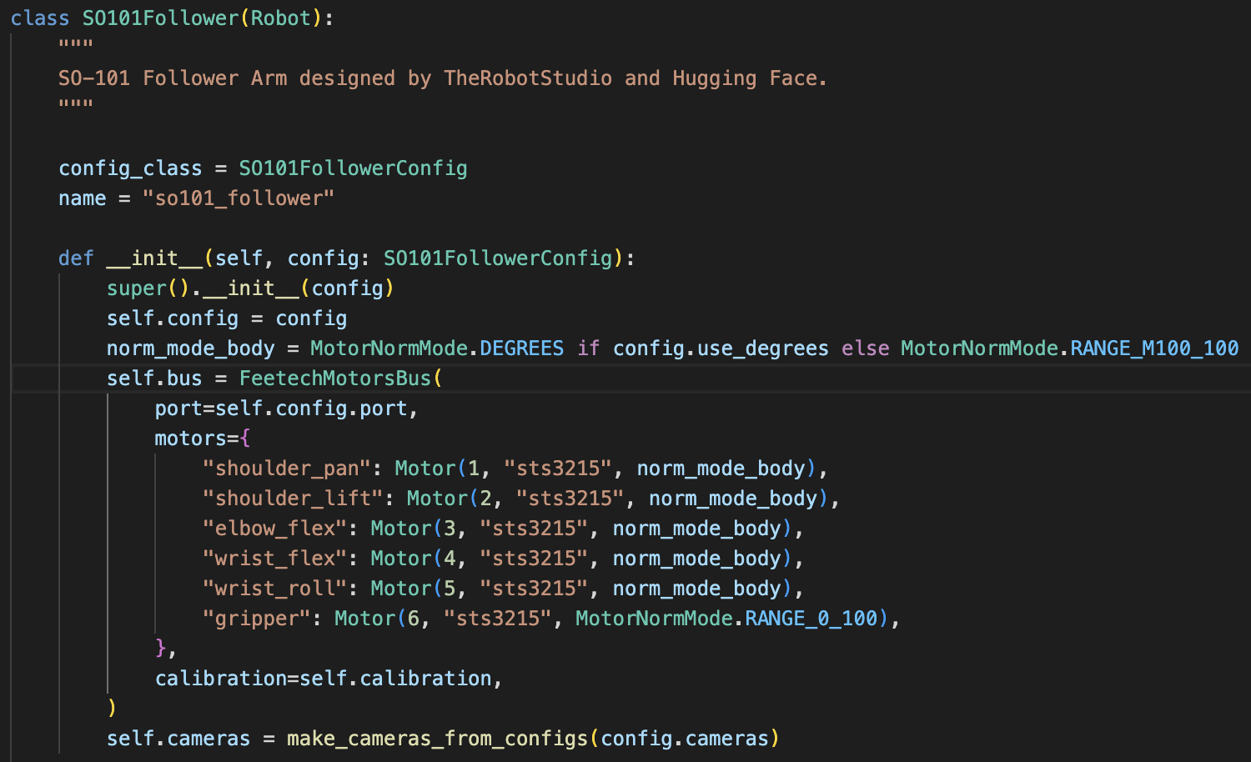
    - robot_config file contains basic setups like port, camera, various other parameters
    - General Config file points towards the location of the .json file storing
  - We would need to create our own motor bus for the servo (feetech motor bus is 500 lines long and is “based on” the dynamixel servo bus)
    - Looked through it quickly and yeah I know nothing about firmware. Need to ask others, but do we even need a bus for our super simple first go? Everything would be running through the arduino and it may not be worth coding it from scratch
    - Note that LeRobot does provide a motor_bus.py super class for us to help define our motors if we want to (make a subclass for our bus)
  - Other methods in the class are mostly setup, shutdown, and for catching errors, but the actual commands for running the robot are in the method “send_action” where the class interfaces with the servos via the motor bus.
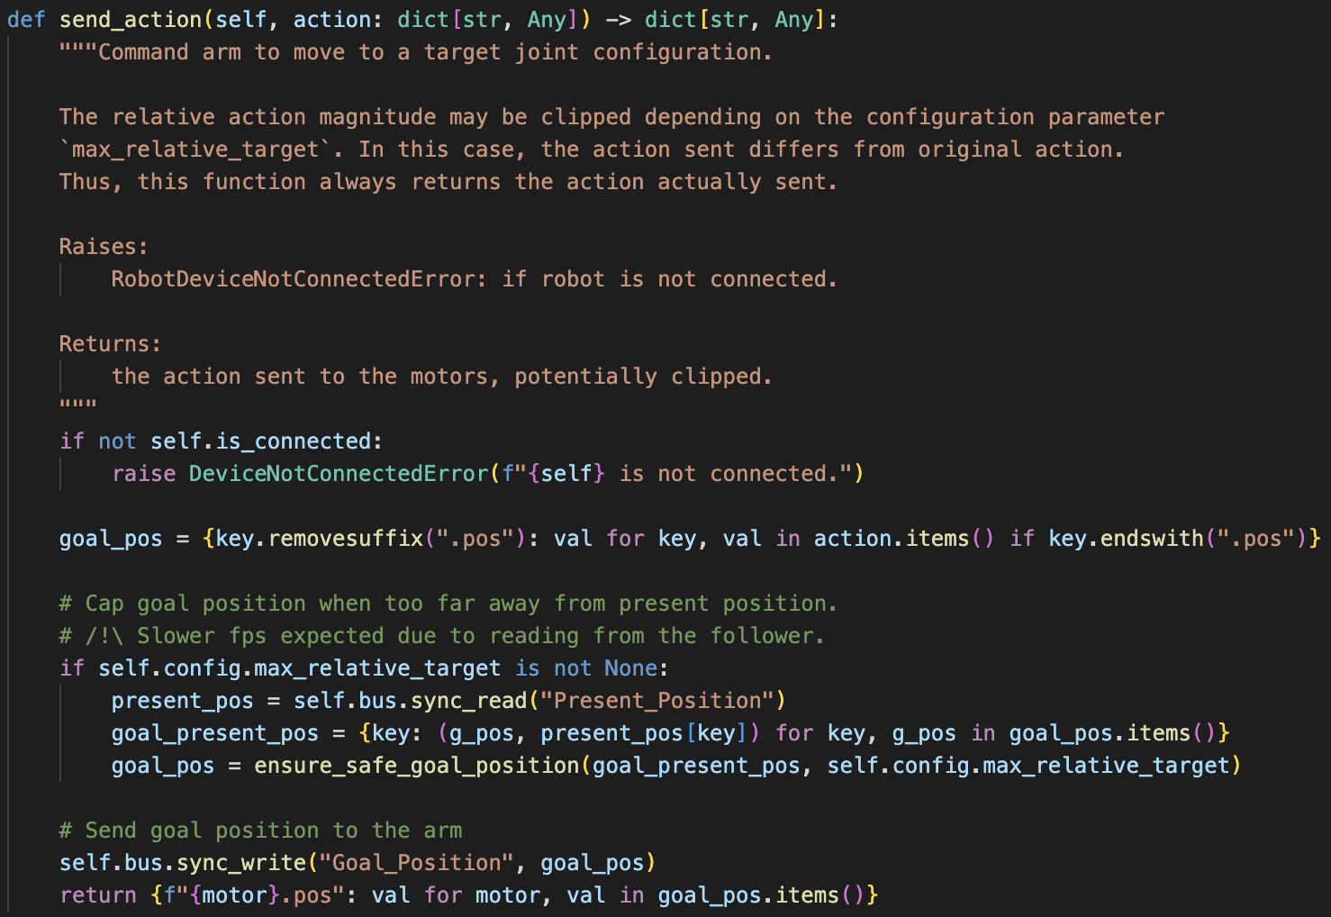
  - This method reads the positions of the servos on the leader arm and then sends them to the follower arm so that it mimics it
    - Need to dig into it more but I’m assuming that when it is in autonomous mode the servo positions are just sent to the robot
    - This is probably wrong, but I think the if statement catches if a leader is present or not and then acts accordingly
- Tested with Charlie why the servo was jittering. The code I found from earlier used communication via the directly input bytes rather than by parsing through the actual serial line. Charlie is changing this to see if this is a potential cause of the jittering

6/26 Notes
Alex:
- Todo:
  - Investigate the LeRobot “Robot” class and see how we can use it with custom hardware
  - Obtain a linux system (still waiting on Ray and he’s not in yet today) and get pyvirtualcam up and running with the project aria system
    - Ray said that he asked around and there are 2 spare laptops but as for whether Charlie and I as interns can use them there are questions. He said he’ll continue to look into it and keep us posted
  - Test SmolVLA on the SO-101
- I tried another way (akvirtualcam) to get the Project Aria glasses to run but ran into some issues midway through and abandoned the approach
  - From my understanding after trying to get this to work this is another virtual camera like OBS virtual cam
  - It does not solve the issue of the Aria Glasses not appearing as a camera device on mac (that is a fundamental security issue that cannot be solved unless some creative bootloader commands are run)
    - Basically the issue lies with MacOS and the Project Aria glasses. The conclusion should be that we can’t solve this if we want to use MacOS (and maintain the integrity of our computers)
- Google Colab for training LeRobot with SmolVLA
  - This could be good for training the model because we can use more powerful GPUs without doing anything crazy technical
  - Also has comments on all of the commands for commandline that we would use when training

Charlie:
- Custom teleop + recording code:
  - TODO: make angle conversion functions global util functions, and clean up when I’m calling those things
  - Get all the code written down, and then parse through to understand and edit as needed
  - Will need to fix the teleop loop again to store a current_frame thing so it still takes in keyboard inputs when ariaframe is None

6/25 Notes
Charlie:
- Currently testing out Aria-specific subclass of Lerobot’s camera class
  - Lerobot wasn’t recognizing the “aria” camera config even though I subclassed it
- If that doesn’t work, will try the pyvirtualcam OBS feed thing on windows
  - Aria SDK does not have windows support
- Worst-case, might be worth just writing custom code for data recording?
- I will just try writing custom code
- Writing teleoperation code (keyboard controlled, probably)
  - TODO: make angle conversion functions global util functions, and clean up when I’m calling those things
- Recording data in the lerobot dataset format

Alex:
- Going to bring in a webcam tomorrow so that we can start working on implementing just a webcam (in the event that the aria stuff doesn’t work)
- Investigating what rerun.io is because it seems that both LeRobot and the Project Aria teams use it so it may make sense to interface using the software
  - Software for data logging/labeling/mapping for AI purposes
    - Think labeling the objects in a scene or mapping out an environment using AR powered glasses and scene capture
  - Can take in multiple camera feeds while simultaneously having the labeling panels up as well
  - Visualizes the data so that you’re not just labeling via numbers and single image boxes but rather whole video scenes and spaces
  - Takes most of the coding out of the process and makes it easier for average people to use
  - For us, Rerun would most likely be used to visualize the data we collect before implementing any policies
- Got LeRobot external camera to work (my mac camera, my iPhone via continuity camera, and OBS virtual cam (although there is no input))
  - Cleaned up code and put everything in one script to make easy run and camera config
  - This file should support the project Aria cams assuming we can get a linux system

6/24 Notes
Alex:
- Emailed Ray about extra windows/linux PCs in the lab to see if we can get a system for ourselves - this would really help things I think
- For Aria streaming as a webcam, Windows and Linux have two slightly different implementations:
  - Linux: v4l2loopback paired with a Python bridge using pyvirtualcam
  - Windows: OBS paired with pyvirtualcam bridge
- I tried again to get a connection to work without pyvirtualcam and was unsuccessful but these are my findings:
  - Gstreamer - this is the closest I got something to work but now I’m running into an issue connecting to the aria glasses (error: recording state is: 0) and apparently I’m missing a pipeline that I can’t figure out how to install ("grpcclientsrc")
    - This works by relaying the info from the cameras through Gstreamer to a MJPEG server which is then supposed to have OBS access that using the virtual cam
  - FFmpeg and RTSP - I very briefly looked into this but ran into all sorts of issues. I’m not actually confident that this is a capability of the aria glasses b/c when I searched the code docs nothing seemed to come up mentioning rtsp. Going to do some more research.
  - Oh update: so the gstreamer and ffmpeg run a translation layer for onboard protocols that enables the project aria to communicate over RTSP (although in my case it’s not working so I guess this is the goal)
- I dug around the Project Aria docs, github, and the web to see if there’s any support for using the RGB camera as a webcam and nothing seems to exist so really ChatGPT’s guessing is our best bet right now

Charlie:
- Literally have still been trying to get WSL installed on my windows laptop (had to uninstall and reinstall drivers, etc)
- So just found out AFTER spending hours installing stuff that I can’t do the fakewebcam thing in WSL without building a custom kernel 😁
- Will try and see if there is a way I can make a subclass of the Camera class in lerobot and just use that (pending Ray’s response about an actual linux desktop)

6/23 Notes
Charlie:
- Goal for today:
  - Get Aria glasses and custom arm system working within Lerobot framework (so we can use the Lerobot framework to record data to fine-tune SmolVLA)
    - Record data
      - https://huggingface.co/docs/lerobot/cameras
        - https://www.perplexity.ai/search/is-there-any-way-i-can-turn-th-Lb498__KTYS5aP7u95a25g
        - https://chatgpt.com/share/e/6852f9d3-d688-8000-8a15-29611206edc6
      - https://huggingface.co/docs/lerobot/integrate_hardware
      - https://huggingface.co/docs/lerobot/getting_started_real_world_robot#record-a-dataset
    - Trying to get virtual camera working with Aria glasses and OBS
  - pyvirtualcam doesn’t work for macOS 14+, so we will need a different solution!
    - Perhaps try using syphon to feed into OBS?
      - https://chatgpt.com/share/e/685963f8-f6ac-8000-adc5-b3b0941f0ff0
      - https://github.com/cansik/syphon-python (?)
    - Or just try doing it on WSL/linux tomorrow (small chance we’ll need to adapt some other aspects of the code for linux but shouldn’t really be a big deal)
  - I will just try to do the rest of the framework (custom hardware interaction) without the camera aspect for now because I don’t want to think about it anymore today
  - If that really doesn’t work, then write custom implementation of data recording (make sure it’s in Lerobot format)

Alex:
- I worked on trying to get pyvirtualcam and OBS work the whole day. Charlie notified me of his discovery at some point which is unfortunate. My very long conversation with ChatGPT is linked here (it’s so long that much of it is not worth looking through)
- After learning about the issues with pyvirtualcam, I investigated whether we could get the project aria glasses to run via an OBS Websocket Server but all of my attempts to make it work seemed to fall short. Going to explore different avenues tomorrow

6/20 Notes
Alex:
- Cloned Charlie’s repo and attempted to run it but it seems I don’t have the right packages installed
  - Should add to the readme an overview of what packages to install (projectaria-tools, lerobot, smolvla tools, etc…)
- Seems like we need a virtual camera environment to interface the project aria with the lerobot code base (using a software like OBS in conjunction with the Aria Desktop app)
  - Ugh ok so the way this works is OBS creates a live screen recording of the video output from the project aria glasses that appears on my screen. This “virtual camera” is therefore just a live screen recording
  - ChatGPT seems to think that this is much easier on linux because we get a direct camera output that doesn’t require this intermediate buffer layer. Driver instructions:
    - sudo apt-get update
sudo apt-get install -y v4l2loopback-dkms v4l2loopback-utils
sudo modprobe v4l2loopback devices=1 video_nr=2 card_label="AriaRGB" exclusive_caps=1
  - You can’t just start as camera stream and then expect the lerobot library to pick it up
- Tutorial site

6/18 Notes
Charlie:
- Making a task listener:
  - Upon keystroke, task listener blocks on separate thread waiting for task input
  - Works! Currently there needs to be an initial task in the code, I will now make it prompt the user for an initial task if they click the spacebar before inputting a task
    - Just implemented this! Also fixed some race conditions by using a threading.Event() field variable to flag when prompting thread is already running
- Control loop bug fix:
  - Initially ran into problems where the keystroke input had to sync with the Aria glasses’ new frame coming in (they didn’t each happen once per loop)
    - To fix this, I added an instance variable self.current_frame
      - From here, if there is a new frame coming in from the Aria glasses, it updates self.current_frame
      - Otherwise, it carries out the logic based on the previously stored frame
      - If the initial frame hasn’t come in yet (i.e. self.current_frame is None), then none of the logic executes and it just keeps on waiting until it has an initial frame
- Added a flag for whether or not to print outputs (observations, predictions, Arduino communications, etc)
- I made it stop executing current task when waiting for a new task input
- Continuous control loop working! Added customizable control frequency parameter to system
- Commands:
  - q / esc: quit system
  - space: make prediction (based on current task and observations)
  - t: enter new task
- Next steps:
  - Record data
    - https://huggingface.co/docs/lerobot/cameras
      - https://www.perplexity.ai/search/is-there-any-way-i-can-turn-th-Lb498__KTYS5aP7u95a25g
      - https://chatgpt.com/share/e/6852f9d3-d688-8000-8a15-29611206edc6
    - https://huggingface.co/docs/lerobot/integrate_hardware
    - https://huggingface.co/docs/lerobot/getting_started_real_world_robot#record-a-dataset
  - Fine tune
    - https://huggingface.co/docs/lerobot/smolvla#finetune-smolvla-on-your-data
  - Full proof of concept
- Eventual TODO:
  - Dynamically set Arduino servo pin from computer? That way everything is centralized?

Alex:
Working with SO-101 today
- Commands for LeRobot:
  - conda activate lerobot #activate lerobot virtual environment
  - pip install -e ".[feetech]" #install servo calibration/configuration API
  - python -m lerobot.calibrate \ #use to calibrate robots in virtual environment
--robot.type=so101_follower \ #change “follower” to “leader” if necessary
--robot.port=/dev/tty.usbmodem58760431551 \ #add robot port
--robot.id=my_awesome_follower_arm #give the robot a name
- Calibration is stored as a .json file for each arm in your computer’s cache. I would redo the calibration every time the clamp setup is changed because the setup will likely affect the robots’ horizontal rotation ranges
  - Okay I think I fixed this on the robots but there is still an issue (see below)
- Got the robot working in teleop (we can manually control it) - YAY!
- Note: The robot sometimes randomly crashes during teleop and it seems to be an issue with the leader arm losing sense of where it is (the servo board just stops sending data packets to the computer and it craps out). I’m not sure what is causing this after some debugging and it’s unclear how to consistently replicate the error. The error seems to temporarily resolve itself when completely power down the leader arm
- Next step is to get a camera up and running. May make sense to get a static camera working first, but I’m going to see what I can do with the Project Aria stuff

Aria stuff
- I got Ray’s Aria code to successfully run on my computer

6/17 Notes

Charlie:
- End-to-end communication with Servo now
  - Need to change angle back to int from float </3
  - End-to-end works! Now just need to abstract Python code, test, then make control loop
- SmolVLASRASystem class:
  - Currently implementing simple control loop that just makes a single prediction when pressing a space bar
  - Eventually I think we will need a task listener to listen for keyword/new task, and I think it will need to be multithreaded/asynchronous (I’m not exactly sure how this will work yet, but we should ask Chat/Perplexity)
  - Got simple control loop with space bar to prompt inference working! Will push to Github and then work on abstracting the code so each class gets its own file, and then work towards continuous control loop
    - This will involve the making the task listener
- For tomorrow: continuous control loop (now that the code is well-structured)
  - Will need to make a task listener
    - https://chatgpt.com/share/e/6851d27a-9ec4-8000-93be-44541bb5de94
- Next next step: refactor code to adjust for multi-DoF (use arrays, multiple servos)
- Setup note:
  - git clone --recurse-submodules https://github.com/CChenalds17/sra.git
    - This also ports over the lerobot directory
  - After git cloning, might need to do cd lerobot && pip install -e ".[smolvla]"

Alex:
- Watched this SmolVLA training video
  - From 12 days ago so there’s a good chance things have changed since then
  - The guy in the video tried to train locally on his computer (recent MacBook Pro), a provided Google Collab environment, and then a Microsoft Azure environment. He got it working in Azure and locally, but went with Azure because it crashed his computer locally due to memory requirements
  - The next video in this series is mostly just setting up their LeRobot and then following the docs for getting the model they previously trained to run. Not very helpful
- Installed all of the ProjectAria libraries into a virtual environment on my computer (conda) but I need to finish setting up the glasses by connecting them to the wifi (whitelist application isn’t working for some reason so I am going to have to do this later)
  - py312env is the name of my virtual environment

Notes:
- Goal is to start designing the real prototype next monday/tuesday
- Hoping to have the proof of concept with full control loop and everything working by the end of this week/beginning of next week. Trying to meet with Slade early next week to show off what we have before we move on

6/16 Notes
Charlie:
- Padding the observation state with 0’s besides the 1st DoF works kind of
  - Predictions are less precise but I think we’ll need to record our own data and fine-tune the VLA on that data anyways
  - It seems like we don’t need to resize the input frame? At least this dataset didn’t, and it’s on the base model (not fine-tuned)
  - We will need to get the mean and standard deviation from our robot-specific dataset for the policy state dictionary
    - I still don’t fully understand this part (it wasn’t in the documentation) but from what I gathered, it’s to essentially “normalize” inputs to the distribution for our specific tasks
- Servo range
  - Seems like training data range is -180 to +180 degrees
  - Our servo’s range should be 0 to 180 degrees
  - We will need to remap that range in the Python script and verify it
    - Might need to rework communication protocol to accept floats instead of just ints
- Feeding Aria glasses’ frame into SmolVLA
  - Added to get_processed_frames to also return a [1, 3, 322, 322] Tensor in RGB format normalized to [0, 1]
  - Inference seems to work in isolation with the Aria glasses frame!
  - Note: only tested on a single frame for simplicity for now
- Testing integrating Aria glasses → SmolVLA prediction → Arduino (single frame still)
  - Tweaked ServoController class and Arduino code to change angles to floats instead of ints, and for the Python script to check Arduino response angle for equality to 2 decimal points
  - Single frame prediction into SmolVLA when hitting the space bar (gets current servo position from Arduino) → sends angle to Arduino → Arduino turns on LEDs to represent the binary value (of the rounded integer)
    - Haven’t implemented with SmolVLASRASystem yet though, working on that now
Charlie Todo:
- Test inference on Meta glasses single frame
  - Abstract that away
- Test communication with Arduino from that
- Integrate full control loop
- Then worry about async stuff

Alex:
- Primarily spent the day building the SO-101 follower and leader arm set
  - Follower Arm:
    - Port: /dev/tty.usbmodem58FA0833311
    - Still need to initialize (once new power source gets here)
  - Leader Arm:
    - Port: /dev/tty.usbmodem58FA0819841
    - Initialized and stored in miniconda runtime cache (realizing I may have forgotten the finger trigger so may want to reinitialize just to be safe when the whole system is up and running again)
- Read into the LeRobot docs and learned a few things
  - Camera options are very diverse. We can use everything from a webcam to a Realsense camera to an iPhone camera using the continuity camera feature
  - Regular cameras run using OpenCV while the Realsense cameras use their own dedicated API
  - It seems that there are no parameters preventing a camera from being a moving one, but it seemingly must always have the area of interest in view (bar some serious coding this is likely always the case)
  - SmolVLA can be applied to robot embodiments similar to SO-101 by creating instances of the “Robot” base class. If the details of a robot can be categorized into the parameters of this base class, then SmolVLA can be used on the robot.
  - SmolVLA is trained to the task, not the embodiment. So if we want our arm to pick up a lego when we tell it to, we can train SmolVLA using any embodiment (the SO-101 for example), adapt it to our specific embodiment, and it should work. This will save a lot of time if we decide to do a novel task that we need to collect data for

Alex Todo:
- Understand exactly how cameras interface with lerobot and try to establish a connection (assuming this can be done without access to the actual robot)
- Figure out how to get files from the miniconda3 environment for git purposes (config files for example)

6/13 Notes
General project timeline/list of things to accomplish:

Coding:
- Interface Python and VS Code with the Arduino Serial Monitor
- Access the Project Aria real time, forward camera feed and plug data into SmolVLA
- Harness eyetracking data before feeding it into SmolVLA for more accurate results
- Reconfigure SmolVLA output layer so that it returns n-values for an n-DOF system

Hardware:
- Build 1 DOF prototype for VLA proof of concept
  - Basic swing back and forth to point at an object (one servo and a stick)
- Build a 3 DOF arm with static mounting system for project demonstration
- Bonus: Add the swiveling function to the robot

Phase 0: (Week 1/2)
Conduct preliminary background research on VLAs and supernumerary robotic limbs (specifically arms). Decide the general direction that we want to go with our project

Phase 1: (Week 2 - Week 4)
Build a 1 DOF proof of concept arm (stick attached to a servo) and demonstrate that SmolVLA can be configured to output instructions for n-DOF arms while using data from the Project Aria front facing cameras

1.1: Build basic hardware setup using an arduino, some basic circuitry, and a servo
1.2: Interface Python and VS Code with the Arduino Serial Monitor
1.3: Access the Project Aria forward facing camera feed and plug data into SmolVLA
1.4: Reconfigure SmolVLA output layer so that it outputs a single angle to be fed into the servo
1.5: Put everything together and test the proof of concept

Phase 2: (Week 5 - Week 10)
Build a 3 DOF, supernumerary arm controlled by SmolVLA that takes in camera and eye tracking data from the Project Aria glasses. The Arm should at the very least be able to pick up objects on a table

2.1.1: Design hardware setup while considering material properties, size/scale, types of DOF, etc…
2.1.2: Research how multi DOF arms work and how to both build and code one
2.2: Create a preliminary CAD design and source parts for it
2.3: Build a first prototype of the arm and then iterate upon it
2.4.1: Integrate eye tracking data into SmolVLA
2.4.2: Retrain model if necessary
2.5: Reconfigure SmolVLA output layer to the specifications of the experimental arm
2.6: Put everything together and see if it all functions correctly.

Phase 3 (if time):
Redesign arm to include a swiveling functionality so that it can swing side to side on the wearer.

Phase 4 (post summer, optional):
Create a basic study/research paper outline by investigating what tasks the arm could functionally perform and then proposing a line of testing, collecting data, and eventually writing a small paper (maybe for a local robotics conference).

Charlie:
- Tried loading a custom config file for SmolVLA (so I can bring the number of cameras down to 1, adjust camera input size, and number of servos down to 1 as well). It isn’t working for some reason so I’m just playing around with the preconfigured model in a separate file to understand it more
  - For now, we can just resize the camera frame to 256x256 and figure out what to do with the other cameras lol
- Example code from https://github.com/huggingface/lerobot/issues/1203 isn’t working
  - It says it’s a torchcodec issue which I’m trying to resolve, but my versions should all be compatible
    - I brew installed ffmpeg but still didn’t help
      - Had to add the fallback library script or whatever to the venv activate script:
        - echo 'export DYLD_FALLBACK_LIBRARY_PATH=/opt/homebrew/lib' \ >> .venv/bin/activate
        - I commented this out again and it still worked… maybe it was just because I needed to restart the venv after installing ffmpeg
- That example code works now! If I try to change like lowkey any of it then it stops working – this means (at least for now) no custom config files, or anything like that. Good news is though that it still works given just an observation state, 1 observation image, and task.
  - We will need to pad the remaining 5 DoFs with 0’s for the input (the attention mechanism should still be able to generalize it by just placing the highest weights on the 1st DoF)
  - We will need to resize the Meta glasses’ image to (3, 256, 256)
  - I am about to try padding the observation state with 0’s aside from the 1st DoF to see if it still produces okay predictions

6/12 Notes
Charlie:
https://github.com/CChenalds17/sra_from_scratch (once u get github set up lmk i will share the repo with u)
- Fixed the issues with the Aria glasses. The problem was I was undistorting after rotating the image – I fixed this by undistorting first and rotating afterwards
  - Created a CameraHandler class for the Aria glasses input. Contains setup() and terminate() functions, and get_processed_frames() which processes and crops images for display and SmolVLA input.
  - I cropped the undistorted output image to get rid of the circular fish-eye view so that only a square ROI remains. I found the ROI bounds experimentally to be [95:417, 95:417] (assuming a 512x512 original undistorted image)
- Command line arguments:
  - --arduino_port: arduino port name
  - --baud: baud rate for serial communication with Arduino
  - --interface: usb/wifi
  - --update_iptables: true/false
  - --profile: streaming profile name (default profile18)
  - --device_ip: device’s ip address if connecting over wifi
- Establishing a connection/communication protocol with the Arduino through Pyserial. This is contained in the ServController class
  - Initializes with a marco polo test
  - Currently testing success with LEDs on a breadboard
    - I have a command line interface working for this now that lets you execute “move” and “status” instructions
  - Every communication has call and response and is initialized by Python script – Arduino blocks until receiving an instruction from Python script
- Started working on SmolVLA integration code. Good news is I found out that you can in fact just use the model itself for predictions outside of the lerobot framework! I am currently working on interpreting and transferring over the Perplexity-generated code. Note, however, that this will be very largely vibecoded and will likely take some trial-and-error and further tweaks until we get it actually working 😁
  - Todo for tomorrow: figure out what preprocessing and which specific functions I need to use to generate a prediction!

Alex:
- Mostly just reading into SmolVLA docs and posts for personal knowledge for later down the line
- Side note: I came across an article on SLAM and I think it does a good job of explaining how it works
- Video 1 and Video 2 from a YT series on how to set up LeRobot with SmolVLA. Maybe a good watch to just see how SmolVLA is supposed to work and then we can try to extrapolate once we have our hardware setup.

6/11 Notes
Alex:
- Spent the morning trying to fix the Arduino Uno given to us by Professor Slade. After a ton of testing, I concluded that there is something wrong with the chip and most likely the board too
  - Chip: Threw errors all around and bootloader would not reprogram due to one error that repeatedly came up (“Invalid Device signature = 0x000000”). Advised by this forum page that the only way to proceed is to purchase extra testing hardware to factory reset the chip. That or the chip is just dead… Seated the chip on a verified working board and the package had uploading issues, meaning there is definitely something wrong with the chip.
  - Board: Unclear if there is something wrong with the board but when a confirmed working chip was seated, the package of the two didn’t work. Interesting to note that with the confirmed working chip, the reset button on the board solicited a response from the onboard LED. Previously, the LED held solid no matter how the button was interacted with. This is most likely an indication that the chip is stuck in a restart loop but not booting.
  - General Notes:
    - Needed a 10 uF capacitor between the programmer board’s RESET and GND pins b/c otherwise the sudden voltage drop forces it to restart when bootloading (note that this should not be in place when uploading the code to the programmer board)
    - Determined that previous USB-B cable was working
- In the afternoon, I familiarized myself with the Arduino Serial Interface and how to utilize it for Servo degree movements. A handy snippet of code handled most of this basic idea. This test sets us up for later if we’re able to convert the outputs of SmolVLA to just one servo position (very basic interface).

Charlie:
- Spent the morning looking through SmolVLA/LeRobot documentation and prompting ChatGPT/Perplexity to figure out how to:
- Connect Aria glasses video streaming feed to SmolVLA
- Convert SmolVLA’s 6-DoF output to 1-DoF output
- Prompt & read in servo states from Arduino to Python program
- Send servo angle instructions from Python program to Arduino
- Two approaches to using SmolVLA:
  - Adapt LeRobot interface to control everything using their framework/structure. This is probably better for scalability because if we map everything correctly from the beginning, the provided LeRobot framework will handle everything. Increasing the DoF will be easier, and teleopting, recording new training data, and fine-tuning the model will also be easier because we can simply just call a function. However, the learning curve is much higher because this requires digesting that library (including figuring out how to add the Aria glasses’ video stream).
  - Code something up from scratch, only using the OpenVLA model for prediction. This is better for an initial proof-of-concept, as it only requires implementing camera interfacing, logic, and serial communication with the Arduino (as opposed to learning a new library altogether). It gives us freedom to structure the code in the most useful way to us, and to only need to think about things that are immediately pertinent to us (i.e. gets rid of bloat for now)
- I spend the second half of the day working off of documentation and GPT/Perplexity logs to begin implementing this “from scratch” framework. I read through the Aria glasses’ documentation and began refactoring the code to abstract away certain features for future ease of use when combining it with the SmolVLA model and Arduino. I am currently still debugging this (I suspect there is something funky with the loop).

6/10 Notes
Meeting with Professor Slade:
- He liked most of what we had and suggested the following for immediate next steps
  - “Activities of daily living” reading about how they define these for older adults.
  - Prepping little hardware mock up (arduino and 3d printed pieces)
  - Figuring out inputs/outputs to run a VLA or alternative model
  - Getting pipeline from glasses input to the VLA to a mock output of the arm
- In the long term, he said the outcome of our project is ultimately up to us. The goal is to get a very basic system working combining VLAs and supernumerary arms and then we can add a ton of things on top of that to spice it up. We are not obligated to write a paper or anything, but he thinks that it could be helpful for our future careers and may be something that we consider (he did concede that this would probably happen post the 10 week course of the summer)
- He recommended starting off with a very simple, proof of concept arm for our proof of concept project that would be a 1 DOF arm using a simple servo and arduino. The goal with this is to demonstrate that a VLA can be used with non-6 DOF hardware
- Professor Slade thinks that combining a VLA with a supernumerary arm and then making use of eye tracking data is a project that reasonably contributes to the body of science. Adding data from SLAM cameras or from hand tracking would definitely be cool but definitely extra relative to the primary goals above
- For camera placement, Professor Slade recommended trying things out and seeing what works before making a call on what to do.
- If we need to train a VLA, we have access to GPUs in the SEC.
- If it turns out that VLAs just don’t work for our project, Professor Slade is fine with us switching to getting a basic LLM/RL model working. We already would have learned something from the VLAs not working and given that the lab has never done research in this area before, we are still doing good/meaningful work.

Activities of Daily Living
- NIH article defines activities of daily living (ADLs) as “personal care tasks” that are “an essential measure of an individual's functional status”
- Basic ADLs are the lowest level tasks necessary for an individual to support themself
  - Ambulating: The Extent of an individual's ability to move from 1 position to another and walk independently.
  - Feeding: The Ability of an individual to feed oneself.
  - Dressing: The ability to select appropriate clothes and to put them on.
  - Personal hygiene: The ability to bathe and groom oneself and maintain dental hygiene, nail, and hair care.
  - Continence: The ability to control bladder and bowel function.
  - Toileting: The ability to get to and from the toilet, use it appropriately, and clean oneself afterward.
- Instrumental ADLs (require more thinking and organizational skills)
  - Transportation: The ability to plan for and manage transportation, either by driving or by organizing other means of transport.
  - Managing finances: The ability to pay bills and manage financial assets.
  - Shopping: The ability to organize and be aware of needed items and procure them, such as maintaining adequate groceries in the home for sustenance or shopping for necessary clothing and other products.
  - Meal preparation: The ability to manage everything required to prepare a meal, including safely operating cooking devices and food storage needs.
  - Housecleaning and home maintenance: The ability to clean dishes after eating, maintain living areas in a reasonably clean and tidy state, and keep up with home maintenance.
  - Managing communication with others: The ability to manage telephone and mail.
  - Managing medications: The ability to obtain medications and take them correctly as directed.

General Notes
- Started working with hardware today but realized that there is something wrong with the Arduino Uno we were given. We couldn’t find another one and all of the Dues require micro usb cables that are not present in the lab. Alex will bring in another arduino and cable tomorrow
- Proof of Concept test rig will be a hand held, 1 DOF horizontal mechanism powered by a VLA. Its goal is to point itself (or a sticker or something) in the direction of objects on a table. Does not have to be voice controlled yet
  - We need to decide which VLA we use. Professor Slade said the 2D, hierarchical models could be an interesting route to go down
  - Really whatever works best out of the box is the way we should go in my opinion
  - Have to make sure available VLAs work for this application and we wouldn't need to collect crazy amounts of data to even get this test rig working.
- Would be very compute heavy, but what if we use limb detection to help our robot navigate its space?
- Charlie started diving into VLA codebases and realized that SmolVLA is probably the only VLA we’ll be able to use without accessing university server rooms (even TinyVLA and OpenVLA were trained on expensive GPUs that our laptops don’t come near matching)

6/9 Notes
The main objective today is to get Slade our “weekly learnings document” in anticipation of our meeting tomorrow. Additionally, remember that we have journal club tomorrow and have to read this paper and take notes on our assigned section (probably will take 30-45 min to read and then 15-30 min to annotate so I would set aside an hour).

Supernumerary Robotics Limbs (SRLs):
- The MIT d'Arbeloff Lab did a ton of research in the mid-2010s and appeared all over the place. Their assistive robotics research focused on many different areas, but their recent works suggests that they have moved towards building supernumerary arms for astronauts and space purposes (they are being funded/contracted by nasa)
- Most supernumerary limbs are controlled by an external source or via

General Thoughts:
- We will need to see how well the VLAs can generalize to more assistive tasks (e.g. helping an elderly person stand up/sit down, hold onto a railing, etc)
- Could think about adding intention recognition based on hand-tracking?
- What if we just use normal cameras instead of the glasses on the arm?
- If we go with fewer DoF, would the training data still work?
- Soft SRL would be better for our use-case, but for simplicity we should make a rigid SRL
- Can VLAs work for SRAs? Are they robust enough? Can they account for human base movement? (We will ideally be answering this through our project)

6/6 Notes
More VLA Models:
- HAMSTER
  - Innovations:
    - Hierarchical model (not the first, but they have some differences)
    - Able to take in non-traditional, non-robot specific data, which means it can train on theoretically almost anything from the web. A good example is point clouds.
    - Draws 2D paths using a VLM before a low-level policy layer focuses on spitting out the exact actions (this apparently helps the low-level policy layer to hone in on more precise actions)
      - Previous works had created VLMs that mark individual keypoints, but never full paths
    - Fine tunes the VLM rather than use the off-the-shelf pre-trained version. Helps to improve accuracy
  - A good metaphor for describing HAMSTER is a muscular system metaphor. The brain of the model is the VLM backbone. The brain is taught individually on anything that seems relevant including non motor/robot-specific information. The muscles in the body are told what to do by the low-level policy layer, which is akin to the sensorimotor complex of the brain. Other VLA models basically have their whole brain as the sensorimotor complex. HAMSTER’s division helps it store general information and then concentrate on creating movement actions after parsing through its broad knowledge.
  - One question we need to ask is if a 3D, depth sensing camera is necessary for this to work. The paper mentioned a few times 3D depth/its camera. From pictures of the camera they are using an Intel Realsense camera.
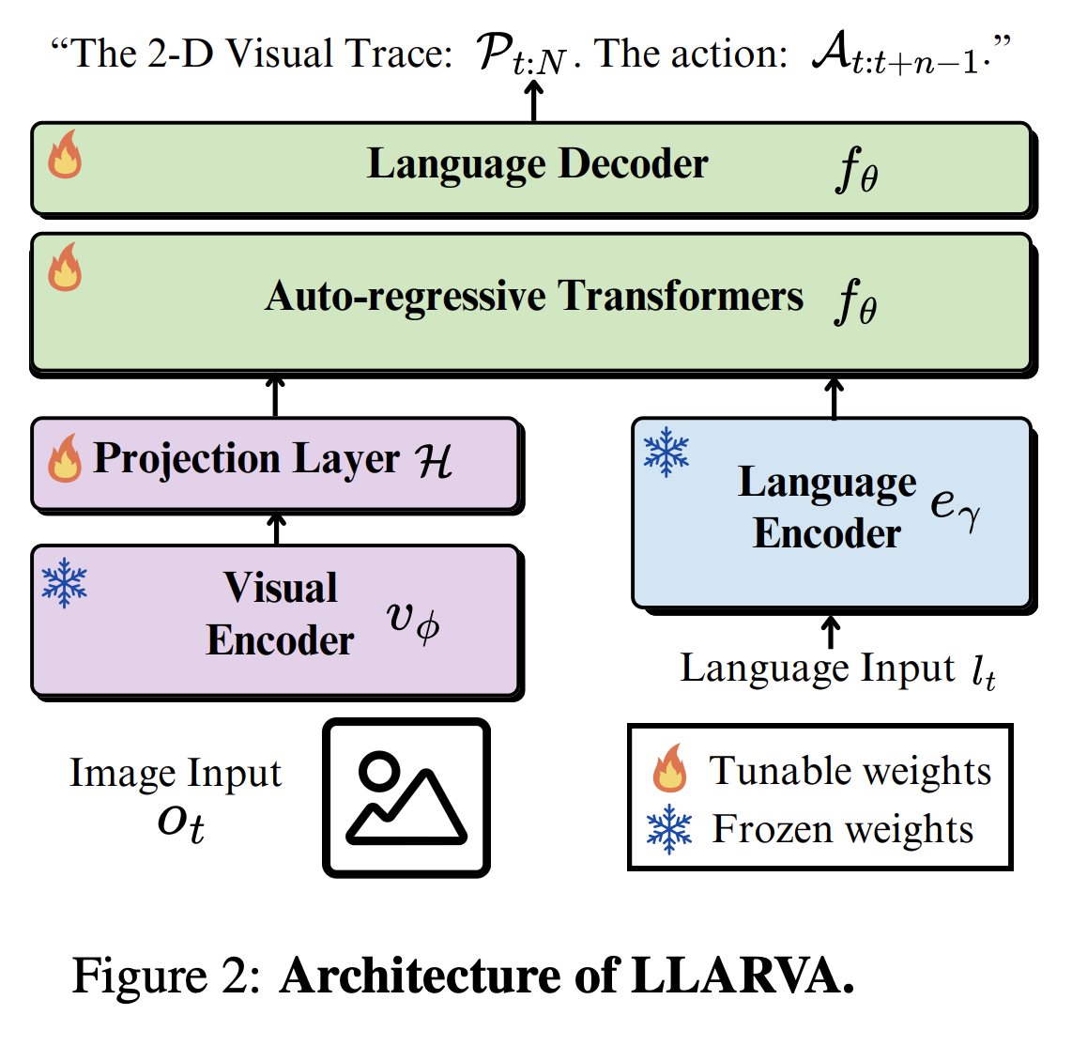
- LLARVA
  - LLARVA is a monolithic VLA that is instruction tuned to output a 2D visual trace alongside actions. It combines the 2D trace line of reasoning that HAMSTER has, but remains monolithic.
  - Paper suggests exploring this framework but with 3D information about the world
  - LLARVA seemed to struggle in the real world. Test results from the paper showed that simulation data was pretty 1:1 with predicted and ground truth trajectories, but physical data was all over the place (some of them probably could have worked, but hard to necessarily tell)
  - 2D pathing for this is complex and curvy while HAMSTER is just rigid lines (at least when shown in the paper)

General Considerations:
- We will likely need some sort of static camera for 2D visual trace approaches (just a wrist camera won’t be enough)
  - The good thing about the traces is that they are 2D so a small, basic camera is fine. But if we go another route we may need to invest in a depth perception camera like the Intel Realsense.

6/5 Notes
VLA Models:
- OpenVLA
  - Outperforms RT-2-X by 16.5% on average across 29 tasks and multiple types of embodiments. Consider that RT-2-X is a 55B parameter model
  - Trained on 970k robot manipulation trajectories from OXE (this is of course on top of the training that enables the VLM backbone)
  - First to perform “parameter-efficient fine-tuning and quantization approaches for VLAs”
    - Performance was increased
  - Interesting find that VLAs need to train through multiple epochs (27 in the case of this model) while LLMs and VLMs only need to train through once or twice
  - VLAs that have been trained on the internet perform SIGNIFICANTLY better than ones that have note been
  - 970k trajectories vs. 350k for RT-2-X
- Octo
  - Researchers themselves admit that their model struggles to process wrist camera data. This may be due to the lack of available training data according to them.
  - Discusses how OXE is all of the optimal results. Paper suggests that in the future sub-optimal or failure based training is employed (just to broaden what the VLAs can learn from)
  - Honestly the paper was very technical detailing exactly how the model is built. One of their major innovations is being able to update the model via fine-tuning wherever is most convenient rather than being restricted to the last layer, for example (all without re-training).
- SmolVLA
  - Manages to achieve small size by skipping VLM layers (other VLAs typically leave the VLM untouched), cutting down on the number of visual tokens used, interweaving self-attention and cross-attention layers
  - Makes use of Action Chunks and diffusion layers, a technique that was pioneered by 𝛑0 and DexVLA
  - Uses community sourced data from Hugging Face (so all different types of setups and form factors). Labeling was tricky due to lack of standardization and could not 100% be automated. Thankfully now the dataset exists for others to use in the future.
  - Has some innovation related to action chunks called asynchronous inference that reduces latency and lag
  - Not pretrained on robotics data
  - Their dataset is only 23k trajectories large which is incredibly small. Seeing how it performed, there is a high chance that it could create even better results if given more data

General Notes:
- Landscape seems to be moving in the direction of VLM → diffusion-based action expert, with action chunking. Best models also seem to utilize some sort of pretraining and post-training. I think this is what we should do, as it yields better results and faster performance
- I think we should at least have 1 wrist camera and 1 shoulder camera
- We will need to figure out how to integrate the additional data that the Aria glasses collect into the VLM/VLA (e.g. eye-tracking data, glasses proprioceptive data)

Tomorrow (6/6):
- Deep dive into HAMSTER
- Decide which VLA/VLM candidates we want
  - Look at docs, codebase, specifics
- Explore 3D info as inputs into VLA
- Explore Aria docs (how data is captured, how to get the stream going, etc)
- Around midday: spend the rest of the time deep diving into our candidates

6/4 Notes
LLM Prompting:
- ProgPrompt paper proposes that instead of giving tasks to a robot purely in statement form, robot plans are instead given in “Pythonic program” form (see example below for what this looks like. Note that black sections are where the user provides an input). It sees the prompter giving the an LLM the basic outline of the code they want (actions function names, available objects, etc…) and then has the LLM fill in the blanks.
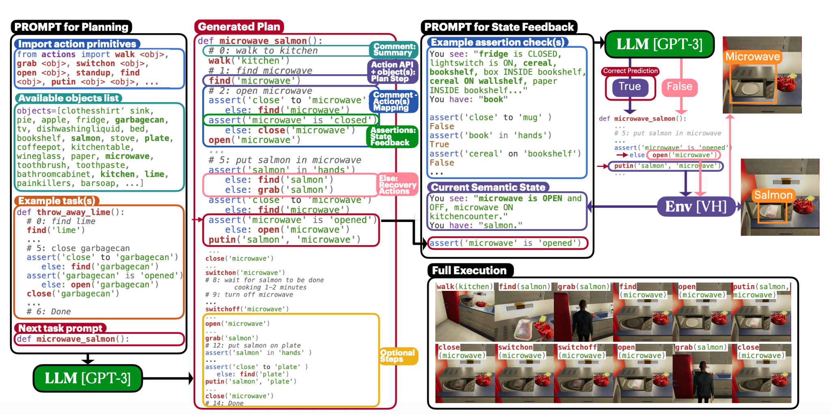
  - The biggest downside of this approach is that it only works if everything in a setting can be labeled according to labels provided/imported by the prompter. While this works well in virtual environments (like what the paper found), it struggles in real world environments unless you’ve basically hand created a scene and labeled everything in code for the robot
    - Real world testing happened in a very controlled environment with only a handful of objects (elementary fruits and a plate) and was subject to random real world failures (as is typical in the real world)
    - Not a very efficient system for real world use, but one way that it could be iterated upon is if we could get another LLM or VLM to produce all of the robot “actions” and “objects”
- In general it seems that LLM prompting papers for robotics have been less prevalent as of late. I think that everyone is shifting over to pure VLA and VLM research because of their easy ability to work in the real world.

VLA Considerations:
- Robotics datasets seem to be largely for 6-DoF robots – how will we get the data for our 1-2 DoF arm?
  - Our arm’s actions will likely be different from the training data as well. We likely won’t be able to do things like “pick up” or “pour”
- Will we be training/fine-tuning the VLA’s ourselves? If so, do we get access to SEAS compute?
- We need to factor in the fact that we will have a very uncontrolled environment
- Hierarchical robot policy (high-level task planning separate from low-level control policies) vs having the VLA handle it all?
- How novel does Slade want this to be? Would he be okay with us just using another paper’s model or does he want us to use those as inspiration but tweak them somehow?

OpenVLA: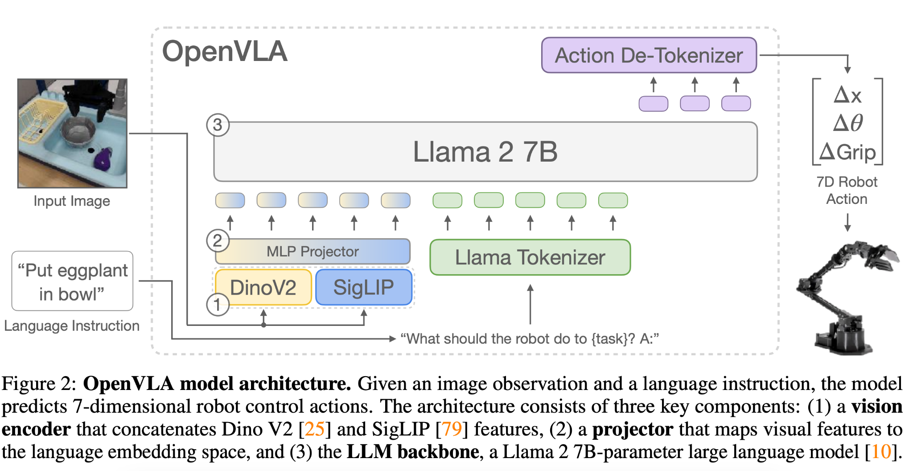
- Open source – something we could build off of
- OpenVLA was restricted to robots with a 3rd-person camera :(
- Didn’t test with heterogeneous sensory inputs
- Image resolutions quadratically effect training compute – OpenVLA used 224x224 resolution (no practical difference from 384x384)
  - Higher resolution has been shown to increase performance for VLMs, but not (yet) for VLAs
    - Even if it does increase performance, I think the compute tradeoff is too great for our use-case
- Previous work has found that freezing the vision encoder during fine-tuning yields better performance, but OpenVLA found that fine-tuning the vision encoder provides massive performance improvement
  - Perhaps because out-of-the-box vision encoders don’t learn enough spatial information & reasoning

Random Thoughts:
- Might be cool if we have the person wearing the glasses to have eye tracking assist the robot as well
  - “finding something within sight of the person” – could have a finding action too, where robot tells the person which direction to look in based on where they are currently looking
- For hardware, we could potentially get this very basic, 6 DOF (!!!) hobbyist arm to work. Made using hobbyist servos and 3D printed parts (I might make this myself at home lol)
  - YT tutorial on how to set it up
  - Obviously would need to change the base and some things, but this will probably drastically simplify the design process and we can make multiple of these b/c they are cheap so one person can test the AI, VLA stuff while another can work on putting it together with a swivel
  - Hugging Face gives a complete, low-level overview of how to work with LeRobot. Great place to start learning about it and at a more basic level how to work with cobots
  - You can make a leader/control arm and a picking arm or two picking arms (just two different attachments at the end of the arm.

To do in the future:
- Thursday Morning: Gather our bearings and set on a more specific direction that we want to go. This will help us come up with more in depth topics to research (we have a general enough of an idea to specialize now)
- Thursday Mid-day: Lab Meeting
- Thursday Afternoon: More paper reading/API exploration
- Friday: Meet with Slade sometime and go over everything we’ve found as well as the direction we think we want to go. Hopefully he’ll give some helpful feedback and insight about how to improve our idea
- Monday: Map out the next few weeks as well as refine our idea based on the feedback that professor slade gave us
- Tuesday Morning: Really bring things together in anticipation for mid-day meeting with professor slade

6/3 Notes
VLM Findings:
- Did some basic research on VLMs and actually from what I can tell (going to have to take a specific look at the code of course) VLMs handle from start to finish controlling the robot. Flow would be as follows:
- Give verbal command
- VLM gets a sense for the surroundings and how thing need to move to fulfill the command
- VLM outputs a text command that can later be configured as line code sent to a robot in real time
  - Note that this is very compute heavy and slow, meaning it may not be suitable for practical use with a person today. All of the VLM videos I see online are played at 4x speed because movement processing is so slow.
- One potential issue is that VLMs only work with what they can see in the current frame (no proprioception for the robotic limb). It looks like researchers have dealt with this by mounting static scene cameras around the table/workspace so that what the arm is grabbing is always in view.
  - For us, this means that we’re going to have to really think about the camera system placement.
  - Potential placements:
    - On the arm limits sight once it has engaged in a task because the scene is constantly changing and there is no guarantee that the workspace stays in frame.
    - On the hip/belt is tricky because there is no ability to see things higher than where the camera is placed (imagine if your waist sits below a ledge).
    - Wearing the glasses themselves is a good option that mimics human sight (most of the VLM studies use cameras that are mounted above looking down), but with no proprioception, a person would need to look directly at what they want the arm to move at all times, which is far from ideal.
  - Theoretically one way that we could solve this is by scanning an environment, creating a 3D simulation of it, and then moving objects both in the simulation and in real life. This would likely run compute power and time through the roof, however.
  - The closest I found to a system with a non-stationary camera was the OpenVLA-OFT+ arm setup shown in their website videos. The demonstration video was filmed from a different camera, however, and it is not clear if that camera was also being used by the system.
- Specifically for robotics, I should mention that people use what are called Vision-Language-Action Models (VLAs), not strictly VLMs. VLMs typically deploy their outputs in a simulated environment while VLAs can be applied to the real world and actually consider the control/planning aspect necessary to get something to work.
  - The benefit of VLAs is that they are basically VLMs with a changed output layer that outputs motor commands rather than text lines. VLAs are also usually trained on robot trajectory data or data from the internet.
  - In Google Deepmind’s RT-2, robot commands are represented by the output tokens of the model, meaning the model literally spits out robot commands

Controlling the Arm:
- We will need to decide how to output the control signals to control the arm
  - Code as Policy: With CaP, the LLM/VLM system will output movement instructions in the form of code. This presupposes the existence of an existing, documented movement library for the arm.
    - Upsides: easier to interpret, less data hungry, rapid prototyping
    - Downsides: deterministic (not reactive), no real time feedback loop within tasks, computationally heavier, latency
    - This could be a good MVP0 – easier to prototype while we’re still tweaking the arm, and then focus on more customizable RL with remaining time
  - LLM-Enhanced Reinforcement Learning: LLMs can enhance RL at many different stages while still maintaining the real time adaptability / error correction of RL. It could process information (from state in environment), design the reward function (from the environment), and also influence the decision-making process by simulating the world, fully making the decision, and/or interpreting the policy in a human-understandable way.
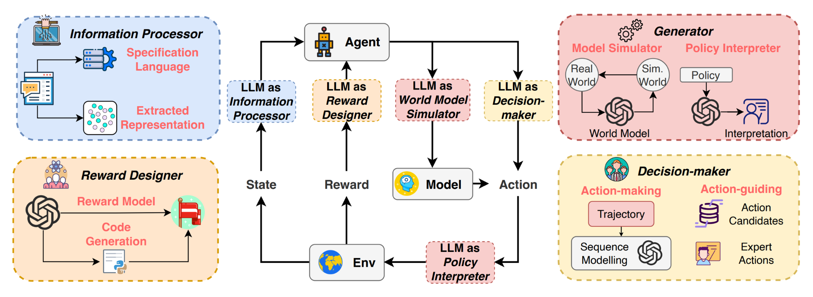
    - Upsides: can error correct
    - Downsides: more data-hungry, requires more training
    - I think this will be necessary in real-world situations, especially if the arm is attached to the human (much more uncertainty in location, movement – not a perfectly stable environment)
  - Merging of the Two: RL-GPT, for example, integrates RL into the LLMs possible actions. It begins with a “slow agent”, which takes in the task and breaks it into sub-actions. Then, the “fast agent” chooses to either write code to carry out the subtask or decides that it is an RL task and then writes an RL configuration for execution
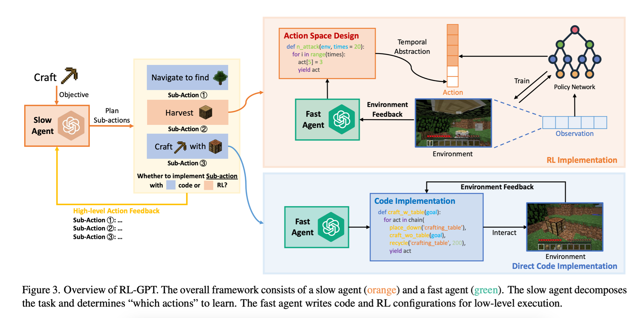
    - Upsides: pros of CaP for simpler tasks, pros of RL for more complicated/error-prone tasks
    - Downsides: not sure how many simpler tasks there will be in our use-case
    - If we start with CaP, this could be a way to transition into/test out feasibility of RL for certain tasks?
- Possible flow:
- LLM breaks down main task into subtasks
- VLM matches subtask landmarks to image/video captures
- Combine these outputs to output control signals?

Project Aria Glasses Note: I downloaded the mobile companion app but was locked out from any of its functions. I think that we need an approved account to access all of the developer tools so I sent an email to Ray to set up a meeting where we can sort all of that out.

Tomorrow (6/4):
- Charlie reads VLM/VLA stuff
- Alex reads LLM prompting stuff
- Meet with Raymond for Glasses logistics + more general guidance

6/2 Notes
Project goal: Create a robot attached to a person that can pick up/move around objects in an assistive manner based on language prompts.

Hardware:
- Swiveling arm system
  - Arm system/attachment can be a simple 1 DOF mechanism
  - Attachment mechanism is ideally flexible and most likely worn at the waist
- The arm will likely have a basic claw attached to its end to pick things up
- Very few restrictions given (no weight requirement, ease of use can be relatively low, doesn’t necessarily require an easy to put on attachment)
  - Really just aiming to create a proof of concept that works

Software:
- Seems like a proof of concept for LLMs/VLMs/VNMs to reliably control an additional robotic limb
  - It’s not entirely clear how other RL, AI systems will be utilized beyond interpreting data
- Minimal viable product/interface would be to have typed commands
  - Theoretically should not be too much harder to integrate voice control using available APIs
- Basic flow chart:
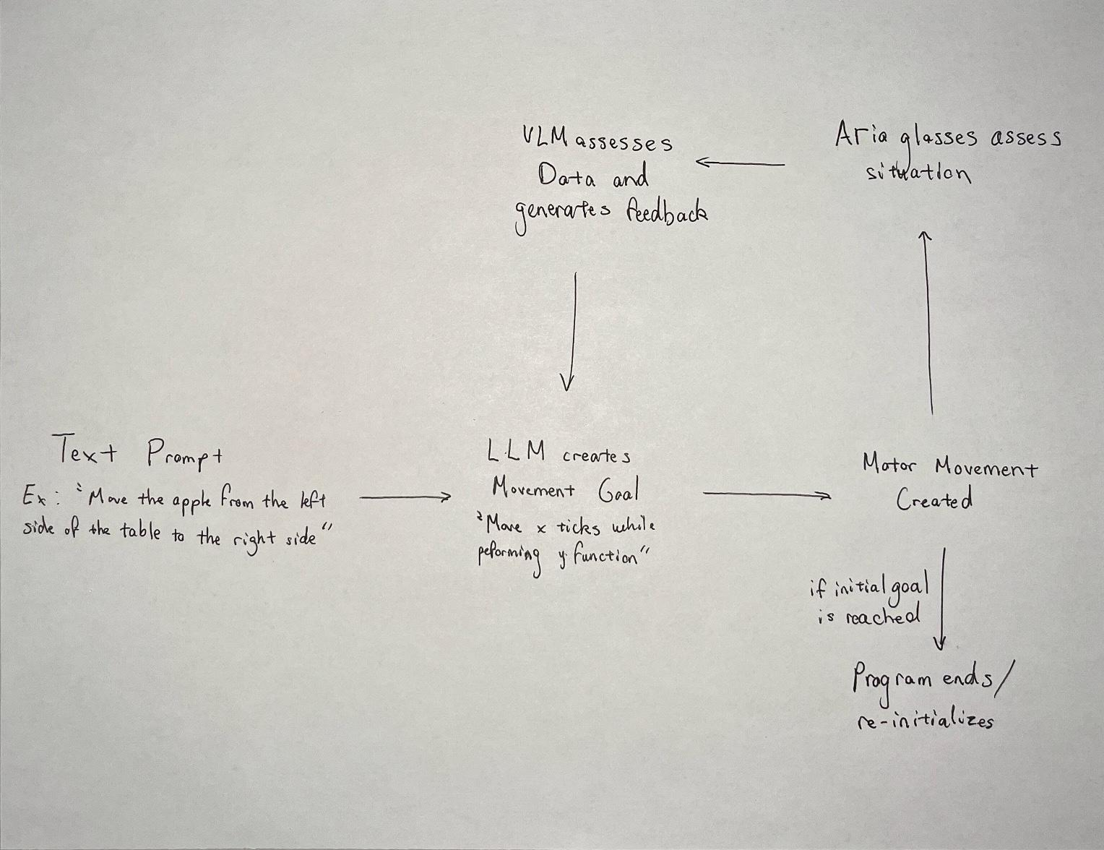
- Main goal: Solve for how the language models will convert what they are prompted to do into usable motor commands

Potential Project Approaches:
- Use LLM to interpret the task and then immediately spit out appropriate motor commands
- Use LLM/VLM to inform RL that then informs motor outputs

First Week Plan:
Mostly just spending the week reading and getting a better sense for the field before deciding which specific direction we want to take the project. Also make sure to play around with the Project Aria glasses.

M, Tu, W - Read papers, experiment with the Project Aria glasses
Th, F - Whole lab meeting, start to put together what we’ve learned and brainstorm a more concrete idea of how we want all the parts to fit together
M - Come up with roadmap for the remainder of the summer

Resources

Control Focused Papers:
- Papers provided by Professor Slade
  - https://paperpile.com/shared/GenAI-for-assistive-robotics-fJNeuwXPwTJilHVfGD0BFlA
- Reinforcement learning:
  - Survey on Large Language Model-Enhanced Reinforcement Learning: Concept, Taxonomy, and Methods
    - How to integrate LLMs into RL paradigm
    - Very helpful overview of possible uses of LLMs to enhance RL
  - Motif: Intrinsic Motivation from Artificial Intelligence Feedback
  - Accelerating Reinforcement Learning of Robotic Manipulations via Feedback from Large Language Models
  - Refined Policy Distillation: From VLA Generalists to RL Experts
- Self-supervised learning (for unstructured environments) – some of these are hella old:
  - Self-Supervised, Goal-Conditioned Policies for Navigation in Unstructured Environments
  - Improving Robot Navigation through Self-Supervised Online Learning
  - Self-supervised Deep Reinforcement Learning with Generalized Computation Graphs for Robot Navigation
  - ViNG: Learning Open-World Navigation with Visual Goals
- LLMs for robotics:
  - How to Prompt Your Robot: A PromptBook for Manipulation Skills with Code as Policies
  - Code as Policies: Language Model Programs for Embodied Control
    - Give the LLM an instruction, and it outputs (Python) code to be executed on the robot. This presupposes that there’s some API for robot movement
  - RL-GPT: Integrating Reinforcement Learning and Code-as-policy
    - Combines RL and LLMs – LLM breaks down task into steps (slow agent), and for each step decides if it should implement it with code or utilize an RL model to carry out the task (fast agent)
  - Statler: State-Maintaining Language Models for Embodied Reasoning
  - ProgPrompt: Generating Situated Robot Task Plans using Large Language Models
  - Do As I Can, Not As I Say: Grounding Language in Robotic Affordances
  - CoPAL: Corrective Planning of Robot Actions with Large Language Models
  - ChatGPT for Robotics: Design Principles and Model Abilities
  - ChatGPT Empowered Long-Step Robot Control in Various Environments: A Case Application
- Voice-controlled robots:
  - The VoiceBot: A Voice Controlled Robot Arm
    - Too old, doesn’t use LLMs
  - Comparative performance analysis of M-IMU/EMG and voice user interfaces for assistive robots
  - A Voice Control System for Assistive Robotic Arms: Preliminary Usability Tests on Patients
- Multimodal robots:
  - Pick and Place Control of a 3-DOF Robot Manipulator Based on Image and Pattern Recognition
  - PaLM-E: An Embodied Multimodal Language Model
    - Takes in images and text as same-dimensional tokens
    - Seems to work with mobile camera
  - A New Era in Human Factors Engineering: A Survey of the Applications and Prospects of Large Multimodal Models
    - Not really helpful – it’s not about robotics applications at all
  - Foundations & Trends in Multimodal Machine Learning: Principles, Challenges, and Open Questions
    - Also pure ML not robotics
  - Beyond Transfer Learning: Co-finetuning for Action Localisation
- Incorporating human feedback:
  - A Survey of Reinforcement Learning from Human Feedback
  - Incremental Learning of Humanoid Robot Behavior from Natural Interaction and Large Language Models
    - This is like GPT-4o running on a robot in the sense that it has a memory and is able to remember preferences/commands for future times
- VLMs/VLAs Research:
  - Vision-Language-Action Models: Concepts, Progress, Applications and Challenges
    - This paper is basically VLA 101 for everything from before May 2025
    - Interesting point about moving robots/objects that employ VLA - Use a lot of state tokens in the form of IMUs, LiDAR, and odometry to maintain an understanding of surroundings. We could potentially make use of lidar sensors
  - Manipulate-Anything: Automating Real-World Robots using Vision-Language BVModels
  - Physically Grounded Vision-Language Models for Robotic Manipulation
    - This is a training data set of household objects
  - RT-1: Robotics Transformer for Real-World Control at Scale
    - Pre-cursor to RT-2
  - RT-2: Vision-Language-Action Models Transfer Web Knowledge to Robotic Control
    - Google Deepmind project that brought VLA research and VLM + robot interactions to the forefront of peoples’ attentions. Requires a static camera
    - Co-fine-tunes VLMs on robotics data
  - Gemini Robotics: Bringing AI into the Physical World
    - VLM → VLA (cloud backbone → local action decoder)
    - Able to run at 50Hz still
    - Made their own embodied reasoning benchmark ERQA
  - Figure AI Helix
    - This may be the most advanced VLA out there. Never going to be publicly released but very cool to keep up with
  - GR00T N1: An Open Foundation Model for Generalist Humanoid Robots
  - Flow Matching for Generative Modeling
  - A Survey on Vision-Language-Action Models for Embodied AI
    - Very dense survey on VLAs with pros and cons for a lot of design decisions
    - Might be worth looking through for its citations to find more examples of VLAs lol
  - HAMSTER: Hierarchical Action Models For Open-World Robot Manipulation
    - Creates a plan of action for a robot to move/complete a task based on a static camera angle (point to point movement on the picture frame)
    - Could be very useful if data for our arm is a problem (LLM-enhanced RL approach & outperforms OpenVLA)
    - Might be interesting to explore passing in eye-tracking data as coordinates to HAMSTER
    - We would likely need to rethink camera placement for this
    - Base VLM: 13B parameters 😬
    - Low-level policies:
      - RVT-2: Learning Precise Manipulation from Few Demonstrations
      - 3D Diffuser Actor: Policy Diffusion with 3D Scene Representations
  - LLARVA: Vision-Action Instruction Tuning Enhances Robot Learning
    - Says it uses an LMM, but this was written so long ago I’m not sure that the term VLA was widespread. This is basically a VLA though
    - Also generates 2D visual trace but uses monolithic VLA
    - Visual traces outputted alongside robot actions
    - Uses 1 camera
    - Could try incorporating this sort of thing with some action expert?
  - π0.5: a Vision-Language-Action Model with Open-World Generalization
    - Successor to π0 but not open source yet
- Small, Open Source VLA Models and Open Source Datasets:
  - OpenVLA: An Open-Source Vision-Language-Action Model
    - Size: 7B parameters
    - # Trajectories: 970k
    - Released: June 2024
    - Has been surpassed by many future models (see below)
  - Fine-Tuning Vision-Language-Action Models:Optimizing Speed and Success
    - Size:
    - # Trajectories:
    - Released:
    - Successor to OpenVLA
    - Slightly better than π0
  - TinyVLA: Towards Fast, Data-Efficient Vision-Language-Action Models for Robotic Manipulation
    - Size: 0.422B, 0.74M, 1.3B params across three sizes (largest one is the only one that is consistently high performing
    - # Trajectories: 0
    - Released: Sep 2024
    - Smaller parameter, easier to run and faster model that may be good for our purposes (assuming performance isn’t terrible)
    - Outperforms OpenVLA. Also check out OpenVLA-OFT+ (upgraded version)
    - Key is that it uses a diffusion layer at the end to decode actions
    - Trained from scratch, does not include a scrub of the internet/general robotics data
  - SmolVLA: A vision-language-action model for affordable and efficient robotics
    - Size: 0.24B, 0.45B, 2.25B
    - # Trajectories: 23k
    - Released: May 2025
    - Alternative to TinyVLA, pi0, etc…
    - Performs on low-cost hardware and often at better rates
    - Smallest version is 0.24B parameters; largest is 2.25B parameters (still very small)
    - Open source
    - Uses multiple cameras
    - Uses asynchronous inference with decoupled VLM/Action expert, decreasing latency in the feedback loop
  - Octo: An Open-Source Generalist Robot Policy
    - Size: 27M parameters (Octo-Small) or 93M parameters (Octo-Base)
    - # Trajectories: 800k
    - Released: May 2024
    - SUPER small (0.09B parameters)
    - Bad with wrist cameras (possibly just due to limited data at the time)
  - ​​π0: A Vision-Language-Action Flow Model for General Robot Control
    - Size: 3.3B parameters
    - # Trajectories: 30k (all publicly available)
    - Released: October, 2024
    - Consistently outperforms OpenVLA
    - Key/novel aspects:
      - Flow matching action expert (form of diffusion) & action chunking
      - Pre-train on diverse data to account for mistakes/variability
      - Post-train on high quality data to learn how to do task well
    - Generalizes across robots
    - Open sourced
  - π0.5: a Vision-Language-Action Model with Open-World Generalization
  - DexVLA: Vision-Language Model with Plug-In Diffusion Expert for General Robot Control
    - Scales the action expert instead of the backbone VLM
      - VLA has 1B parameters
    - Pretrains on cross-embodiment data, aligns to specific embodiments, then post trains for adaptation to new tasks
    - Videos seem like it moves wayyyy too slow
- VLA Datasets:
  - VLA-3D: A Dataset for 3D Semantic Scene Understanding and Navigation
    - Dataset with 3D info (bounding boxes, point clouds, etc)
  - Open X-Embodiment: Robotic Learning Datasets and RT-X Models
  - DROID: A Large-Scale In-The-Wild Robot Manipulation Dataset
    - Data from DROID was added to OXE
  - Open X-Embodiment: Robotic Learning Datasets and RT-X Models
    - This is a constantly updating, incredibly large open robotic data set from Google Deepmind that has different scenes, is applicable to different embodiments, and capable of performing many many different skills
  - BridgeData V2: A Dataset for Robot Learning at Scale (smaller dataset, easier for prototyping apparently)
    - Included in OXE
  - Learning Fine-Grained Bimanual Manipulation with Low-Cost Hardware
    - Sell their custom arm setup (more industrial and sturdy than the LeRobot but much bigger from the looks of it (table top)
  - ChatVLA-2: Vision-Language-Action Model with Open-World Embodied Reasoning from Pretrained Knowledge
    - Claims to be a midpoint in terms of abilities between VLMs and VLAs (VLAs become too robot oriented and lose the generalist abilities/knowledge of VLMs)
    - Not necessarily going to be helpful for our project, but this demonstrates that a robot could solve basic math problems on a white board and move digit cards to indicate its answer to the question
- VLAs with heterogeneous inputs:
  - Beyond Sight: Finetuning Generalist Robot Policies with Heterogeneous Sensors via Language Grounding
    - Factors in things such as touch and sound (e.g. “grab the object that feels squishy” or “grab the button that plays classical music”)
    - Works despite lack of training data for touch and sound
    - Uses a wrist camera as well as a third person camera (this is a system that I could see us actually implementing)
    - Touch factor (seems to help in situations where the robot drops an object) could technically be implemented in our project due to the availability of very small, easy to use touch sensor pads.
  - Scaling Proprioceptive-Visual Learning with Heterogeneous Pre-trained Transformers
    - Maps multiple vision/proprio sensors onto a shared latent space (accounts for e.g. different camera placement on different robots in training data)

Project Aria Glasses Resources:
- General Website
- Ray’s Github API
  - Ray described this as a starter API that allows for real time gaze estimation and object detection
- Project Aria: A New Tool for Egocentric Multi-Modal AI Research
- Case Studies
  - I think research results from projects that use Aria are sent to Meta and are not generally published. This is about as good as it gets in terms of inspiration for use
    - A “hit” article on the closed doors nature of the project
- Machine Perception Services (MPS) Documentation
  - This gives us access to SLAM, point clouds, etc.

Supernumerary Limb Resources:
- Human augmentation by wearable supernumerary robotic limbs: review and perspectives
  - This a “state of the industry” paper and good to start with
  - Has a lot of references to supernumerary arm papers
  - A lot of talk about control/feedback for SRLs, but I don’t think that will really be a problem for us since ours is just voice controlled
  - Groups by device types
- Review of Research and Development of Supernumerary Robotic Limbs
  - Alternative 101 paper that groups things based on purpose rather than by device type
  - Shared control strategy (SRL system’s role in making larger decisions)
- Embodiment of supernumerary robotic limbs in virtual reality
  - We aren’t writing a paper, but embodiment has been really popular in human-focused robotics papers as of late (makes sense)
  - This would be important data to collect if we were running tests
- The Wearable Robotic Forearm: Design and Predictive Control of a Collaborative Supernumerary Robot
  - Example of a supernumerary forearm
  - Very dense design and physics heavy paper
  - Uses a recurrent neural network and gated recurrent units (GRUs) for arm motion prediction (this is something that we might look into more in the future). This is as opposed to augmented reality
- MIT d'Arbeloff Laboratory
  - This lab started formal supernumerary limb research
  - NGL I read one of their recent papers and the research was just okay in quality. Cool concepts but execution could have been better imo
  - They had a lot of success in the mid-2010s and appeared all over IEEE
  - A lot of the successful research is tied to this Federico Parietti but he’s been working for a company for 10 years now
- Exploiting body redundancy to control supernumerary robotic limbs in human augmentation
- Multifunctional Remotely Actuated 3-DOF Supernumerary Robotic Arm Based on Magnetorheological Clutches and Hydrostatic Transmission Lines
  - Supporting IEEE Explore article that is very easily digestible
  - Big, impractical system that is teleop controlled
  - Beginning 2 sections mention some design considerations that could be useful to us (e.g. each join should have maximal angular speed of 400º / s, good backdrivability)
- Bracing the human body with supernumerary Robotic Limbs for physical assistance and load reduction
- A Teaching Mechanism of Supernumerary Robotic Limbs for Natural Human-robot Collaboration
  - Control focused paper for supernumerary limbs (none I’ve seen have made the jump to include VLAs yet)
- Bi-Directional Human-Robot Handover Using a Novel Supernumerary Robotic System
  - Shoulder mounted supernumerary arm
- Design of a Supernumerary Robotic Limb Based on Hybrid Control of Motion Imagination and Object Detection
- The KIT whole-body human motion database
  - Human motion dataset – we might need to use this to teach our model about human movement (if there’s a way to capture that info without mocap)
- Leveraging the Human Operator in the Design and Control of Supernumerary Robotic Limbs
  - The concept theory behind this regarding degrees of freedom is sort of what I had in mind initially (albeit the device is centered on the waist, not off to the side
- Motion-Compensation Control of Supernumerary Robotic Arms Subject to Human-Induced Disturbances
  - Feedback loop to account for the wearer moving while the arm is too – this step should be eliminated by the VLA (because it should account for all of this as a part of its feedback loop)
- A Human Motion Compensation Framework for a Supernumerary Robotic Arm
- MetaLimbs: Multiple Arms Interaction Metamorphism
  - Supplementary video
  - Cool project but this has a ton of restrictions that make it a strictly lab-only device
- Soft Poly-Limbs: Toward a New Paradigm of Mobile Manipulation for Daily Living Tasks
  - Soft robotics example
- Toward Seamless Transitions Between Shared Control and Supervised Autonomy in Robotic Assistance
- Independent, Voluntary Control of Extra Robotic Limbs
  - EMG control for a pair of robotic stabilizers controlled by patients’ pectoral and abdominal muscles
  - Solution was proposed so that patients would be able to still use their arms and legs freely without interfering with the supernumerary arm
  - Feels like this solution only works in a bubble/lab setting because the paper didn’t at all touch on what would happen if a person was stretching/moving around. Just assumed that their arms would be stationary
- Toward Seamless Transitions Between Shared Control and Supervised Autonomy in Robotic Assistance
- Contact-initiated shared control strategies for four-arm supernumerary manipulation with foot interfaces
- A 3D head pointer: a manipulation method that enables the spatial position and posture for supernumerary robotic limbs
  - Head bobbing to control SRA – voice commands just to indicate function of a head bob
  - VR-type system for calibration
- Vision-based control of supernumerary robotic limbs for grasping tasks
  - SRA with a vision system (no GenAI though)

Hardware:
- Standard Open 101 Arm (6 DOF Arm associated with SmolVLA paper)
- Kinematic Analysis for Trajectory Planning of Open-Source 4-DoF Robot Arm
  - Multi-DOF arms are less complicated in their hardware and physical build than they are in their control schemes. This whole paper details a control scheme for an open source multi DOF arm just so that its tip always goes where the researchers want it to go.
  - Keep in mind that forward and reverse kinematics are whole different deals and actually reverse is much harder to implement.
  - The math behind this involves a ton of dynamics (meaning there’s a chance I won’t know how to create the control frame for a custom system)
- Multi-degree-of-freedom robot arm motion simulation based on MATLAB
- Introduction to Robotics: Mechanics and Control
  - I did not realize there are whole text books on control

ADLs + Assistive Devices:
- Activities of Daily Living
- A Review of Assistive Technologies for Activities of Daily Living of Elderly
  - A lot about activity theory – I don’t think we really need that info
  - Doesn’t talk about SRLs/robots at all, just data-based stuff
  - There is some interesting things about types of activities we could factor into our task selection
- A Quantitative Analysis of Activities of Daily Living: Insights into Improving Functional Independence with Assistive Robotics
  - About wheelchair-mounted robotic manipulators (WMRMs)
  - Comes up with taxonomy for highest-priority ADLs to prioritize functional independence
  - Opening & closing doors, using electronics, drinking & eating, toileting
- Understanding the Potential for Robot Assistance for Older Adults in the Home Environment
  - More of just a survey of robots that help with ADLs and the categories of tasks they assist with – not rly that useful
- Assistive supernumerary grasping with the back of the hand
  - Grasping blocks (measure time taken to grasp)
  - Grasp & release test
- Adaptation Robotics and Cognitive Load: Use of a Supernumerary Finger for Activities of Daily Living
  - Tracking EEG data for adaptation/learning to use SRF. Not useful for our case
- A soft supernumerary robotic finger and mobile arm support for grasping compensation and hemiparetic upper limb rehabilitation
  - They just used established dexterity tests, not useful for us

Abstract Writing Workshop
Draft Abstract:

Vision-language action models (VLAs) can generalize pre-training data to understand unseen environments and instructions through their visual-spatial and semantic understanding, Existing research analyzes VLA performance on statically mounted, multi degree-of-freedom robotic arms executing tasks for applications in [...]. To our knowledge, no prior reserach has investigated VLA’s in moving, dynamically changing environments involving human subjects. This study aimed to evaluate the effectiveness of VLAs embodied by supernumerary limbs in performing tasks that require human-robot interaction. Participants performed five trials of four daily living tasks with the assistance of the supernumerary arm. For each trial, tasks were evaluated for success on a xxx scale. At the end of each session, participants were surveyed regarding usability. [Results: specific, not vague values]. [Discussion: what it means, why they matter].

Notes:
- Content of abstract:
  - Intro
  - Methods
  - Results
  - Discussion
- Abstract introduction:
  - Context & brief discussion of importance of study
    - What it’s about + stakes (why pay attention to it)
  - The knowledge gap or problem
    - What is not known, not understood, or currently being debated?
    - “However, xxx is still not understood adequately”
  - Objective of study & what you set out to investigate
    - “This study aimed to xxx”
- Abstract methods:
  - Describe study design (e.g. RCT, cross-sectional survey, lab experiment, qualitative interview study)
  - Describe participants or samples
    - Who or what was studied? How many? (be specific)
  - Describe procedures or interventions
    - What did you do?
    - “Participants did xxxxx”
  - Describe what was measured or analyzed
- Abstract results:
  - Include most important data that directly relate to your objective
  - Include specific data values
    - Quantify findings (percentage, means, confidence intervals, etc)
    - Avoid vague language
- Abstract discussion:
  - Interpretation of results
    - What do the findings mean in the context of the research question?
  - Significance and implications
    - Why do the results matter?
    - How do they contribute to the field?
    - “This supports the emerging evidence that…”
- Should NOT include:
  - Graphics
  - “Spin” and overstated results
  - Disciplinary jargon
  - Explicit reference to other studies
  - More than 300 words
- Writing tips:
  - Pare down language
  - Avoid nominalizations (use verbs instead of nouns)
  - Use words like “might, could, may, seem, suggest”
    - Be intellectually honest
- For ongoing research, acknowledge that you are not done
  - “The preliminary results indicate”
  - “Thus far”
  - “Might”
  - “If our hypothesis is supported, then”

Meeting 1 Learnings

What we tried/learned this week
[GenAI]
We spent week one diving deep into the types of ML models we could use to turn a voice/text command into a physical action policy. Our search started with the provided papers, which detailed applying large language models (LLMs) and vision language models (VLMs) towards optimizing low-level reinforcement learning-based policies. In keeping with the focus on generative AI, we looked at multiple hierarchical approaches that fed an instruction and environment observations into a VLM, which then outputted either a) broken-down instructions to feed into an RL policy model, or b) Python code to be executed on the arm (code-as-policy). Looking at very recent sources (early 2024 and on) revealed that GenAI/ML for robotics research has shifted almost entirely towards using vision-language-action models (VLA), which is what we hope to use for this project.

VLAs combine text/voice input instructions (ex: “pick up the apple on the table”) with camera data fed into a VLM, all in all producing policy actions for robots. Early models such as RT-2 tweaked the VLM to output policy actions directly as tokens, but recent high-performing models instead add a diffusion/flow-matching-based “action expert” to decode the tokenized VLM output into actions, increasing performance and efficiency. Newer models such as SmolVLA output “action chunks” – a sequence of actions – and an asynchronous action executor with a non-overlapping action queue to reduce latency in the feedback loop when waiting for the VLA.

Available open source VLA models are not embodiment specific but perform significantly better when post-training on testing-specific embodiment is conducted. Potential open-source, small, generalist VLA models we could use include TinyVLA, SmolVLA, π0, and OpenVLA-OFT+.

An especially interesting avenue for this project is to incorporate the Project Aria glasses’ real-time eye-tracking data into a VLA to further inform a supernumerary arm on where it should be. One possible way to achieve this is using hierarchical VLAs with intermediate 2D pathing stages. These 2D paths would create a “point A to B” outline from which robotic functions could be derived. VLA models HAMSTER and LLARVA have already investigated 2D pathing and would be used as close references.

[Project Aria]
Towards the end of the week/beginning of the next, our focus shifted towards the Project Aria Glasses APIs and understanding available supernumerary robotic arm (SRA) research.

According to the Project Aria Docs, we could use the following types of data as environment observations to our VLA: RGB video, audio, eye gaze, 6DoF glasses trajectory, semi-dense point cloud generation, and hand tracking. The last four SLAM features are offered through Meta’s Machine Perception Services, though we are unsure if it’s possible for us to get all of this data in real-time when running the program. We are still in the process of combing through the documentation and implementing example projects, as the code is a little bit more complicated than we anticipated, but we will continue to figure it out and use Ray as a resource as needed.

[Supernumerary Arms]
SRA research is a newer field that has only seen consistent output since 2012. Outside of the MIT d'Arbeloff Lab, few institutions have repeatedly contributed to the body of available work on SRAs. But of the available work, most seems to be focused on work auxiliary devices that assist healthy individuals with doing more in their jobs (ex: holding a large metal panel’s edges while performing maintenance on the interior) rather than devices that assist disabled individuals perform like healthy ones. We hypothesize there are two primary reasons for this: 1) existing SRA testing rigs are unwieldy in size and weight, with even healthy individuals struggling to independently use them and; 2) SRAs have limited and complex control schemes that are difficult and impractical to use in generalized capacities.

Throughout many papers, only 3 systems seem to be in use for controlling SRAs: limb mapping (MOCAP on an existing limb), EMG signals, or entirely external control. These control schemes all currently require lab settings to perform optimally and safely, meaning deploying them to even working settings (let alone elderly settings) would prove difficult and inefficient if not impossible. Very recent research has begun using rudimentary machine learning for control, but only in a supportive capacity to one of the control schemes mentioned above.

[Project Proposal]
To our knowledge, SRA control is almost-entirely manual right now and nobody has tried fully automating SRAs using VLA voice/text prompts. We believe that this is a logical direction for us to take our project this summer, and that if successful, could show proof-of-concept for a new class of voice-controlled SRAs built on GenAI. We should note, however, that we are not certain VLAs are robust enough to adapt to quirks of SRAs, such as involuntary movement of the wearer, making sure the SRA does not collide with the wearer’s arm, etc… Existing VLAs are trained exclusively on self-contained, autonomous robots with controllable and predictable bases. Some papers we read implemented human intention prediction with motion capture to adjust for any movement by the wearer – we could explore using the Aria glasses’ hand tracking feature to do this in the wild. We may likely need to fine-tune or even re-train our VLA on supernumerary scenarios.

Questions that we’d like to discuss
VLA focused questions:
- VLA testing rigs from papers we read used at least one stationary camera (often more) to capture the workspace/setting. If a robot ever moved, it always stopped to frame its workspace before performing a task. What are your recommendations for dealing with this lack of frame stability when a camera is mounted to a person? Should we shoulder or wrist mount it? What about the person wearing the Project Aria glasses and always looking at the workspace?
- How do you suggest we go about dealing with the discrepancy between existing training data for VLAs and our more targeted use-case (e.g. specific Aria glasses data, SRA-unique scenarios)?
  - If we needed to fine-tune or re-train a VLA, would we have access to the resources to do so?
SRA focused questions:
- What types of “basic” tasks are you looking for the arm to perform? Are we expected to create a multi-DOF arm from scratch or can we modify open-sourced designs from online to facilitate our experiments?
- How many DoF would you recommend?
  - For an arm with fewer DOF, what do we do if training data doesn’t exist? (commonly the case for VLAs)
General Questions:
- How do we go about ordering parts? And what if a part we want to source is only available from China?
- What do you expect us to accomplish with our project after the 10 weeks? Is it to generate the materials necessary to write a low-level paper? Create a working proof of concept for a future grad student to make a reality? Just explore an interesting field and give a final presentation/slideshow about what we learned/did?

Suggested gameplan for next week

- “Activities of daily living” reading about how they define these for older adults.
- Prepping little hardware mock up (arduino and 3d printed pieces)
- Figuring out inputs/outputs to run a VLA or alternative model
- Getting pipeline from glasses input to the VLA to a mock output of the arm
Tuesday afternoon:
Debrief from meeting, adjust project direction based on feedback

Wednesday:
Finish research into SRAs (Note: we only started SRA research early this week which is why we want to spend some more time on it)
Thursday - Monday:
Start designing the SRA and the overall system. Order appropriate parts if we are able to determine they fit within our design parameters

Tuesday:
Look through APIs (write code to grab Aria data to be passed into VLA, look through VLA APIs to see if we can pass in additional data)
Start CADing the SRA

Meeting 2 Learnings

What we tried/learned since our last meeting
TL;DR: We spent our time since last meeting building a proof-of-concept 1-DOF SRA powered by SmolVLA. We have recorded a training dataset and fine-tuned the base model to point to glasses on a table. We’ve been running into a lot of implementation issues, but are hopeful that our most recent fix will yield results and give us room to figure out what direction to go from here!

Week 1-2:
- Used the spare servo/arm we found around the lab to create a simple 1-DoF arm
  - This is controlled from the Arduino using the Servo.h library
- Wrote a simple custom MotorBus for serial communication between our Python code and the Arduino
  - Spent time debugging and making the protocol more efficient to reduce servo jitter
- Wrote a CameraHandler to handle interfacing with the Aria glasses
  - Setup, undistorting + cropping image, and cleanup
- Note: We spent a while trying to figure out how to integrate the Aria glasses and our custom arm with the LeRobot framework (the plastic 6 DOF arms on Alex’s desk) so we could just use their provided scripts for recording data, autonomous operation, etc, but it didn’t end up working
Week 2-3:
- Wrote an autonomous loop that continuously feeds glasses feed and SRA servo state into SmolVLA’s base model and executes predicted action
  - Since the base model was trained on 6-DoF arms, we decided to keep the shoulder joint’s actions and 0-pad the other 5 joints
  - The base model didn’t really understand & correctly execute our instructions, so we moved onto fine-tuning
- Wrote custom code for teleoperation and data recording
  - Fixed some dataset formatting bugs
  - Fixed more bugs with SRA communication to smooth out movement
Week 3-4:
- Collected 160 episodes of training data on prototype setup and then uploaded to HuggingFace
- Successfully fine-tuned SmolVLA on our 1-DOF embodiment using the FASRC cluster but the fine-tuned model wasn’t very good
  - Worked well moving to the left but couldn’t move to the right at all
- Realized we mislabeled servo ranges the first time around so we re-processed the dataset and are currently fine-tuning the model again
  - Update: This fix (+ some other bug fixes) worked!!
- Project Media with an example video and setup picture

Questions that we’d like to discuss

- If our newest fix doesn’t produce the results we want, what direction should we move in? (More data collection/fine-tuning? Trying out a different model?)
- What is our end goal for the project this summer (and timeline as in going post summer)?
  - More advanced arm? More fine tuning/data collection? Try a different model with eye tracking?
  - Start thinking about concrete steps for a conference paper?

Suggested gameplan for immediate future
- Work on more complicated arm
- Adapt code to accommodate for more DOFs

Notes from Slade:
- Environmental scene understanding problem? Understanding human instruction (breaking down scene to VLA model)?
- Research questions:
  - Having to interact with people AND objects
    - Different activities of daily living, motivate them with other studies
    - How does the robot work with the human to do that? How is that different from other models?
    - Focus more on interaction with human?
    - Showing that you can do tasks with human as a part of the environment/changing environment
    - Grab objects + interact with the human effectively
  - Is the human able to accomplish what they want to do? (different from controller side)
- Example tasks motivated by older adults (self feeding, hygiene, chores, etc)
  - Min DOF to do those things
  - Get MVP, try out, see what hurdles are
  - Then design simple experiments to show it works and come up with metrics (survey user after task?)
    - Standard SRA benchmarks? Do more research here
- “Minimum hardware needed to answer that question”
  - Lock DOFs of lerobot arm?
  - Old PS4 controller? Lol
  - Jo is VR expert, has access to the VR headset

Action items:
- Build more complicated arm
  - Decide whether to build from scratch or to try with SO-101 Arm
    - Start with SO-101 Arm (at least just for prototyping)
      - Lock 2 DOFs to make 4?
- Core area to explore:
  - SRA/VLA’s interaction with the human as a part of the environment (the very end goal is to have something that enables this in either a subset of general tasks or it’s able to do a small handful of tasks in a constrained environment very well)
- Specific list of tasks:
  - Pick up item
  - Place item in hand
  - Etc (human interaction focused, maybe in elderly setting or acting like a third arm for something like cooking support)

Arm stuff:
- Look at SO-101 library/codebase to see what we can do
  - How we can lock DOFs
  - Can we easily integrate simplified arm version into Lerobot framework or do we need custom code for that
- Glasses vs webcam:
  - Webcam simpler, can just use it with Lerobot code
  - Glasses end-goal, need custom code to accommodate (the problem right now is that we’re only using the glasses as a webcam b/c the VLA can’t take in other data inputs)
    - But ditching this is some regards just undermines what we’ve been doing for the past three weeks

This week:
- Look through SO-101 codebase (Charlie)
  - How easy it would be to transfer to custom software
- Figure out how to attach SO-101 arm to a human (Alex)
  - Attach webcam and just use Lerobot library

Overarching question: How effectively can VLAs perform tasks that require human interaction?
- How effectively can existing VLAs be applied to supernumerary robotic arms (as opposed to stationary arms in a controlled environment)
- How effectively can existing VLAs understand their surroundings and instructions while performing human-interactive tasks

Overall timeline:
- Use existing SO-101 6-DOF arm (the one on Alex’s desk) + a webcam (instead of Aria glasses) to perform human-interactive tasks
  - Mount the arm onto a human (CAD a new base piece, design an interface for human to wear)
  - This serves as an MVP0 for an SRA running on SmolVLA performing human-interactive tasks, and is an intermediate step before custom hardware
  - Note: this allows us to have some sort of presentable milestone by the end of the summer, but it runs parallel to the work we did this past month (instead of building off of it)
- Once we have that MVP, do one of the following tasks for the rest of the summer:
- Start coming up with benchmarks/conduct trials with humans for human-interactive tasks
- Start building a custom 4-DOF arm to carry out human-interactive tasks (so we’re not just using this one existing library for all of our implementation)
  - This also allows us to use the Aria glasses instead of a webcam
- During the school year:
  - Continue with whichever task we chose not to go with
  - Explore building our own VLA that takes in the additional data that the Aria glasses collect

Proposed plan for this week:
- Use existing hardware & software:
  - Re-CAD the base part of the SO-101 arm to be human mountable
  - Attach a webcam to the user (instead of the Aria glasses)
    - Most likely chest height or forehead go-pro style mounted
  - Use existing Lerobot and SmolVLA library to test out human-interactive tasks
- Look through SO-101 codebase/Lerobot library to see how easily we can integrate a custom arm
- Come up with a list of human-interactive tasks we want our SRA to be able to perform

Questions/what we would like guidance on:
- How much do we need to do to warrant writing a paper/poster? Does taking mostly the same Lerobot/SmolVLA hardware and software but just changing the task/environment count as significant work worthy of publishing? Or would we want to build our own hardware setup and/or VLA?
- Is it worth it to try using the pre-built arm + a webcam first, or should we just jump straight into designing our own custom arm?
  - Our worry is that starting with the custom arm now (and skipping the SO-101 + webcam setup) will require a lot more time spent on implementation and debugging, potentially preventing us from having a presentable milestone with robot-human interaction before the end of the summer

Week 2 Gameplan
- “Activities of daily living” reading about how they define these for older adults.
- Prepping little hardware mock up (arduino and 3d printed pieces)
- Figuring out inputs/outputs to run a VLA or alternative model
- Getting pipeline from glasses input to the VLA to a mock output of the arm

1-DoF Arm
Arm moves horizontally, attached to person/table for now
Instructions would be simple pointing tasks, e.g. “point to the green water bottle”, or “point to the plastic container”

Things we’ll need to do
- Control the 1-DoF arm from the Arduino – do this tomorrow with working Arduino
  - Servo library (should just be the basic Arduino one used in tutorials)
  - Code that does a predetermined set of movements of the servo/arm
  - Code that turns the servo/arm based on Serial input
    - Are we thinking about the number of degrees? This is not too difficult to do and example code probably exists online
      - EX: Arduino site
- Learn how to properly wire out electronics so that we don’t have crazy current and voltage drops
  - We’re going to need to look for or buy capacitors
- Interface the Arduino code with Python (i.e. control arm/Arduino from Python code)
  - Pyserial library
- Work with undistorted Aria glasses video in Python
  - Look at sample code
- Run a VLA
  - Start with text input (not voice)

SmolVLA:
- Configure/fine-tune SmolVLA to work with 1-DoF arm
  - DeepWiki
  - ChatGPT instructions
  - Perplexity instructions
- Set up camera input to SmolVLA (Aria glasses code)
  - This will need to be implemented within LeRobot

- LPF/moving average for predication
- Move to voltage source

Meeting 3 Learnings

What we tried/learned since our last meeting
TL;DR: We adapted the LeRobot SO101 to a mountable form factor for testing in the future. Issues with implementation prevented us from immediately testing, but that allowed us to focus on writing our experimental protocol. The experimental protocol details 4 base tasks based on general activities of daily living that we will be testing, how we will quantify and measure success, variations on those tasks, and general things we need to successfully accomplish the experimental protocol.

Hardware and Testing:
- Adapted LeRobot to a mobile capable form using CAD and used additional prototyping features to test (see images below)
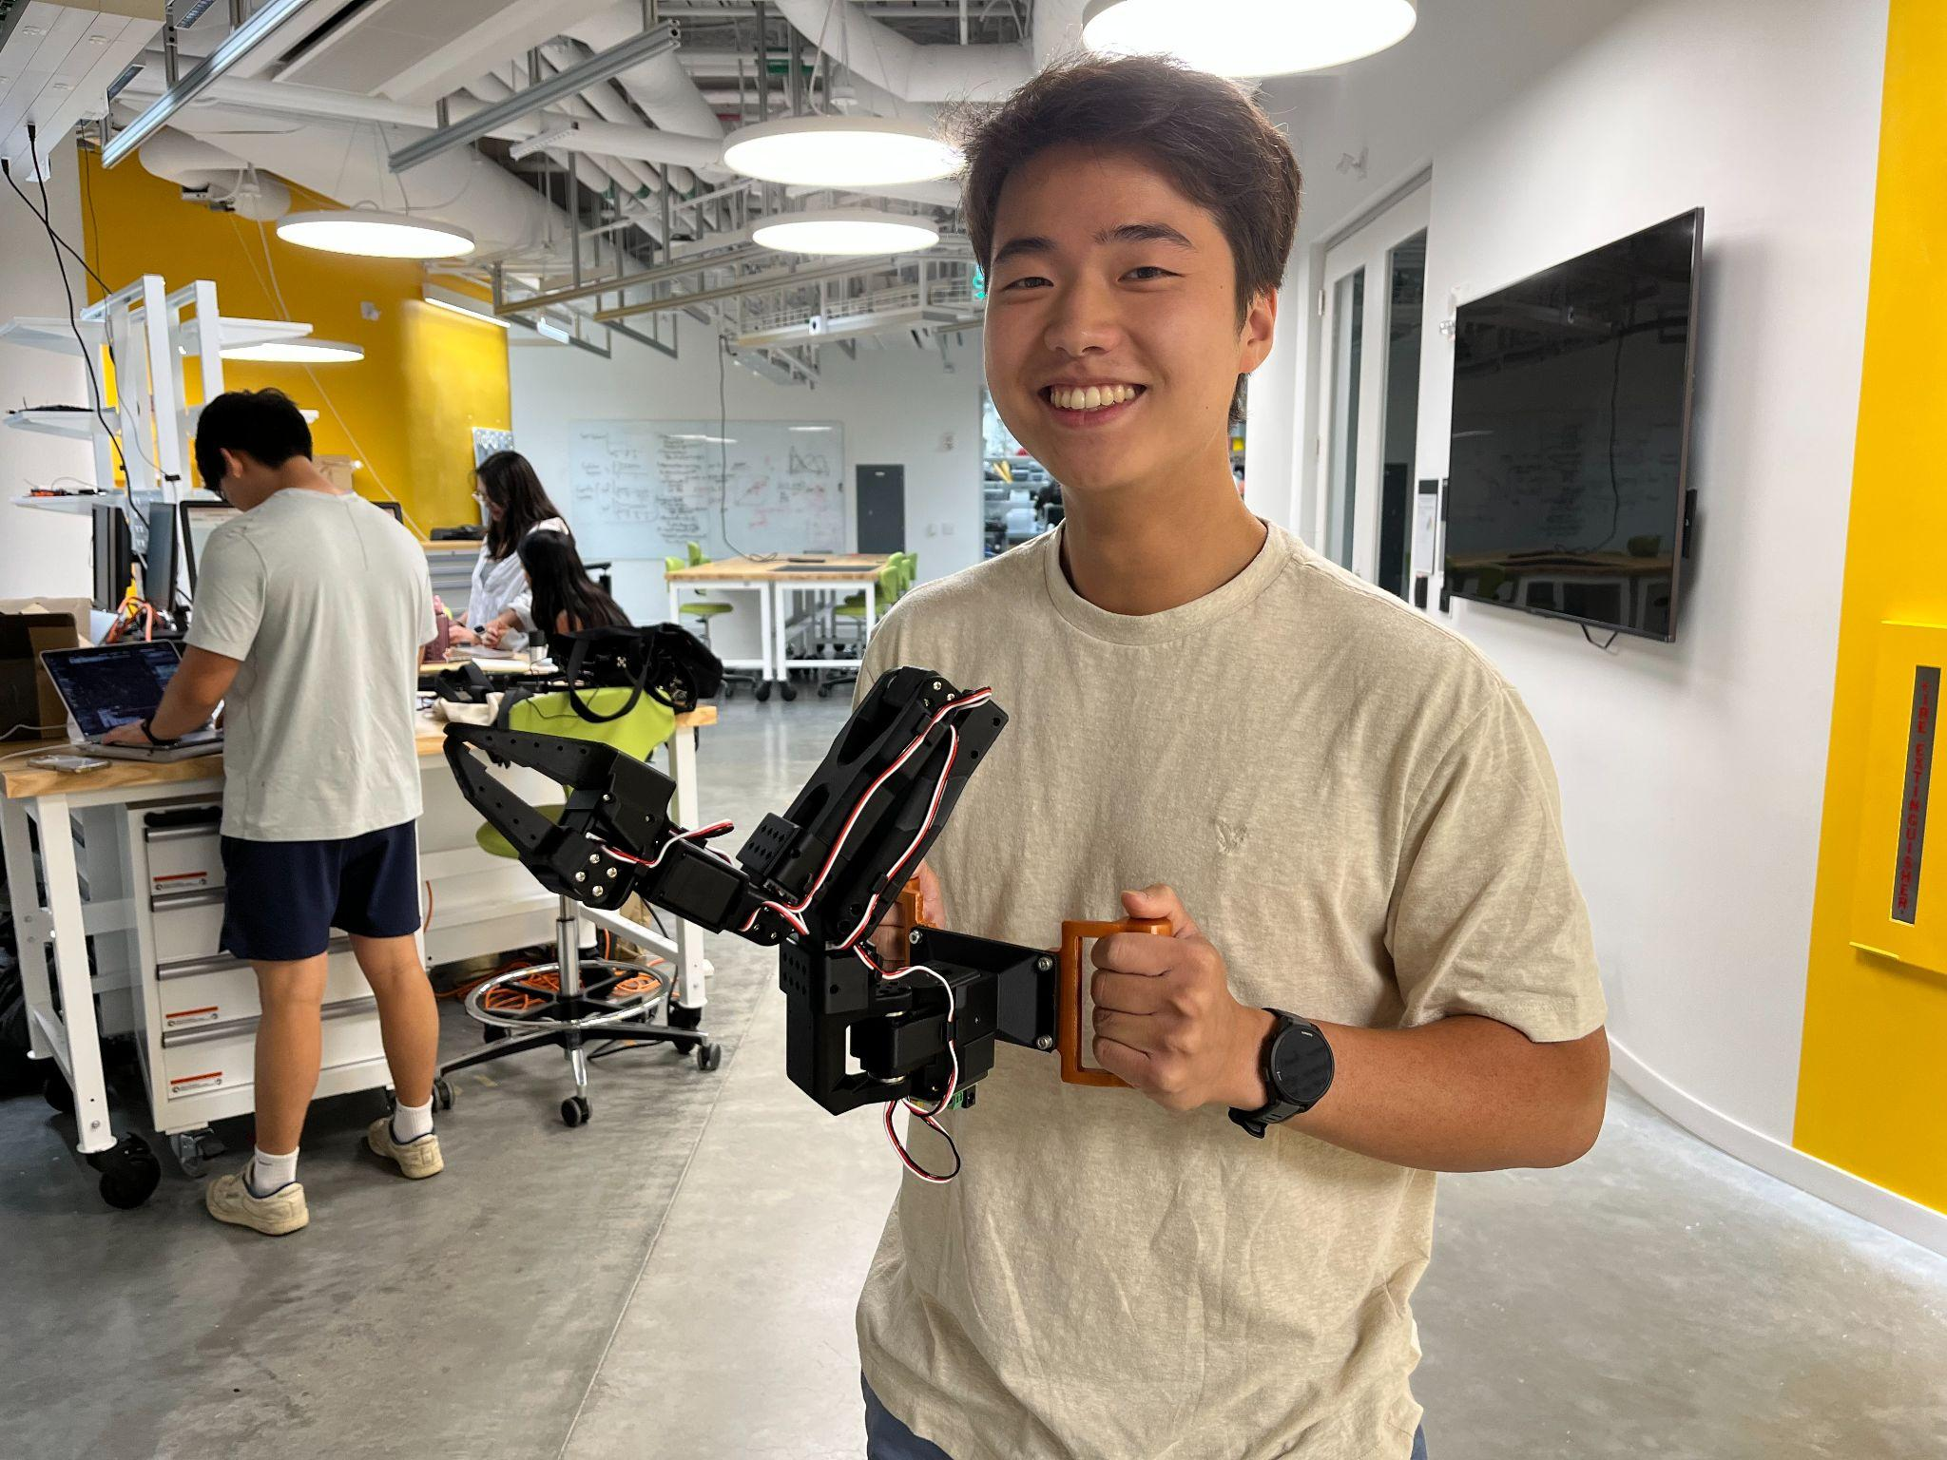
- Tested mobile hardware setup and confirmed that it works with teleoperation
- Realized that inference doesn’t work with base SmolVLA model, so we will record data and fine-tune the model end of this week/beginning of next week
- Next thing we need to figure out is where and how to mount this to a person. We are meeting with Haedo on Friday so he can go over the third arm research with us and any challenges/findings he ran into when it came to mounting.

Study/Paper Aspects:
- Conducted research on ADLs and identified the following tasks as some of the most common ones where supernumerary arm support could be helpful:
  - Find and pass glasses
  - Pick up and hold water bottle while human drinks
  - Spoon-feed human (this may not be feasible with our camera setup)
  - Stabilize hand while brushing teeth
  - Hold pants up while human is putting on a belt
  - Picking up something they dropped (though this would require the human to bend down)
- Crafted preliminary abstract in the “Abstract Writing” tab (still subject to tons of work as the study progresses, but fills in the intro based on a writing research workshop Charlie went to earlier this week)
- Discussed and created a potential study protocol (below)

Experimental Protocol:

Protocol Overview: For each of the four base tasks, we conduct 5 trials of every permutation of variations. Each task will be evaluated for success rate on a normalized scale from 0-1. We take the average of the 5 trials for each task-variation combination. At the end of the experiment, we will survey the user for perceived success and helpfulness of the arm.

Things we need: We will need IMUs and an arduino controller attached to the human to measure/quantify human movement throughout tasks (in order to assign level of human movement for task variations). We will also need a controlled, uncluttered environment (e.g. empty room, desk pushed up against a wall) to ensure we can control the amount of clutter/distractions in the environment.

Limitations: The human must always be looking at what they are doing due to lack of spatial awareness from the robot.

Base Tasks:
Assign normalized point values at different progress checkpoints for each task (this way we can fairly provide partial credit). A 0 represents failure to hit the first checkpoint, and 1 represents full successful task completion.

- Find and pass glasses
- HRI mode: Robot passing object to human
- ADL category: General (?)
- Progress checkpoints:
  - Robot moves towards glasses
  - Robot picks up glasses
  - Robot moves towards human hand
  - Robot places in human hand
- Pick up and hold water bottle while human drinks
- HRI mode: Robot holding object for human use
- ADL category: Feeding
- Progress checkpoints:
  - Robot moves towards water bottle
  - Robot picks up water bottle
  - Robot holds water bottle still & in correct orientation
- Stabilize forearm while brushing teeth
- HRI mode: Robot stabilizing human body part
- ADL category: Hygiene
- Progress checkpoints:
  - Robot moves towards forearm
  - Robot provides stabilizing force on forearm
  - Robot follows forearm movement throughout task
- Hold up pants while human puts on belt (start with pants unbuttoned, a little lower than waist height)
- HRI mode: Robot holding object for human manipulation
- ADL category: Dressing
- Progress checkpoints:
  - Robot moves towards pants waist
  - Robot grasps pants
  - Robot releases pants only when told

Task Variations:
- Amount of human movement (quantify human movement with IMU data – magnitude of acceleration < threshold for each level)
  - Camera frame and person’s torso (or wherever the camera is mounted) is as still as possible
  - Slight movement side to side throughout the task, quantified by IMU acceleration
  - Fast or larger movement or quick stops throughout the movement
- Amount of workspace clutter
  - Workspace only features objects involved in the task (and ones that cannot be removed)
  - Workspace features a small, quantified number of background artifacts (could be physical objects or distracting shapes/colors)
  - Workspace features a large, quantified number of background artifacts (could be physical objects or distracting shapes/colors)
- Orientation of object of interest (upside down for example)
  - Object is in a standard orientation (defined on a task by task basis)
  - Object still features identifiable characteristics, but those characteristics may be slightly obstructed or in different orientations
  - Object is the same type of object, but a different version entirely (different pair of glasses, for example)
- Initial arm location
  - Human arm always starts in the expected position (maybe as similar to how data was recorded)
  - Arm starts in a different position not normal for the given task
  - Arm starts somewhat or entirely out of frame and then moves in/out depending on how far into the task the robot is

Post-Experiment Survey Questions:
- On a scale from 1-10, how successful was the arm in completing its task?
- On a scale from 1-10, how useful was the arm in helping you complete the task?

Questions that we’d like to discuss
- How can we quantify the success of teeth brushing task based on how long it stabilizes the forearm?
- Our study is going to be closer to a VLA paper than a traditional biomechanics paper. Is it okay if we just have success determined by the success/failure rate of accomplishing tasks under certain conditions?
- How robust should our fine-tuning data be? Should it contain a variety of initial arm locations, object orientations, etc? Or should we leave that to test the VLA’s generalization capabilities?
- ADLs vs. human-robot interaction – is our paper primarily analyzing human-robot interaction tasks, and ADLs are just the applications of tasks that we are testing? How do we frame these motivations/stakes in our paper?
- Should we do ablation studies? (is our application different enough to warrant ablation analysis of the VLA, or is the SmolVLA paper enough)

Suggested gameplan for immediate future
Rest of this week:
- Collect simple training data for human-held arm setup
- Fine-tune model based on training data and test inference code
- Meet with Haedo on Friday to figure out mounting mechanism to human
- Wait for webcam to get here on Friday
Next week:
- Refine experimental protocol
- Refine hardware setup (with webcam, human mount, IMUs, etc)
- Start collecting fine-tuning data if all goes well!
Future:
- Start conducting experiments

Meeting Notes
- Completion metrics
- Patient Questions - Ask a few more but we’re going in the right direction
  - System usability scale SUS - can ask around in the lab
  - NASA TLX - task load indicator survey
    - Physical, cognitive strain while using
    - Good for comparing with ALL types of user tech because it gives you a referencable scores
      - Can look up percentile for use-case
  - Most likely take verbatim the survey questions to easily compare
  - Can always ask longer form questions
  - This is an additional piece but nice to have for the paper writing portion
- Main contribution is human interaction task within this framework
  - Show bench marks, what we need to do to improve it
  - Tack on “oh it’s easy for people to use”
- ADLs
  - Great to have a citation and pull from somewhere else (so that we have some backup and don’t just look like we’re making things up)
  - Some of the tasks are tough to map 1:1 to our arm, but we can cherry pick a subset
  - We will likely have two subareas of the study
    - Move towards item, follow the checkpoint system
    - Find three or four tasks that have the exact same checkpoints
    - Completion rate on the graph
  - Another set is a different type involving holding the human, directly interact
    - Use different but ideally very similar metrics
  - Consistent metric for each category, couple categories, could be motivated by different things but consistency is key
  - Could get handwavey with things if things just look cool
- How specific of a task and training?
  - Isolate whatever we think we want to assess
  - EX: if other groups have trained the model to assess how well it generates to other positions, but maybe we want to abstract away from it a little
    - We’re not really evaluating the model
    - But maybe we need to see for this use case
  - Talk about the workarounds (say that you could easily finetune in a few minutes with your pair of glasses and you’re good for the future)
    - Or different positions
- IMU motion
  - Like this, but only thing we have to worry is velocity limiting the arm (there may be no completion then if we are moving faster than how we move)
  - Agrees that it’s important to evaluate
  - Baseline do stationary
    - Then give them tasks to complete while the arm is moving something (so simultaneous task motion)
    - Can try to measure the motion, but it’s also reasonable to say we just did it and use surveys (maybe use IMU)
- Random thoughts
  - Sometimes we measure completion time (show that it’s quicker to run with the robot)
    - Might be irrelevant or too abstract for this specific use case
  - One could be handing item to human, one could be completing a simultaneous task, one could be holding the human
  - Once we have the rig do a bunch of pilot testing to see what’s reasonable vs. not
    - Would move slightly further from ADLs, but professor slade says that is fine (all about the motivation that matters)
- Ablation?
  - Most likely no unless it directly relates to the things we are testing
  - Is it relevant to the human component?
- Next steps
  - Once we finalize the protocol, do some base level predictions for the task before testing
  - After is thinking about paper flow and can use pilot data to inform that
    - Draw expected graphs to lay out the paper
- OpenCap system (instead of IMUs?)
- Class in the fall
  - BE 224 - Just class space
  - No matter what though put time aside to really work hard on this in the fall to get the paper out

Meeting 4 Learnings

What we tried/learned since our last meeting
TL;DR: Created a human mount for the arm and began collecting data/testing out fine-tuned models. Right now, our model results are not very promising, and we are unsure as to what our next steps should be.

Hardware:
- Fully figured out the mounting system
  - We took inspiration from chest phone mount that Ray/Louis used in their experiment
  - 3D printed a chest plate for the arm
  - Used straps and buckles to create a rig that can be donned and doffed without too much hassle
    - Chest strap/buckle
    - Shoulder straps that loop around back of subject’s neck
  - Padded chest with foam to keep arm upright, padded straps at neck for comfortability
- 3D printed physical stop for the arm joints (to limit range of motion so the arm doesn’t swing into the subject)
- Created a handle for the leader arm to make dataset recording easier
- Started using a shoulder-mounted phone camera holder, installed a wrist-mounted camera to the arm, and added an (optional) 3rd environment camera to the setup
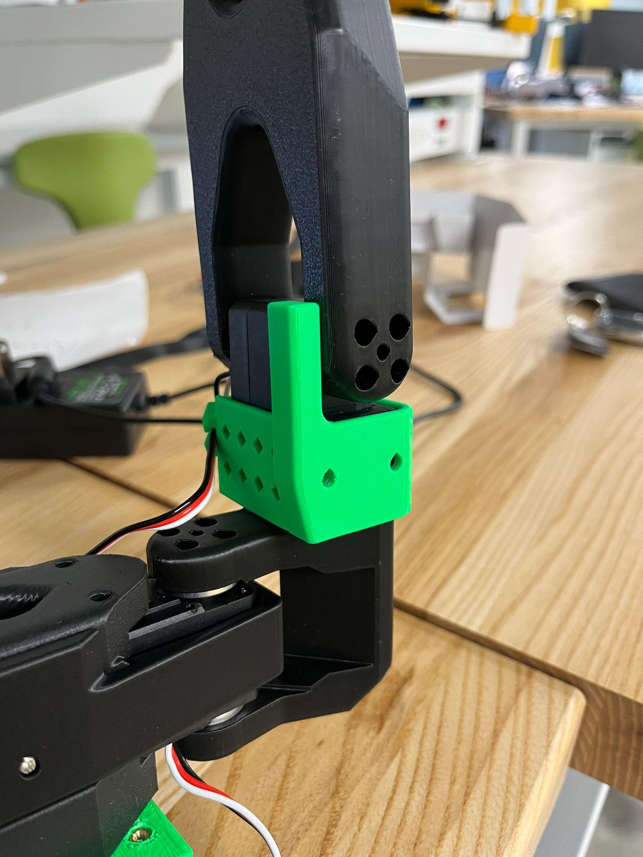
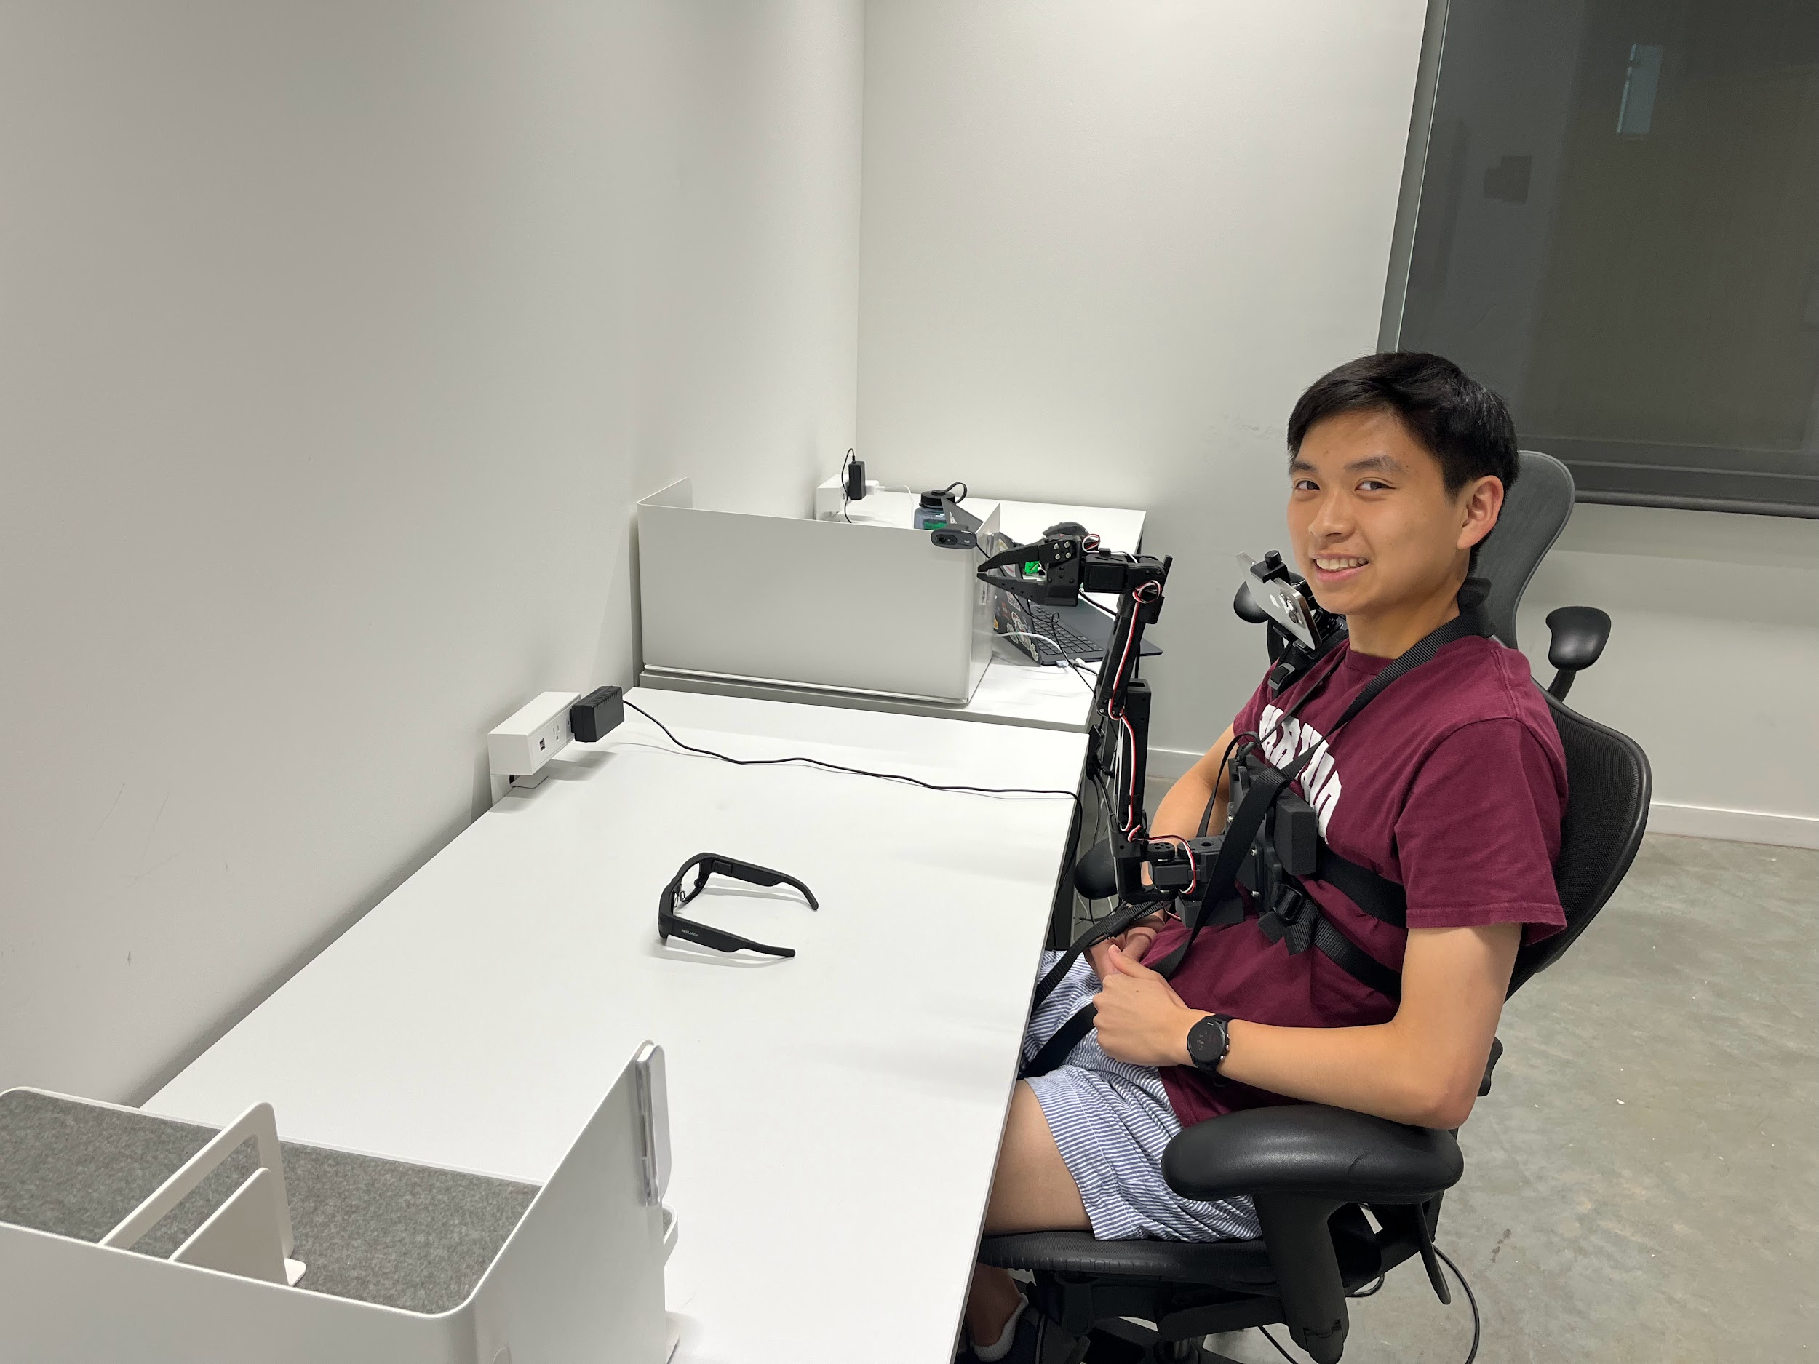

Testing:
- Tested the autonomous inference on an initial low-quality small dataset with 1 camera
  - Was very overfit
  - Only learned the movement pattern, seemed to not recognize the glasses, failed if the glasses were moved at all from center of the table
- Added wrist + environment camera and rerecorded dataset
  - 2 cam setup: 2cam_128_20k_chunkSizeThreshold_point3.MOV
    - Arm consistently moved too far to the right
    - Failed to pick up the glasses
  - 3 cam setup: 3cam_64_20k_chunkSizeThreshold_point3.MOV
    - Semi-consistently completes the task (with some stumbles)
    - Seems like the 3rd camera helps a lot and is lowkey necessary – but this means we couldn’t have a fully portable rig
    - Performance still isn’t that great
- Tried fine-tuning pi0 (different VLA model) but ran into bugs

Random:
- Learned about OpenCap from Haedo and played around with it a little
- Just learned more training related things with FASRC

Questions that we’d like to discuss
- Improving the model performance: We aren’t really sure what is causing our model to not work as well as we would like
  - Hypotheses:
    - Just need to tune hyperparameters more
    - We need to collect more/better training data
    - The model itself is just too limited
- Dedicated Trial Space: For the actual trials (and maybe even training data collection, depending on how well our model can generalize to different backgrounds/environments), we will need a bigger space than the call rooms we’ve been using because we’ll need enough space for the OpenCap setup there as well
- Continuing term-time research in the fall
  - What are your expected hours/weekly commitments (e.g. lab meetings)?
  - Do you prefer us to come in at a certain time or do weekends/late nights work too?
  - Can we apply to HCRP? (we would need to focus on very different aspects of the project within our applications b/c they generally discourage joint projects)
    - If so, we will need letters of recommendation from you (one per person)
    - Due date is usually first week of September

Suggested gameplan for the future
(depending on what you think our next steps should be as well)
- Just try collecting more, more varied, and better training data
- Try even more hyperparameter combinations
- Debug pi0 fine-tuning script (we might just need to wait until they push bug fixes to the repo)

Meeting Notes
- ES91r – research for credit, but we can just do HCRP
- Write draft rec letter for Patrick for HCRP
- Easy way to avoid challenges with this model?
  - Bigger model?
  - Slightly different camera configuration? – just simplify the problem
    - Add another wrist camera at a different angle
    - Use OpenCap camera angles too as environment cams
- Record more data
  - Be more deliberate with teleoperation
  - Just record more
  - More variation?
- Make rigid shoulder mount – same phone mount, just add a rigid piece
- Sounds like he’s saying go big as much as we can
- Testing location: swap 2 desks so we have cameras pointing from wall to desk
- Yilun Du - new faculty joining (doing VLA stuff) probably talk in the future and maybe get as an advisor
  - Reach out in the fall when we have questions
- Don’t have to attend lab meeting
  - Typically when new undergrads join they block time and upfront block 10 hours a week (it won’t be as strict for us, but really just as much as we can work on it)
  - As long as we’re making progress
- Heinous hours are fine
- For motivational purposes maybe look into conferences to look at
  - Options are usually 6-8 page type of paper
  - ICRA, IROS conferences (IEEE) - 40% acceptance rate (great experience) - everything (7000 people per conference, good for recruiting purposes too)
    - Due dates are staggered five months apart (sep/oct and feb/mar. Conferences are a few months later)
  - Also more niche/competitive learning conferences (ICLR, NEURIPS) – types of stuff that Yilun submits to
    - Lower acceptance rate

Meeting 6 (Re-Orienting)
- lab meetings 1-2pm, thursday (okay if we miss)
- 3d point data into vla — easiest way to get a base functioning system
- 1 grad student interested
- yilun du — set up a meeting with them to just chat
- writing paper — maybe start writing small segments to visualize how we can tell the story
  - Think about what best-case scenario is (have that in our initial paper writing)
  - Think about figures – what each figure is gonna be (e.g. vla system, success rate, plots, etc)
  - can write an abstract
  - Abstract → results → figures
  - And then write topic sentences for each section
  - Hard to scope everything in
  - Could start with the intro in our own time (Talk about 3rd arms, VLA models, HRI, how these tools have been used but in different settings – we’re gonna do this new thing and this is why it matters)
  - Paragraph(s) about similar things, differentiate what we did from what they did

How to write an Abstract: https://www.nature.com/documents/nature-summary-paragraph.pdf

